Once Ted Brickler got his feet wet in locksmithing, the whole family got deep into it. Story on page 44.

|  |  |
| --- | --- |
| ly/August 1^ | Volume 45, Issue 7 |
|  |  |
|  | FOCUS... |
|  | ALOA’s Annual Report, |
|  | The Future of Proximity, |
| ■ | ALOA ’99 Class Review,  ■ and our authors’independant 2rL ■ product reviews. |

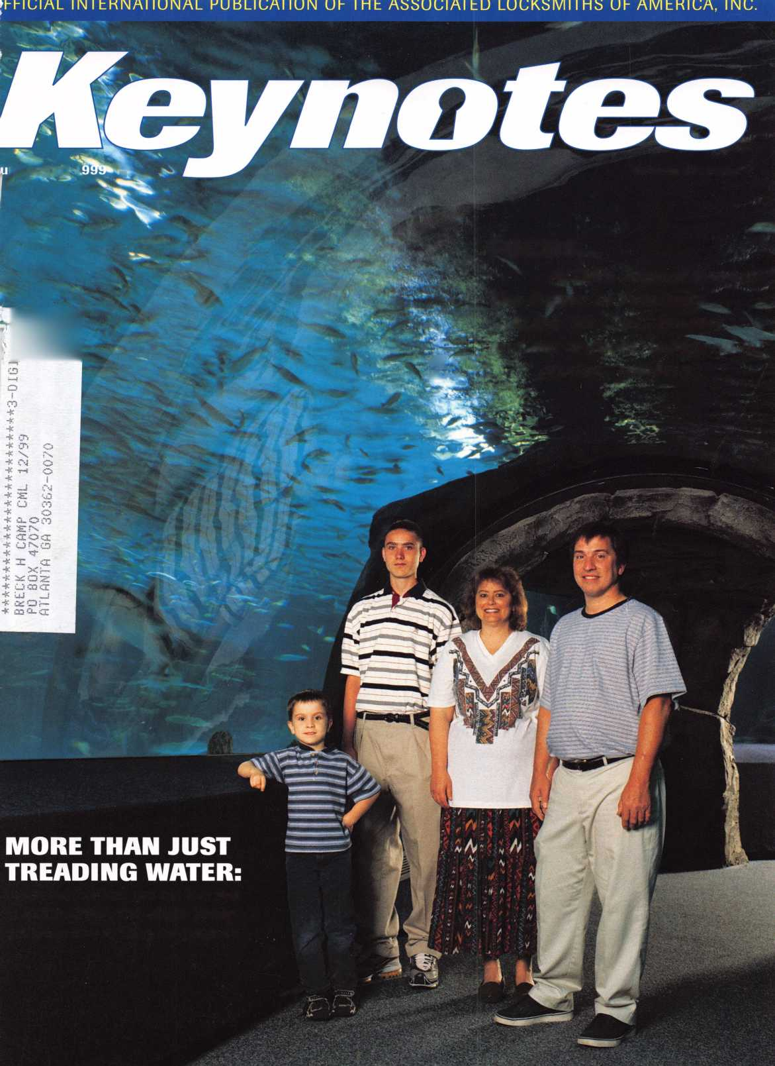

fitVD's

Service Manual Library

Producing high quality, automotive locks, keys and kits is only part of our job...

Helping you install them right is the other part!

BWD is the only automotive lock manufacturer that offers a growing line of service manuals and BWD Certified training for the automotive locksmith.

For a complete list of available manuals, contact a BWD SML Center. For a listing of training seminars, contact BWD at (800) 647-4926.

BWD

AtiiMxnotiyfiCofpafatiafi

Hey Modular Lock

BWD Lockcraft brand Automotive Service Manuals are availabe at:

Allied Locksmith Supply Youngstown, OH (800) 544-2102

Key Products McDonald Dash Locksmith Supply

Columbus, OH Memphis, TN

(800)457-1019 (800)238-7541

Hardware Agencies Ltd. Toronto, Canada (416) 462-1921

Serrubec, Inc. Dorval, Canada (514) 631-6791

BWD

BWD

74 ifti&kKMe**

smmai i&KMmrtm

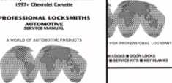

m mm* iatimmnmm * *$.* m**m



in a

BWDBrand

VATS Replacement Keys, Locks and Service Tools

Need it now, need it fast!

Always ready to serve the locksmith, BWD has over 35 VATS Centers located nationwide; Each with a complete line of Lockcraft brand VATS replacement keys, locks and tools.

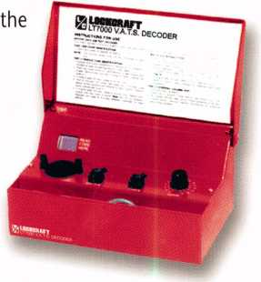

All Lockcraft parts are high quality factory replacements, and come complete with a 5-year/50,000

mile warranty*.

Lockcraft VATS tools are precision made and durable enough to withstand

knocks and kicks associated with automotive service.

BWD's VATS replacement keys not only offer the locksmith a low cost alternative to using original equipment, they also come with a limited lifetime warranty*.

For a complete listing of Lockcraft brand VATS Centers, contact BWD at (800) 647-4926.

* - Proof of purchase required. Warranty applies to defects in workmanship and material on Lockcraft parts and/or components only. Liability limited to cost of part or replacement part at the option of BWD. For a statement of Warranty Terms & Conditions, write to BWD Automotive Corp., 4555 Water Ave., Selma AL 36701.

*BWD*

Automotive Corporation - Selma, Alabama

See us at booth 433

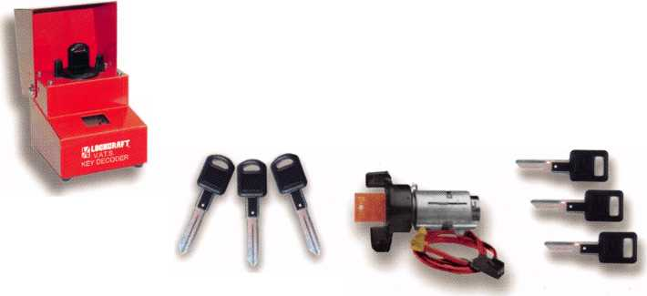

're saving,space

r you

Content

Features

President's Journey

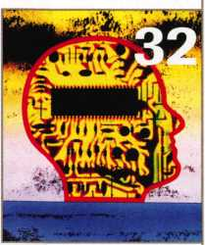

6

Meet the ALOA Staff

A bubbly, effervescent crew who is always willing to lend a hand, the ALOA Staff takes to the water in this issue.

10

Marketing at Work

ALOA’s marketing expert expands on the timeless art of marketing.

By Vicki Morgan

18

Class Preview '99

class preview of what to

at ALOA ’99.

By Patanya Johnson

Legislative Comment

most productive year for

locksmiths! ALOA’s legal eagle

why, plus more updates.

By Tim McMullen

22

Millennium Fever The year 2000 may cause more then panic from technophobes. It may be the key to securing your bottom dollar!

By Claire Cohen, CML

On the

Cover

44

Live and Learn How the Bricklers use their educational skills to make SecureTech one of the area’s top security specialists. By Mike Emery

Cover story photos Bill Devore

Art direction/design Valerie Rowe

24

Scattershooting

A prolific author remembers a prolific industry figure. Bill Reed is fondly remembered.

By Sal Dulcamara, CML

28

More Electric Strike Options from HES

New products to make life easier.

By Paul Chandler, CRL

32

The Future of Proximity Access Control

Top technology at reasonable prices? Learn more about offerings from Keri Systems.

By Paul Chandler, CRL



Keynotes

36

Olympus Old & New

Out with the old and in with the new? That’s not necessarily the case with cabinet locks.

By Don Dennis, CPL

July/August 1999

Core

Meilink turns 100 and sings about it! Honeywell acquires C&K!

Upcoming Events

Security Marketplace

July/August

40

Souber Tools

A British Invasion! New tools from the U.K. are about to make their American debut.

By Sal Dulcamara, CML

49

Meilink’s New Labeling System

A kinder, easier labeling system.

By Anelia M. Banda

Made in America: Wilson Bohannan

16

Applicants

A true tale of history and fortitude. Wilson Bohannan’s story of perseverance through the ages!

By Michael A. Ferrill

77

Authors in this Issue

57 so

Scholarship Recipients Backpage

Meet this year’s Scholarship Recipients. Plus, “Where Are They Now?” A look at what’s happened to past scholars.

By Patanya Johnson

60

GPLA Turns 50!

One of the industry’s premiere associations celebrates its birthday next month.

By Evelyn Wersonick, CML, CPS

62

Schlage Redefines the Patented Key for Locksmiths

A thrilling new development for commercial locksmiths.

By AJ. Hoffman, CML

68

State of the Association/ ALOA Financial Report ALOA’s president reflects on the past year.

By Dallas Brooks

74

Ad Index

78

Classifieds

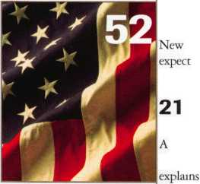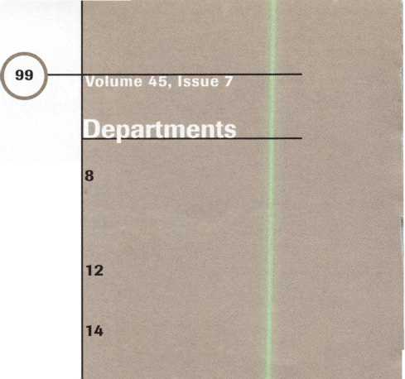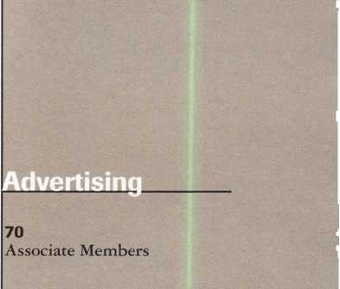

|  |  |
| --- | --- |
| Editor | Mike Emery keynotes @anet-dfw.com |
| Technical Editor | David Lowell, CML, CMS [david@aloa.ioffice.com](mailto:david@aloa.ioffice.com) |
| Communications Coordinator | Patanya Johnson |
| Editorial Advisor | John D. Cannon, CML j dcannon @ worldnet .att. net |
| Advertising Sales | Marvin Diamond  Native American Journal Co. (770) 998-7056 [thediamonds@mindspring.com](mailto:thediamonds@mindspring.com) |
| Contributing Editors | Paul Chandler, CRL  Claire Cohen, CML  Sal Dulcamaro, CML |
| Contributing Authors | Jerome V. Andrews, CML  Brian Costley, CML, CMS  Bob De Weese, CPL  Ray D’Adamo, CML  Michael A. Ferrill  James Glazier, CML  Daniel Graffeo, CRL, CMS Wayne Gurnee, CRL  A.J. Hoffman, CML  Ken Holmlund, CRL  Ray Lusk, CML  Mark Ohno  Randy Simpson, CML  Robert Stafford, CPL  Dave Thielen, CML |
| ALOA Professional Staff | |
| Executive Director | Charles W. Gibson, Jr., CAE [charlie@aloa.ioffice.com](mailto:charlie@aloa.ioffice.com) |
| Operations Manager | Mary May  [mary@aloa.ioffice.com](mailto:mary@aloa.ioffice.com) |
| Comptroller | Kathy J. Romo |
| Finance Coordinator | Janelle Vergara |
| Meetings Manager | Jessica Smith [jessica@aloa.ioffice.com](mailto:jessica@aloa.ioffice.com) |
| Meetings Coordinator | Janelle Vergara |
| Government Affairs Manager | Tim McMullen [tim@aloa.ioffice.com](mailto:tim@aloa.ioffice.com) |
| PRP/Education Manager | David Lowell, CML, CMS [david@aloa.ioffice.com](mailto:david@aloa.ioffice.com) |
| PRP/Education Coordinator | Ashley Spencer |
| Membership Manager | Brandon Durrett [brandon@aloa.ioffice.com](mailto:brandon@aloa.ioffice.com) |
| Membership Coordinator | Jackie Arnett [jackie@aloa.ioffice.com](mailto:jackie@aloa.ioffice.com) |
| Chapters & Regional | |
| Associations Liaison | Tim McMullen [tim@aloa.ioffice.com](mailto:tim@aloa.ioffice.com) |

Executive

Grand Master Key Sponsors of the ALOA ’99 Convention and Security Expo:

Medeco Security Locks

Meilink Safe Co.

medeoo

HIGH SECURITY LOCKS

MEILINK

Additional contact information for the ALOA Board and most Keynotes authors are available through “Locksmith Search'” on the ALOA website- [www.aloa.org](http://www.aloa.org) or by contacting the ALOA office at3003 Live Oak Street; Dallas, TX 75204; [800]532-2562; FAX (214J827-1810; e-mail [aloa@aloa.org](mailto:aloa@aloa.org).



Mission Statement: The Associated Locksmiths of America, Inc. is dedicated to enhancing the professionalism, education and ethics among locksmiths and those in related sectors of the physical security industry. With approximately 10,000 members in the United States, Canada and the freeworld, ALOA is poised to help members obtain the knowledge, the strength, and the confidence to perform their role in the physical security field with pride and dignity. But it is only through active involvement and participation that ALOA can fully achieve its potential-and can help members to achieve theirs.

Policies: Keynoted is the official publication of the Associated Locksmiths of America, Inc. (ALOA). Keynoted acts as a moderator without approving, disapproving, or guaranteeing the validity or accuracy of any data, claim, or opinion appearing under a byline or obtained or quoted from an acknowledged source. The opinions expressed by the authors do not necessarily reflect the official views of ALOA. Also, appearance of advertisements and new products or service information does not constitute an endorsement of products or services featured by the Association. The Association does not accept responsibility for the inaccuracy of any data, claim, or opinion appearing in this publication, due to typographical errors on the part of the authors, Association staff or its agents. Editor’s Note: This publication is designed to provide accurate and authoritative information in regard to the subject matter covered. It is provided and disseminated with the understanding that the publisher is not engaged in rendering legal or other professional services. If legal advice and other expert assistance is required, the services of a competent professional should be sought.

Authors’ Payment: Payment for eligible submissions to Keynotes will be based on the following criteria: topic, time spent and past contributions. Authors who regularly submit to Keynotes are generally paid a higher rate. The latter is especially true of authors who write to fit specific editorial needs and submit said copy by Keynotes deadlines. As a general guideline: Average payment for a 750 word, business or ’light’ technical article would be $200. Payment for a 1500 word article involving significantly higher time and research efforts would be $400.

Payment will not be offered for articles submitted by ALOA employees or members of the ALOA Board of Directors (unless material is of a technical nature), nor for articles submitted by a company that promote that company’s products or services. ALOA reserves the right not to pay for articles submitted by an individuals) that promote a particular company’s products or services.

Disclaimer: The Associated Locksmiths of America, Inc., (ALOA), reserves the right to refuse any article for any reason. Additionally, ALOA reserves the right to edit amend or modify any article submitted for publication in order to preserve technical accuracy, clarity, fairness or grammatical correctness. ALOA will make the best efforts to notify the author of any changes. The extent of ALOA’s liability for any article or information contained therein will be a notice of correction or retraction in the next possible issue.

Keynoted* (ISSN 0277 0792) is published monthly except for the combined June/July issue by The Associated Locksmiths of America, Inc., 3003 Live Oak St., Dallas, TX 75204-6186. Telephone: (214) 827-1701; FAX (214) 827-1810; e-mail [aloa@aloa.org](mailto:aloa@aloa.org). Subscription rates for members-$15.00 per year. Second class postage paid at Dallas, Texas. POSTMASTER: Send address changes to: Keynotes, 3003 Live Oak St., Dallas, TX 75204-6186. © Copyright 1999, All rights reserved. No part of the contents may be reproduced or reprinted in any form without prior written permission of the publisher.

3oard



President

Dallas C. Brooks (334) 826-8990

Secretaiy

John D. Cannon, CML (703) 960-6413

Directors, Northeast

James H. Glazier, CML (301) 831-5454 John C. Magee, III

1. 845-3434 Wiliam L. Young, CML
2. ) 647-5042

Directors, Southeast

Jeffreys. Nunberg, CML, CMS (305) 324-8800 Donald E. Rule, CML (601) 324-2658

Directors, North Central

Mark E. Blum. CML, CPS (517) 482-5809 John J. Greenan, CML, CPS (773) 486-2030

Director, South Central

Randy L. Simpson, CML (713) 780-7026

Directors, Southwest

Gordon Racine, CML (719) 384-4707 John I. Shandy, CML (303) 774-9791

Director, Northwest

Scott Henke, CRL, CPS (907) 248-3785

Director, Associate Members

Judd Penske (800) 634-5465

Non-voting Directors

Jerome V. Andrews, CML (216) 642-3900 Steve G. Engel, CML, CPP (920) 731-5400

D^kmLowell.CML, CMS (800) 532-2562 Breck H. Camp, CML (770) 455-6244 Henry H. Printz, CML (973) 538-2737 Leonard J. Passarello, CPL (416) 752-7210 Edwin Toepfer, RL (416) 225-5589

Chairmen of International Affairs

Laurence P. Mills/Australia (129) 958-0445 Hans Mejlshede, CML/Europe FAX (453) 139-1004

Past Presidents

1995-1997 David Lowell, CML, CMS 1993-1995 Breck Camp, CML 1991-1993 Henry Printz, CML 1989-1991 Evelyn Wersonick, CML, CPS 1987-1989 Leonard Passarello, CPL 1985-1987 Joe Jackman, CML 1983-1985 Stanley Haney, CPL 1981-1983 Louis LaGreco, CPL 1979-1981 John Kerr, RL 1977-1979 Clifford Cox, CML 1974-1977 Charles Hetherington 1972-1974 Gene Laughridge 1970-1972 Wiliam Dutcher, RL 1968-1970 Constant Maffrey, RL 1966-1968 Harold Edelstein, RL 1964-1966 Wiliam Meacham 1962-1964 Robert Rackliffe, CPL 1960-1962 Edwin Toepfer, RL 1956-1960 Ernest Johannesen

July/August 1999

Keynotes **ii**

with Dallas Brooks



c

CD "D cn CD

**i_**

Q-

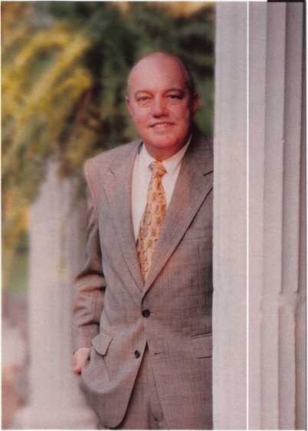

I joined ALOA in October of 1984, the same year I began my own locksmith business in Auburn, Ala. I started with one employee, one service vehicle, a bank loan, and a vision of what I expected my business to be like in ten years. I now have two locations, nine service vehicles and 15 employees. Yes, my vision and my dreams of 1984 were achieved. Of course this was accomplished through a lot of long hours, family support, dedicated employees, a strong desire to get there and the Associated Locksmiths of America.

Yes, I said ALOA. How did ALOA assist me in achieving my dreams? I believe most of you know the answer to this question because I am preaching again to the choir. You already know that without technical classes, product knowledge, peer support, and updated information about our industry, your businesses would have great difficulty surviving. Well, ALOA and the Alabama Chapter of ALOA provided me with the tools needed to succeed and I will always be indebted to them for this.

I also want to thank you, the members of ALOA, for allowing me to be your President for the last two years. It was a very humbling experience to be elected to this position. I began my term with a vision for ALOA’s future, a far-reaching vision of prosperity and growth for ALOA. This vision was shared by many on the ALOA Board and changes began taking place in the governance of ALOA. With a new set of Bylaws and a professional prepared Governance Policy, the ALOA Board and Staff are now pointed in the right direction for growth and prosperity.

This will be my last article to write as your president as you know. By the time you read this, a new President will have been elected and will be taking office at the end of the convention in Cincinnati. I am proud to say this will be the first president elected under the new vote-by-mail system. I want to thank all of you who took the time to participate in the election process.

I could ramble on for several more pages about ALOA and my experiences as your president, but I am sure the Keynotes editor does not have the space available.

It has been a great two years, thanks again!

Dallas C. Brooks President

July/August 1999

Keynotes

***The complete line of high security padlocks recommended by professionals worldwide.***



**MUlffLOCK**

*For more information:*

**I-800-MULTLOCK**

Mul-T-Lock USA Inc., 300-1 Route 17 South, Suite A • Lodi, New Jersey 07644 • [www.multlock.com](http://www.multlock.com)

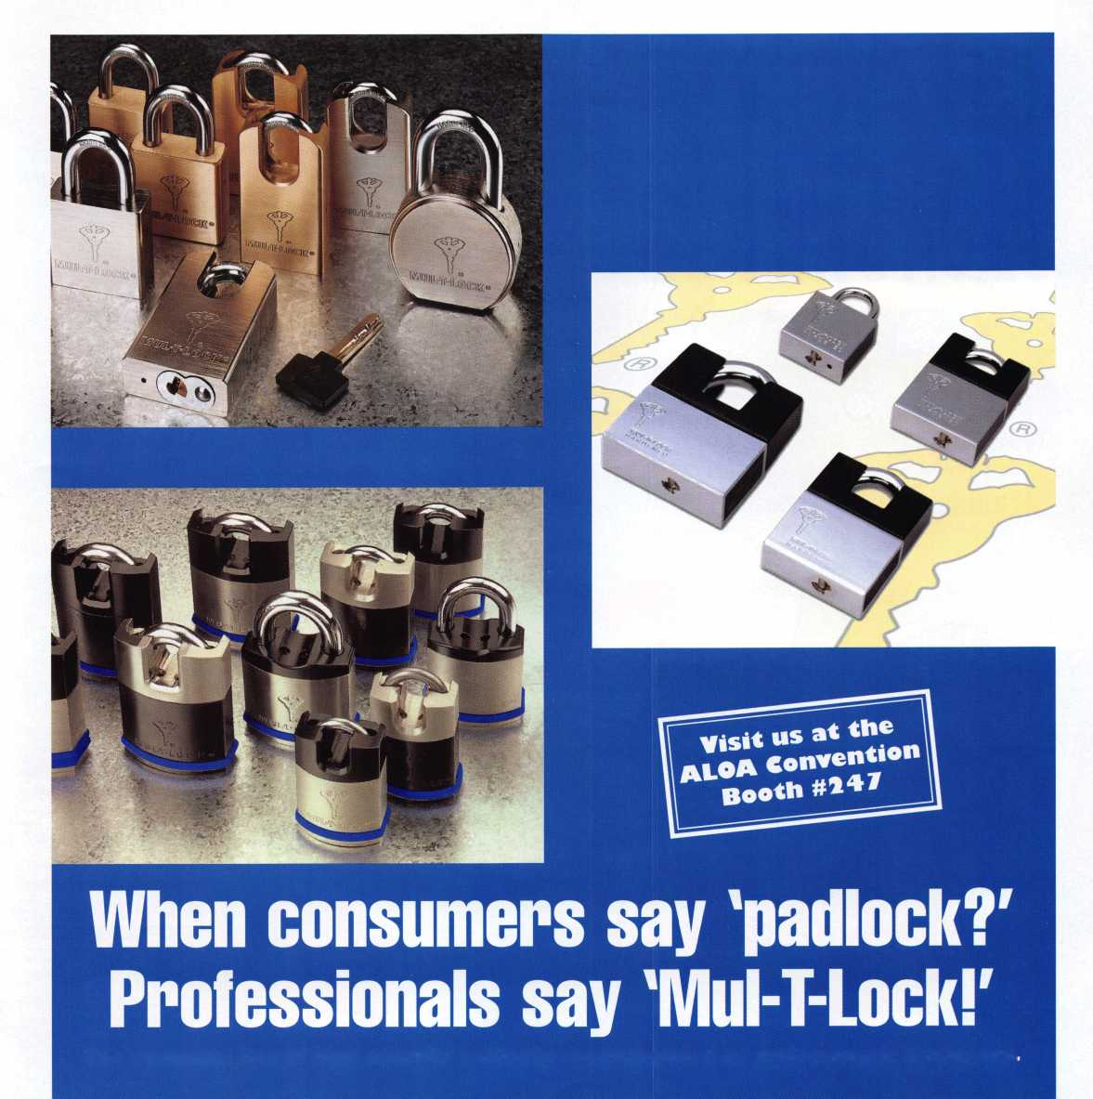

**Captain Ahab and Ishmael they're not. But Executive Director Bill Gibson and Operations Manager Mary May run a tight ship at ALOA headquarters. Hey, they've been through thick and thin together. From the storms of organizing an ALOA show to managing the crew at the office, these sailors know what it takes to get the job done! |**

**as ever!**

*Photos by Je*

**r**

**Education is like  
a flotation device.**

**It can save your life and  
keep you above water.**

**That's how ALOA's Education  
department sees it! With  
Education Manager, David  
Lowell and Coordinator**

**Ashley Spencer in charge,  
ACE classes have been**

**running as smooth**

**They'll go anywhere for a story.**

**Even to the bottom of the sea! Meet the staff of** Keynotes**- Editor, Mike Emery and Communication Coordinator, Patanya Johnson. Mike claims to have swam the Nile in search of an ancient Egyptian lock. Meanwhile, Patanya says that her diving expertise led her to discover a sunken vault worth millions. Be it land or sea, these daring journalists will go anywhere for a story!**

Keynotes

• **if**

*mm*

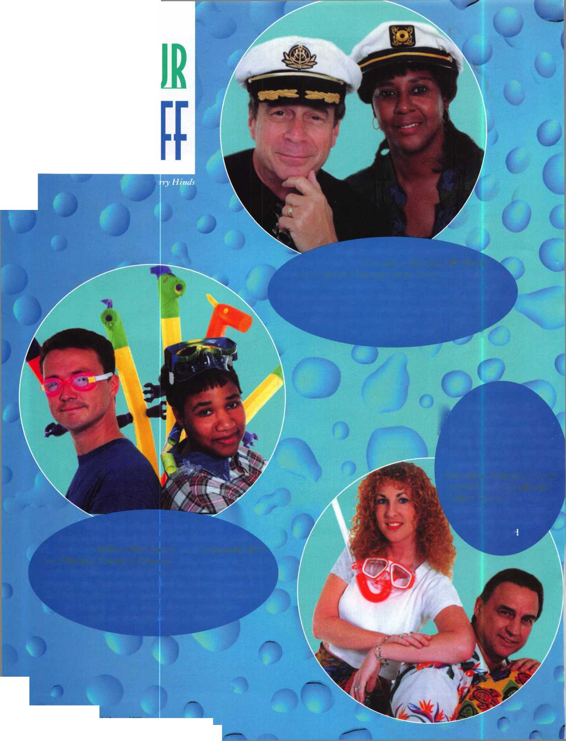

July/Augpl/i9(

**Connected by 1 - ^7 \***

**bubbles, Comptroller^, /**

**Kathy Romo and Meetings |.** /

**Manager Jessica Smith ||||** /

**have one thing in common.** /

**Janelle Vergara! She serves as J**y **/**

**Coordinator for both Meetings v** /

**and Financial Departments!** /

**Juggling two jobs isn't ‘ /**

**k**

**difficult for Janelle, /**

**>ut juggling bubbles? r ~||j**

**That's an entirely**

**different matter. He's loaded with legal knowledge!**

**Our legislative commando (actually Legislative Manager),**

**f**

**Tim McMullen is always on the watch for bills and laws that**

**affect the security industry. Likewise, he's ALOA's Chapter  
Liaison! This guy's aim is dead on, so if you see him in  
ALOA's Legislative Booth, stop by and say "Hi!"  
Chances are, he won't be armed.**

**Fishing for new members  
is Membership Manager,  
Brandon Durrett's and  
Membership Coordinator,  
Jackie Arnett's specialty!  
They help maintain ALOA's  
database, dues billing  
and computer  
troubleshooting.**

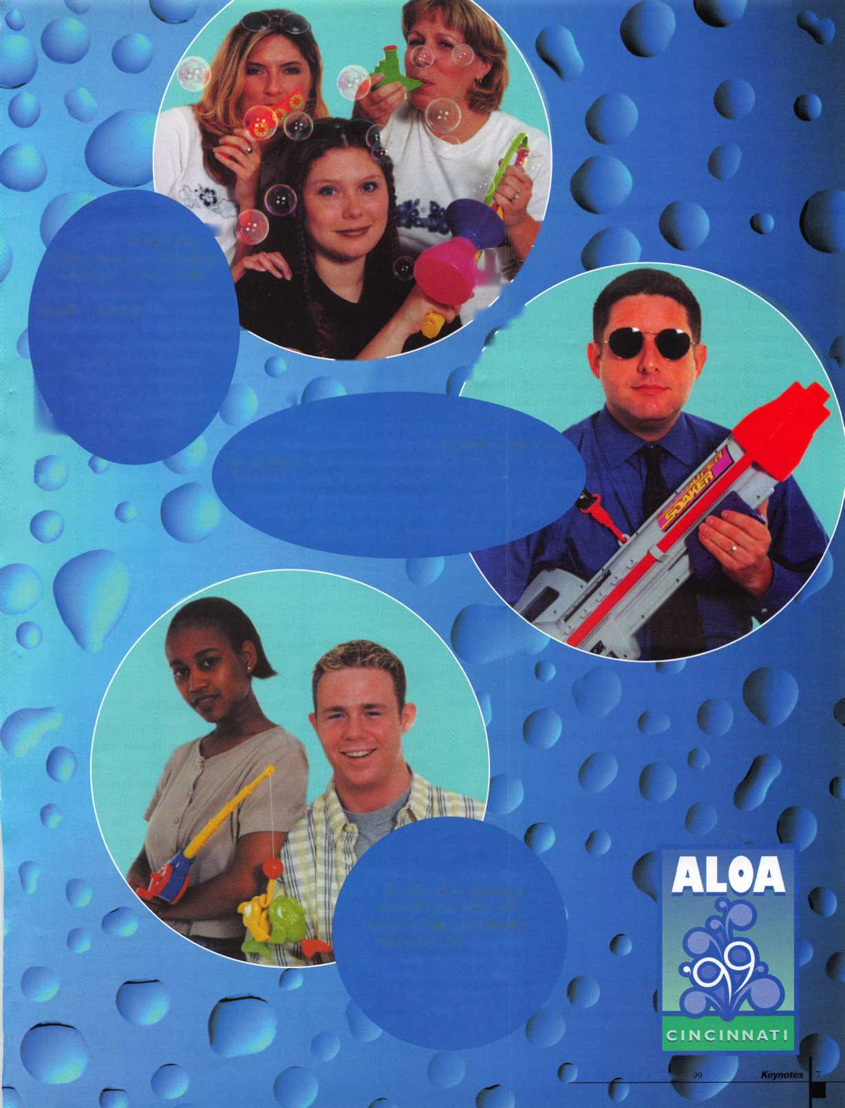

**core**

* Honeywell acquires C&K

Honeywell has acquired C&K systems, which specializes in residential and commercial security products.

Currently based in Folsom, Calif., C&K’s products are sold in 61 countries through a broad network of distribution and installation partners.

Both companies hope to gain much from this new partnership. Honeywell will no doubt utilize C&K’s sensor technologies and extend global distribution channels. Likewise, C&K will benefit from Honeywell’s offerings and reach even more countries.

In a recent press release, C&K’s CEO and president said, “C&K has built a worldwide security franchise with state of the art technology and Honeywell is in an excellent position to take C&K to the next level. The systems group can leverage the Honeywell name, combining security offerings to further grow this business, while also providing customers with a single, high quality source for their total security needs.” At press time, the closing of the transaction is subject to regulatory approvals. Terms of the purchase were not disclosed.

•100 Years of Meilink!

One of the many exciting events at ALOA ’99 will be Meilink Safe Company’s 100th Anniversary Presentation. This tribute to **Charles Meilink,** founder of Meilink. Among the featured items will be a dazzling musical review about the company and plenty of nostalgia! There will be a light reception from 6:30 p.m. to 7:00 p.m. followed by dinner and entertainment from 7:00 to 10:00 p.m. A voucher for the event is included in the convention packages if you purchased them in advance. However, you must exchange your voucher for a ticket by 12:00 p.m. on Friday, July 30. Space is limited and dress is black tie optional.

* Community Service

Hats off to the Central and Southern Colorado Locksmith Associa­tion! Three of its members were instrumental in helping the Colorado State Veterans Center open a turn of the century walk-in vault. The three, **Gordon Racine, Mike Middick** and **Dennis Heath,** used their vast experience to aid the center in opening and preserving this safe, which is being used as the centerpiece of a museum display at the Veterans Center.

* Battelle Soars

The Federal Aviation Administration recently awarded Battelle with a contract to test and evaluate airport security technology. The company already has vast experience with this type of work. Past assignments have included vulnerability studies, assessment of civil aviation security threats and analysis of chemical and biological

weapons threats.

* Crackdown on Unauthorized Duplication

Medeco High Security Locks recently filed a lawsuit against a New York area locksmith for the unauthorized duplication of the patented Medeco key. As a result of the infraction, Medeco seeks to enjoin its violations of patent rights and damages in excess of $1-million dollars, plus punitive damages resulting from the locksmith’s unauthorized duplication of the company’s keys. Using the Biaxial system, Medeco restricts duplication from unauthorized dealers. Duplication also requires express permission from the customer and signature verification. Patented key blanks are manufactured exclusively by Medeco and issued only to authorized dealers.

* ADT and Checkpoint team up

ADT, the world’s largest electronic security company and Checkpoint Access Control Systems have joined forces. ADT will now sell, install and service the Checkpoint’s Threshold line of computer-based access control systems. The agreement makes Threshold Systems available through ADT branches nationwide as well as former Wells Fargo Alarm Company branches.

* Abus Rolls Out

Express Service For Locksmiths

Abus announced a new “Express” Program to serve the locksmith market. Abus is known for its “same-day shipment” policy and now offers direct shipment of padlock products to locksmiths.

Abus developed the new program to give the locksmith an alternative source of quality padlock and hasp products with the same-day shipment and in-store merchandising support. The increasing demand on distributors for quick product delivery and special pricing also contributed to the need for this program. Locksmith distributors will participate in the program and be kept advised of locksmith “Express” sales to maintain special programs existing between the locksmith and the favored locksmith distributor.

The new competition of consumer direct programs offered by national chain stores through E-commerce/internet has been recognized by Abus. Also the traditional locksmith supplied keyed alike padlock products offered through large home centers is also of concern to Abus. These two places give locksmiths other places to go, but the “Express” program will keep locksmiths going back to Abus and keep them competitive in large quotes of padlock products.

July/August 1999



* We’ve got MORE winners!

Ken Stemig recalled his favorite baseball moment and was drawn from numerous entries. He receives two tickets to see the Cincinnati Reds and the San Francisco Giants! By the way, his most precious baseball memory was seeing the Minnesota Twins win the World Series in 1987 and ’91. Also, Ray Catalado provided the correct answers for our “WKRP in Cincinnati” quiz. He will receive admission for two on one of the ALOA ’99 tours! The correct answers were as follows:

1. Scum of the Earth
2. Fever
3. Rock
4. Loni Anderson
5. Venus Fly Trap

* Growing, Moving

As of late, several security companies have either relocated or expanded their headquarters. Here’s a lowdown on some changes that have occurred with different facilities.

* ADI has moved to 263 Old Country Road in Melville, NY where it is now consolidated into one large facility instead of four (as was the case previously).
* Security Lock’s Florida warehouse has relocated into a larger building with a 100 percent increase in space.
* Auth-Florence has moved its headquarters and manufacturing operations into a new 85,000 square foot building at 591 Mitchell Road in Glendale, 111.
* Schwab Corporation expanded its manufacturing location in Cannelton, Ind. and moved its corporate offices to 110 Professional Court in Lafayette, Ind.
* U.S. comes to Texas U.S. Lock Corporation is opening its 6th Full Service Distribution Center in Dallas, Texas.

The address is:

U.S. Lock Corporation 2610 Andjon Drive Dallas, Texas 75220 (212)351-3747

CPL

John S. Todd, Littleton, CO

CRL

Tom Appel, Concord, CA

William A. Fadgen, Albuquerque, NM James A. Nelson, Las Vegas, NV Neil Stratton, Ranacho Cucamonga, CA



INTERCHANGEABLE COREPRODUCTS

Interchangeable

with:

•BEST • ARROW •FALCON /

Quality • Price *Delivery*

That's what KSP is all about!

KILLEEN SECURITY  
PRODUCTS

Ask your wholesaler about  
our drop shipping**.**

***33 Hermon St.  
Worcester,* M4 *01610  
Phone (508) 798-3200  
Fax (508) 753-2183***

*COME TO THE SOURCE*

**HIGH SECURITY LOCKS FOR ALL  
VENDING AND TRUCKING  
APPLICATIONS**

**KEYED TO YOUR SPECIFICATION  
AND SHIPPED WITHIN 24 HOURS.**

***VENDING***

*Cam Locks* • *Switch Locks  
T Handle Locks* • *Screw Locks  
Plug Locks* • *Cash Boxes* • *Padlocks  
Coin Vaults* • *Safes*

*TRUCKING*

*King Pin Locks* • *Glad Hand Locks  
Refer Door Locks* • *Utility Trailer Locks*

**RA-LOCK COMPANY**

3570 North Hwy. 67  
Midlothian. Texas 76065

**1-800-777-6310**

**Ra-Lock is a Factory Center for:**

MEDECO • FORT • ABUS • SARGENT & GREENLEAF  
ASSA • ABLOY • KABA



July/August 1999

Keynotes

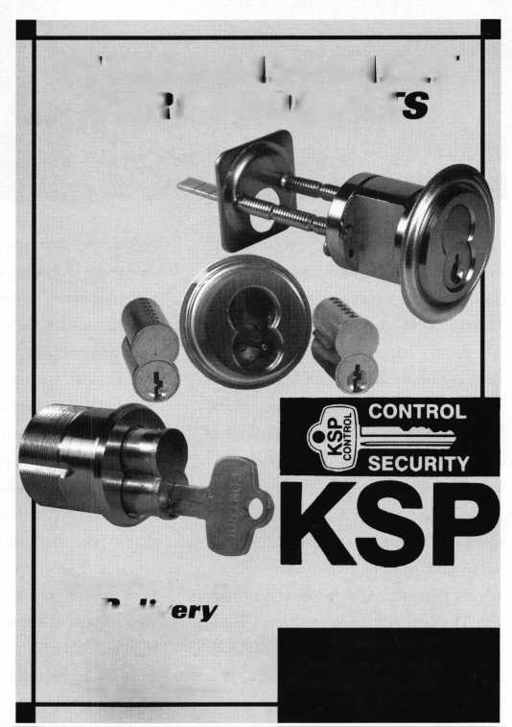

Marketing at Work

by Vicki Morgan

Everywhere we turn we’re bombarded with messages by marketers designed to entice us to try something new, stay with something old, go with something better or buy into the latest concepts. On a grand scale, big business spends billions a year to influence the products and services you buy. You’re targeted as a consumer hundreds of times a day. Why? Because—when done correctly and consistently—marketing works.

Marketing at work is dedicated to presenting basic marketing tools that you can put to work to gain greater exposure that increases business, and drives up your bottom line. Think marketing is a mystery? Tried it before but it didn’t seem to work? Marketing does work, and it can work for you.



**SAFE CORPORATION**

MANUFACTURERS OF QUALITY  
DEPOSITORY SAFES AND CHESTS

DISTRIBUTING FROM WAREHOUSES IN

* LOS ANGELES, CA
* CHICAGO, IL
* GLASSBORO, NJ

A&B is now a stocking distributor  
for Mutual Safes featuring

TL-15 • TL-30 • BISCHOFF CUB

Choose from over  
75 models in stock

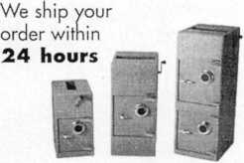

See us at [www.a-bsafecorp.com](http://www.a-bsafecorp.com)

800-253-1267

Fax 856-863-1208

CALL FOR YOUR CATALOG TODAY

July/August 1999

The basic principle of marketing is to choose your key messages and communicate them effectively to your audiences through various vehicles, such as advertising, signage, logo, product price, or product packaging.

For example, you first determine what it is that you believe will appeal most to your potential customers and set you apart from your competitors. If you’re a certified locksmith who’s on call 24 hours per day in a college town, you’ll want to communicate that to potential customers. Or, say you specialize in residential lock installations and have an inventory of decorative hardware at your disposal. Determine your messages, then we’ll address the best, most economical and creative ideas for communicating with your potential customers.

At this point, you may be wondering exactly how to determine this target audience for your services. While situations will vary, locksmiths enjoy a wealth of potential customers. The locksmithing profession is one that touches everyone. Everyone who lives in a home, drives a car or goes to work, can use the assistance of a locksmith at some point. In terms of the size of your audience, it’s pretty much the entire community. That translates into really good news for locksmiths, since many professions don’t have that luxury of such an expansive potential customer base. But, having a large audience for your services also means you’ve got a large audience to reach with your message.

It’s important to get used to thinking of not just marketing your business, but also marketing yourself. Regardless of your lock- smithing specialty, you’ll benefit by touting your professional attributes to customers and your employer. Self-employed locksmiths can see results in the bottom line by marketing personal skills and announcing the advantages they have over their competition. Given that locksmithing is such a precise

trade, letting others know about your qualifi­cations and capabilities can make a big difference in drawing in new business and keeping old business.

Let’s address exactly what marketing is not. It’s not about spending big bucks to launch a massive advertising campaign that reaches way out of your service area. It’s also not just being nice to people. While attitude is important, marketing is really about combining the truth of what you do profes­sionally, with the right people. People who need the services of a locksmith to stay safe.

Another element of marketing is knowing the competition. Depending on your community or personal situation, you may be competing with local law authorities. You may be in tight competition with other certified locksmiths in the area. Know your competition, and you’ll be able to examine what they’re doing right and wrong in attracting business.

Each month, you’ll be able to turn to our new Keynotes column to get the latest in marketing strategies, learn about what’s worked for others and how to apply success to your locksmithing business. This is truly an interactive column and we need to hear from you. Readers are encouraged to send in examples of marketing strategies that have worked in the past. We also want to get your questions or marketing dilemmas and we’ll address them in future columns. We’ll share successes and examine challenges. Consider this your marketing clearinghouse of information and a place to learn, a place to teach.

We want to hear from you! Write to: Marketing At Work do Keynotes

ALOA

3003 Live Oak Dallas, TX 75204

Keynotes

What do I get?

When you recruit 10 members, you receive a handsome blue blazer with a President's Club crest. For each additional five members you recruit, you receive a lapel pin with gold-filled numbers, indicating your recruiting successes.

You also get the satisfaction of knowing that you are helping your association, helping your industry grow, and you are helping fellow locksmiths achieve success,

How do I get started?

Contact the ALOA office for a supply of applications (800) 532-AL0A or FAX (214) 827-1810. One President's Club credit is awarded for each new applicant. Credit is awarded only after the membership application is approved. However, the credit will apply for the period in which the application is received. Failure to identify yourself as the sponsor on the application form at the time it is submitted to ALOA for processing will forfeit any credit.

*ALOA Board of Directors not eligible for membership in the President's Club.

.Keizo Takahashi,

_William McElheney, CML

Russell Fuller, CRL

Rex Parmelee, RL

James Gruber, CRL

Robert Duman, CML

Daniel Landry

Edwin W Scott

Peter Gauthier, CPL

Frank Hartung, CML

Jon Griswold, CML

Paul Souber

Richard Sievers

Joe Lee, CRL

Steven Spiwak, CRL

Robert Rodocker, CRL

Keiryu Tsukishiro, CRL

Rolando Bouza

Lonnie McKinney, CML

James Brickler, CRL

John Engel, CRL

Donald Shiles

Eric Veal

Herbert Dusenberry, CML

Raymond Lusk, CML

Robin Horsley

Michael Groves

Thomas Demont, CML

Ernest Wright

_William Wickward, CML

Lester Brodsky

Joseph Whitaker, CPL

Dale Knowles, CPL

John Ilk, CRL

James Hawley, CRL

175 93 _ 92 _

66

65 _

64

61

51

48

40 _ 38

35 _ 33 _ 32 _

31

31 _ 30

28 _ 26 _ 24 _ 24 24

24

24

23

23

23

22

22 _ 22 _

21

21

21

21

20

19

19 _ 18

18

18

18 _ 17 _ 17 _ 17 _ 17

16 _ 16 _ 16 _ 16 15

15 _ 15

_Kwok-kei Leung  
_Henry Raymond

_Toshihiro

_Stewart Levine,

.Charles Robertson,

Mary Ohmit,

Yuriko Yanai

Jack Hobin,

Allen Konrath

.Salvatore Dulcamaro, CML

Myeong-Rae Cho

William Neff, CML

David Lowell, CML

.Thomas Freehling, CML

Dana Barnum, CML

John Heckman, CML

Jeanne Lodge, CML

Barry Leas, CRL

J Thomas Hood, CML

.Lawrence F. Smith, Jr., CML

Danny Rudd, CPL

John Elliott, CML

Larry Warnick, CML

Roy Renderer, CML

James Watt, CML

Robert Carroll, CPL

Robert DeWeese, CPL

Diana Barnum, CRL

Barbara Watt

Jim Williams

.Anthony Ramunno, CML

Jerome Cohen, CML

David M A Federico

Eugene Altobella

.Elvis Hammerschmidt, CPL

Marian Swann, CRL

Charles Cole, CML

John Dorsey, CPL

D Michael Lee, CPL

James Fowler, CML

David Harris, CML

John Kerr, RL

Ronald Heidzig

.Philip Rovenolt, CPL William Lee

Joseph Ferrero, CML

James Cawby, CML

.Michael Robinson, CRL Brian Reetz

Walter Lascar, RL

.Thomas Vandersteen, CML William Grant, CRL

Best.

How can I join

You can earn membership in this prestigious  
recruiting just 10 new members for ALOA.  
*Any ALOA member may participate.

club by



Upcoming

Events



[Dept)

JULY

10

^ ALOA PRP Sitting

ALOA

Dallas, TX

Contact: David Lowell (800) 532-2562 (214) 827-1810 fax

10-15

DHI Technical Schools Arizona State Univ Tempe, AZ Contact:

(703) 222-2010

22-25

DHI Chapter Leadership

Conference

The SunBurst Resort

Phoenix, AZ

Contact:

(703) 222-2010

25-31

ALOA ’99 Security Expo Cincinnati, OH (800) 532-2562

31

Locksmith Flea Market Milpitas, CA

The Silicon Valley Chapter of CLA

1444 S. Main Street

Contact: Thomas Reeves-Messner

(408)262-5517

(408) 262-5517 fax

[silvallock@aol.com](mailto:silvallock@aol.com)

AUGUST

i

£r\ ACE Classes Cincinnati, OH ALOA ’99 Security Expo (800) 532-2562

6-7

DHI Continuing Professional Development TBD

Seattle, WA (703) 222-2010

6-7

ACE Classes Albuquerque, NM New Mexico Locksmiths Assoc. Contact: Steve Highland (505) 268-8663

(505) 268-8802 fax

6-7

ASTM Committee F-33 on Detection and Correctional Facilities Hyatt Regency Denver, CO

Contact: Cathryna Blackwell

(610)832-9737

[cblackwe@astm.org](mailto:cblackwe@astm.org)

8

ALOA PRP Sitting Albuquerque, NM New Mexico Locksmiths Assoc. Contact: Steve Highland (505) 268-8663

(505) 268-8802 fax

14

ALOA PRP Sitting ALOA Dallas, TX

Contact: David Lowell (800) 532-2562 (214) 827-1810 fax

15

GPLA/SJLA Picnic Clementon Amusement Park Contact: Fred Radich (609)939-6373

15

Family Picnic/Social

Green Bay, WI

Fox Valley Chapter of ALOA

Contact: Bill Smith

(920)893-5282

19-20

ACE Classes Orlando, FL SERLAC

Contact: Austin Curry, CRL (813) 837-8488 (813) 839-1825 fax

21

Annual Picnic Kendallville, IN

Northern Indiana Chapter of ALOA Bixler Park Campgrounds Contact: Steve Youngblood (219)266-0072

22

& ALOA PRP Sitting Baltimore, Md.

Clark Security Products Contact: Terri Burges (619)974-5273 (619) 974-5284 fax

22

ft? ALOA PRP Sitting Orlando, FL SERLAC

Contact: Austin Curry, CRL

(813)837-8488

(813) 839-1825 fax

27-30

MLA’s London Convention Contact: Dave Stokes 139 Wood Street Walthamstow, London, E17 3LX 01144 181 520 7450

SEPTEMBER

ii

& ALOA PRP Sitting Dallas, TX

Contact: David Lowell (800) 532-2562

1. 827-1810 fox

15-19

GPLA Annual Convention

Philadelphia* PA

Jack Magee (registration)

(609)845-3434

Don Amole (booth space)

1. 288-5588 [www.gpla.org](http://www.gpla.org)
2. 19

TAOL’s 26th Anniversary Convention International Plaza Hotel and Conference Centre Toronto, Ontario (888) 272-8265 (416) 321-5115 fax

1. 19

Distributors Show Inn of the Ozarks,

Eureka Springs, AR Ozark Professional Locksmith Assoc.

Betty Gray: (501) 524-3660 day (918) 427-1066 evenings or Bill or Janis Reves (501) 631-0017 day (501) 631-6406 evenings

19

ALOA PRP Sitting Philadelphia, PA

Greater Phil. Locksmiths Association Contact: Bill Young, CML (610)647-5042 (610) 647-5950 fex

30-Oct 2

MINK Convention Marshalltown, LA Iowa Locksmith Association Contact: Kenneth Novey (319)377-4295

OCTOBER

1-3

Jo-Van National Trade Show and Educational Seminar Contact: Ron Wilson (416)752-7249

9

^ ALOA PRP Sitting

ALOA

Dallas, TX

Contact: David Lowell (800) 532-2562 (214) 827-1810 fax

Keynotes

July/August 1999

ALOA HAS  
FAX ON  
DEMAND!

|  |  |
| --- | --- |
| 10 | 10 |
| ft ALOA PRP Sitting | ft ALOA PRP Sitting |
| Burbank, CA | Sturbridge, MA |
| Clark Security Products | Yankee Security |
| Contact: Terri Burges | Contact: Robert Mahoney |
| (619)974-5273 | (800) 209-8266 |
| (619) 974-5284 fax | (860) 646-2122 fax |
| 14 | 11 |
| DHI 5 th Annual Golf Tournament | ft ALOA PRP Sitting |
| Dallas, TX | ALOA |
| Door Hardware Institute | Dallas, TX |
| (703) 222-2010  16-17  Professional Safe Moving Class  Eau Claire WI  Indian Head Chapter of ALOA | Contact: David Lowell (800) 532-2562 (214) 827-1810 fax |
| Contact: John Dorsey (715)832-4207 | DECEMBER  ii  ft ALOA PRP Sitting |
| 16-18 | ALOA |
| DHI 24th Annual Convention and | Dallas, TX |
| Exposition | Contact: David Lowell |
| Dallas, TX | (800) 532-2562 |
| Contact: DHI  (703) 222-2010 | (214) 827-1810 fax |

17

ft ALOA PRP Sitting Coraopolis, PA Penn/Ohio Locksmith Assoc. Contact: Martha R. Eggler (216) 676-8464 (216) 267-2511 fax

29-31

Convention

Basildon, London

Master Locksmiths Association

London Region

Contact: D. Stokes

0181-520-7450

0181-521-8376 fax

[MLA_LR@hotmail.com](mailto:MLA_LR@hotmail.com)

NOVEMBER

6-10

ACE Classes 1999 Yankee Security Convention Sturbridge Host Hotel Sturbridge, MA Rob Mahoney (800) 209-8266

2000

APRIL

6-9

MLANJ 2000 Annual Convention Somerset, NJ (973) 267-8884 (973) 538-2248 fax [www.mlanj.org](http://www.mlanj.org)

MAY

1-6

SAFETECH 2000 Birmingham, AL (214)827-7233

JULY

23-30

ALOA 2000 Las Vegas, NV (214)827-1701

2001

MARCH

28-April **1**

MLANJ 2001 Annual Convention Somerset, NJ (973) 267-8884 (973) 538-2248 fax [www.mlanj.org](http://www.mlanj.org)

JULY

15-22

ALOA 2001 Security Expo Baltimore, MD (800) 532-2562

2002

JULY

21-28

ALOA 2002 Security Expo Rosemont, IL (800) 532-2562

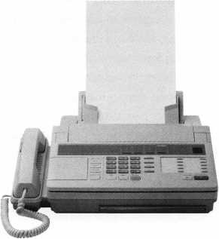

NEED INFORMATION  
IN A HURRY?

Just call 310.575.5074  
and you will be faxed:

#1 A list of all documents available through this service #2 Becoming A Locksmith #3 Locksmith Career Summary #4 Locksmith School List #5 ACE Class Schedule #6 Certification Information #7 PRP Category List #8 ALOA Membership Application #9 ALOA List of Benefits #10 Scholarship Application Form #11 ALOA Video Library Order Form #12 ALOA Membership Items Order Form #13 Safe & Vault Technicians Association Member Application/Subscription Form #14 ALOA Chapter Roster #15 Legislative Action Network #16 Legislative Action Network Newsletters #17 Various State Laws #18 Industry Position Paper

Indicates ALOA ACE Class Indicates PRP Sitting

YOUR ASSOCIATION  
CONTINUES TO EXPLORE  
WAYS TO PROVIDE YOU,  
OUR MEMBERS,  
WITH NEW BENEFITS  
AND SERVICES.

July/August 1999

Keynotes

**Security**

Marketplace

Knaack Manufacturing Company

Weather Guard Products, introduces a “user friendly” ladder load­ing system for full size cargo vans. The EZ-ONE EZ-LADDER LOADER is designed to load and unload without lifting the ladder over your head, the hand crank does all the lifting for you. The oper­ator is in complete control of the load and never directly beneath it. Safety straps hold the ladder in place and plastic pads protect the ladder from wear due to road vibration. The ladder support assem­blies are made of cast aluminum and other parts are powder coated steel. For a free brochure or full line catalog, call (800) 456-7865. **Weather Guard tvtvw.weatherguard.com Knaack Manufacturing Company [www.knaack.com](http://www.knaack.com)**

Security Door Controls

Security Door Controls introduces the new SDC 40 Series electric strikes. The new electric strikes are designed for use with locksets having up to 3/4" throw latchbolts. Features include low current draw, fewer moving parts for increased reliability, reversible insert for auxiliary deadlatch feature, keeper alignment adjustment and plug connector.

Security Door Controls

3580 Willow Lane

Westlake Village**,** CA 91361-4921

(805) 494-0622

(805) 494-8861 fax

[www.sdcsecurity.com](http://www.sdcsecurity.com)

Crest Electronics, Inc.

Crest Electronics Incorporated, introduced two new mini color cameras. Crests new CJ-9612 and CJ-9712 mini color cameras feature DSP circuitry, 1/3" CCD image sensor, 330 lines of resolu­tion, 1 lux and 12 vdc operation. The CJ-9612 accepts C or CS- mount lenses and can be used with auto or manual iris lenses. The CJ-9712 has a built-in mini lens with macro focus. All of Crests cameras and accessories come with a two-year warranty.

Crest Electronics, Inc.

3706 Alliance Drive Greensboro, NC 27407 (888) 50-CREST [www.crestelectronics.com](http://www.crestelectronics.com)

Jet

Jet Hardware announced the release of their M900 key blank to fit Master # 900 padlocks. In addition, eight new General Motors Plastic Bow keys including B46-PH and B47-PH are part of the basic series of B44-PH through B51-PH keys.

Jet Hardware Mfg. Corp 800 Hinsdale Street



Brooklyn, NY 11207 wtvw.jetkeys.com

**Keynotes July/August 1999**



llco Unican Corp.

Ilco Unican announces the 515 electro-mechanical safe lock. The Safe lock 515 is the founding member of the 515 Series family and is UL listed Type 1. The features include four security levels, program­mable dual custody, time delay, open window, tamper shutdown and lockout. It also has a Convert-A-Bolt technology that provides the user with a field-selectable deadbolt or springbok operation.

The bolt is manually retracted and extended, accommodating push-pull attachments.

Ilco Unican (800) 849-8324 wtvw. ilcounican.com

Marks USA

Marks USA will provide free on request a Facilities Lockset Guide introducing the “Survivor” key-in lever series, “Defender” deadbolt series and “Protector” mortise lock series. The guide assists the institutional user by informing the reader of lockset features which will satisfy the requirements of institutional facilities for both design and maintenance. All locksets feature a lifetime mechanical warranty, satisfy ADA requirements and are UL Listed for 3-hour fire rating. For application assistance or brochure contact:

Marks USA

5300 New Horizons Blvd, Dept K4 Amityville, NY 11701 (516) 225-5600 (516) 225-6136fax

Checkpoint Systems Inc.

Checkpoint Systems Inc.’s Access Control Products Group announced the release of Threshold Xpress, the latest Windows- based facility security systems. Threshold Xpress is as multi-tasking system that is fully networkable and yet flexible enough to stand alone. Like typical access systems, it uses proximity cards and readers for hands-free scanning and recording of employees and visitors, but surpassing other systems Threshold Xpress features an interface to easily integrate with closed circuit television for real-time viewing and comparing cardholders against stored system data and images. It also integrates easily with human resources data bases and systems such as CentrePointe and Checkpoint s Activity Management system.

Checkpoint Systems Inc.

(800) 257-5570 ext. 2432 tvunv.checkpointacpg.com

Corby Industries, Inc.

Corby introduces a Building Master Keypad access system. Each system is shipped complete with four weatherproof, heavy-duty, cast- metal keypads. With the addition of a door lock and power supply for the lock. The built-in relays can switch power to electric door locks, arm or disarm alarm systems, shunt alarm devices, or operate garage doors. The system supports four doors, 750 users and high- security digital keypads. The system can easily be expanded into a

larger eight door system, by linking an expansion board to the main panel. Users can be added or deleted on-site or from a remote loca­tion using Video Display Terminal or PC. In addition, the 250 event audit trail can be viewed or printed at this remote location. After all data has been programmed, the supplied backup program can be used to save all system and user data to floppy disk using your PC. Corby Industries, Inc.

1501 E. Pennsylvania St.

Allentown, PA 18103 (610) 433-1412

Panasonic Security & Digital Imaging Company

Panasonic Security Systems Group offers a new series of color digital signal processing (DSP) cameras that features the highest resolution available. The WV-CP230 Series Color DSP Cameras provide 480 lines of resolution in only 2 lux at FI.4. Key features include auto gain control (AGC), auto tracing white balance (ATW), electronic light control (ELC), auto light control (ALC), soft or sharp aperture adjustment and backlight compensation. The cameras are available in 120V AC, 24V AC and 12V DC models, and accept either C or CS mount lenses for added application versatility. Panasonic CCTV Products (888) PAN-CCTV [www.panasoinc](http://www.panasoinc). comlcctv

KeySoft

KeySoft Security Software has introduced software that can make master keying quick and easy. Masterkey-Pro M is used to create mas­ter keying systems and print a number of useful reports like,

Pinning reports, that show you what to cut the key and how to label it, what bottom pins and master pins to put in each chamber and a description. Master Keying reports, showing you the different levels of Masters, Sub Masters and the groups they fit, etc. Cross-Keying reports, Pin Count, Description, these reports take the confusion out of master keying and can save you many hours of frustration. Each system you create can be customized, each report can be edited and the easy point and click working environment puts you in charge of the features.

KeySoft

(800) 505-6636

Cold Steel

Cold Steel introduces a new folding knife, the Cold Steel Scimitar. The Scimitar is a high impact titanium linerlock. The blade is a hol­low ground from tough AUS 8A stainless steel, precision honed to a razor sharp edge. The needle-sharp point pierces with the slightest touch. The pistol grip handle allows a forward, reverse or palm rein­forced grip. Finger groves, checkering and hard-hitting pommel pro­vide a solid grip, while the pocket clip makes the Scimitar easy to carry. The contoured Zytel and steel-frame was designed exclusively for the Scimitar, which retains the curve of its ancient namesake.

Cold Steel

2128-D Knoll Drive Ventura, CA 93003 (800) 255-4716

PRISON and JAIL EQUIPMENT

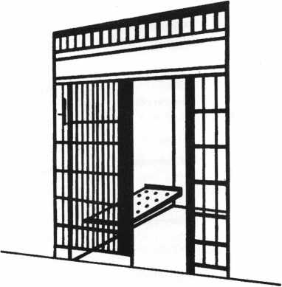

Qeorge *cA.* Keene, 3nc.

1101 NIAGARA FALLS BLVD.  
BUFFALO, N.Y. 14226  
PHONE 716-832-0180  
FAX: 716-832-5422

When you need VATS Components, get fust, inexpensive VATS Replacement locxs and keys from bWD Certified VATS Centers. Plus, become a Certified

131/1/0 AutomotfVe

Automotive Locks, Keys, Service Kits, Manuals & Training  
for the Professional Locksmith

Schedule, see offer below.

**FREE!**

1999 **Illustrated Automotive Parts Catalog**

including BWD Service Manual Library Centers,Distributors,  
VATS Centers, Seminar Schedule, and more... call

**(800) 647-4926**

or take your web browser to [www.alllock.com](http://www.alllock.com).

July/August 1999

Keynotes

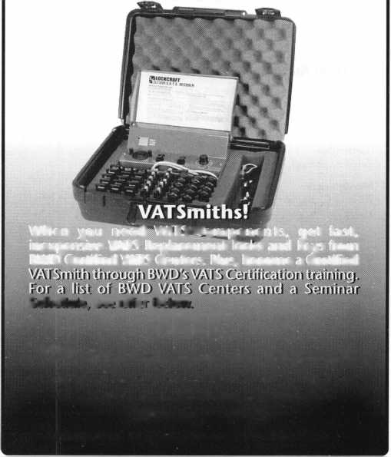

Applicants

For Membership

Dept

**^ *The following applicants are scheduled for clearance as members of  
ALOA. The names are published for member review and comment prior to  
August 1, and September 1, 1999, respectively, to ensure applicants meet  
standards of ALOA’s Code of Ethics. Protests, if any, should be addressed to  
the Membership Department and must be signed. Active Membership  
applicants (A) have worked in the industry two or more years. Allied  
Membership (AL) applicants are not locksmiths, but work in a security-  
related field. Apprentice Membership (AP) applicants have worked in  
the industry less than two years. A***

Clearing August **1** USA

ALABAMA

Gardendale

Shelton A Cummings, A

Montgomery

William E Garrett, AP Alan H Pyron, A

ARIZONA

Glendale

David Kitchen, A

Peoria

Harry D Byers, A SPONSOR: William Lee

Phoenix

Robert A Charella, AP SPONSOR: William Lee

CALIFORNIA+

Irving

G Yee, A

DELAWARE

New Castle

Rocky R Hershey, A SPONSOR: David Braun

FLORIDA

Homestead

Linda Varnadore, A

Kissimmee

Patrick M Gatward, A

Largo

Nick Radziseski, A

Miami Lakes

Rose Guglielmo, A

Miami Beach

Ramon Hernandez, A SPONSOR: Joseph Nogueras

GEORGIA

Atlanta

Richard E McGee, AP

MICHIGAN

Grand Blanc

Marc A Dearing, A

Mattawan

George M Coffey, A SPONSOR: Terry Bussema

MINNESOTA

Lake Elmo

Tracy Little, A

Stillewater

Jim Duncan, A

MISSOURI

Jefferson City

Timothy C Doane, A SPONSOR: Bruce Jamison

Knob Noster

Kevin W Haynes, AP

NORTH CAROLINA Cary

Jonathan M Herman, A SPONSOR: Jeanette Busse

Newport Beach

Paul Linder, A

R.S.M.

Jeff Zettel, A

Ridgecrest

John A Robb, A SPONSOR: Gregory Perry

San Diego

Donald L Smith, A

Soqeul

Scott M Edelstein, A

Vallejo

Jefferson L Folks, A SPONSOR: Arthur Patch

West Hills

Michael Katz, A

COLORADO

Denver

Arlin H Lund, A SPONSOR: Kent Smith

Englewood

Brian Hambleton, A

LaJunta

Thomas R Gonzales, AP SPONSOR: Gordon Racine

Security

Russ W Cottrill, A SPONSOR: Bruce Eagan John B Harris, A SPONSOR: Bruce Eagan Marc J Serravezza, A SPONSOR: Bruce Eagan

Westcliffe

William M King, A

CONNECTICUT

Old Mystic

Kenneth J Donovan, A

Rome

John W Ross, AP

IOWA

Cedar Rapids

Harold G Shoemake, A

ILLINOIS

Arlington Heights

Christopher B Germana, A

Elgin

Len Stoia, A

Vernon Hills

Rich Bond, A

INDIANA

W Lafayette

Steve Y Davis, AP

KANSAS

Marysville

Doug G Ackerman, A SPONSOR: Elvis Hammerschmidt

LOUISIANA

New Orleans

Derek L Douget, A

MASSACHUSETTS

NEW JERSEY

Brielle

Dave Bryant, A

Cherry Hill

William H Busse, AP SPONSOR: Carlton Prescott

Colonia

John Marchuk, AP SPONSOR: William Young

Lodi

Stephen J Bell, A

Randolph

Salvatore Scarpa, AP

Wall

Benjamin J Stoner, AP SPONSOR: David Rible

Woodbrigde Twp

Walker J Glen, AP SPONSOR: William Young

NEW MEXICO

Albuquerque

Scott E Green, A SPONSOR: Debra Coleman

NEVADA

Las Vegas

Anthony L Roberts, A Ruben Romero, A

Concord

Kenneth T McAdams, A

Deerfield

Peter J Bernard, A SPONSOR: Russell Fuller

MARYLAND

Towson

John Butler, A

NEW YORK

Binghamton

Stirling W Baldwin, A SPONSOR: William Ryan

Castle Point

John W O'Dell, A SPONSOR: Joe Lee

East Syracuse

Kevin M Slomn, A

Glendale

eter Bertolino, A SPONSOR: John Shea

Islip

Eugene A Baumann, AP SPONSOR: Robert DeWeese

OHIO

Canal Fulton

Randall D Grage, A

North Canton

Ronald L Burns, A

Pomeroy

David K Vujaklija, A SPONSOR: John Barton

Walbridge

Scott W Lucas, A SPONSOR: James Pirolli

PENNSYLVANIA

Aliquippa

Michael F Jabaut, AP SPONSOR: David Pavlakovich

Malvern

Michael A Schell, AP SPONSOR: William Young

SOUTH CAROLINA

Clemson

Matthew S Miller, A SPONSOR: Kenneth Ellis

SOUTH DAKOTA

Pierre

Michael D Wells, A

Spearfish

James W Treadway, A

TENNESSEE

Knoxville

Steve E Delaney, AP SPONSOR: Marian Swann

Memphis

Reuben J Cashon, A SPONSOR: Jackie Clark

Morristown

Jeffrey A Chappell, AP SPONSOR: William Vaught

Nashville

Chris J Abigt, AP

TEXAS

Dallas

Ed Lockey, A Paul J Marshall, AP SPONSOR: David Lowell Robert V Walker, A

Houston

Keith Johnson, A

Humble

Donald R Lanmon, A SPONSOR: Darrel Moore

Killeen

Hiran Medina, AP

VIRGINIA

Arlington

David Jacobi, A SPONSOR: Gary Baldino

Richmond

Steve Wilkinson, A

Salem

Dave Paterno, A Bernd Wempen, A

VERMONT

Burlington

Bradley D Manchester, AP SPONSOR: Russell Zehnacker

WASHINGTON

Redmond

John Sekreta, A

WISCONSIN

Antigo

Phil G Tautges, A

Crandon

Adam D Short, AP SPONSOR: John Engel

West Allis

David B Fairbrother, A SPONSOR: John Soderland

AUSTRALIA

Nunawading Victoria

Ian Lamer, A

BAHAMAS

Freeport

Charles S Cox, A SPONSOR: Charles Robertson

CANADA

Montreal

Guy LeBlanc, A

BRITISH COLUMBIA

Richmond

Ken Barry, A Tom Urquhart, A

ONTARIO

Maryhill

Steve Elvy, A

Orillia

Gordon R Vander, A

Toronto

Monique Elliott, A

QUEBEC

Kirkland

Serge Blouin, A

ENGLAND

Chelmsford Essex

Peter Moule, A

EL SALVADOR

San Salvador

Calixto Quan, A SPONSOR: William Lee

JAPAN

Fukuoka-City Ken

Akemi Kuroki, A SPONSOR: Toshihiro Asano

Ichihara-City, Chiba

Hiroshi Watanabe, A SPONSOR: Toshihiro Asano

Kuki-City Saitama-Ke

Toshihiko Hirose, A SPONSOR: Toshihiro Asano

Matsudo City Chiba

Shinichi Hosoya, A SPONSOR: Toshihiro Asano

Tokyo

Naoto Sugimoto, A SPONSOR: Yuuji Sagawa

Toyama

Tsuyoshi Hashimoto, A SPONSOR: Isamu Hashimoto

Yokohama Kana Wa

Tadashi Sakura, A SPONSOR: Keizo Takahashi

TOKYO

Adachi

Seiji Yabe, A

Shinjuku-Ku

Takeshi Kihara, A SPONSOR: Toshihiro Asano

KOREA

Dong-Rae, Pusan

Kim Young-Hwa, A SPONSOR: Man Seo

Pusan

Yang Young-Ho, A SPONSOR: Man Seo

NORWAY

Bergen, Ulset

Stein E Hansen, A

TURKEY

Bakirkoy, Istanbul

Sinan Okay, AP SPONSOR: Niyazi Okay

UNITED

KINGDOM

ENGLAND

Crawley W Sussex

Ian T Burns, AP SPONSOR: Andrew Ross

Keynotes

July/August 1999



A**pplicants**

For Membership

Clearing September 1

USA

ALASKA

Wasilla

Charles D Jones, A SPONSOR: Donald Brazil

ALABAMA

Bay Minette

Paul A Przyborski, AP SPONSOR: William Brown

Red Bay

John W Johnson, A

ARIZONA

Chandler

Roger A Schwab, A SPONSOR: John Ilk

Parker

Paul S Rothachen, AP SPONSOR: William Lee

Peoria

Carol L Byers, AP SPONSOR: William Lee

Tampa

Frances F Watanabe, AP

CALIFORNIA

Livermore

Robert Sharp, A

San Diego

Jeffrey S Bowers, A

Kevin Conine, A

SPONSOR: Denise Lopez-Maxwell

Yorba Unda

Shane Garcia, A

CONNECTICUT

East Hartford

Jayne Mosely, A SPONSOR: Leonard Whitford

Norwald

David A Fitzgerald, AP SPONSOR: John Bradley

FLORIDA

GEORGIA

Cloumbus

WillardS Wilson, A SPONSOR: Alan Davis

Macon

Jack A Bass, A SPONSOR: Patrick Filholm

ILLINOIS

Chicago

James M Baker, A SPONSOR: Gerald Menard

Coal Vblley

Jennifer Robinson, AP

MASSACHUSETTS

Fall River

Antonio S Monteiro, A Joseph E Tavares, A

Springfield

Denice M Outhuse, A SPONSOR: Edward Delphia

MICHIGAN

Detroit

Duane DiFranco, A

Lansing

Robert Rose, AP SPONSOR: Mark Blum

Redford

Kirk Hitchcock, A

Sterling Heights

Stanley P Podolan, AP SPONSOR: Salvatore Dulcamara

MINNESOTA

Minneapolis

Sandy Sproat, A

MISSOURI

Kansas City

David S Holtzclaw, A

NEVADA

Las Vegas

Ron D Butkus, A Robert S Mason, A

Las Vagas

Charles S Walker, A

Las Veoas

KathieJWhite, A

NEW YORK

Bridgeport

Brad J Bullock, A SPONSOR: Terance Campbell

Parish

Robert Magnan, AP SPONSOR: Bruce Carey

Staten Island

Mark A Ulitto, AP SPONSOR: Michael DiCicco

OHIO

Bellefontaine

Kimberly NAldo,AP SPONSOR: Thomas Smith

Mantua

John F Nanassy, AP

PENNSYLVANIA

Enola

Michael W Webster, AP

SOUTH CAROLINA

Camben

Lee Griggs, A SPONSOR: Robert Painter

TENNESSEE

Columbia

David L Darling, AP SPONSOR: James Hollander

Fayetteville

Gary Follansbee, A

Moberiy

John E Hackett, A SPONSOR: James Hawley

NORTH CAROLINA

Greensboro

Donald F Lackey, AP

McMinnville

Jimmy A Smartt, A SPONSOR: Ted Hollins

Nashville

Kevin R Hobt, A

Bonita Springs

Michael C Galdine, A SPONSOR: James Rock

Kissimmee

Neil R Allen, A

LaBelle

Charles Kirkpatrick, A SPONSOR: William Bough man

Miami

SPONSOR: BarE Watt

NEW JERSEY

Stratford

Robert C Fasciglione, A SPONSOR: Felix Radich

NEW MEXICO

Albuqurque

Michael J Murray, A

Pensacola

James E Nichols, A SPONSOR: Russell Turner

Tampa

Bobby J Porter, AP

West Palm Beach

Wade K Casto, AP

|  |  |  |
| --- | --- | --- |
| TEXAS | CANADA | JAPAN |
| Freeport  William K McElveen, A | BRITISH COLUMBIA | Lasaoka, Okayama |
| SPONSOR: Patrick Hollis  Houston | Langley  Paul Neumann, A | Hideji Kochizawa, A SPONSOR: Koichi Fujii |
| Bervin R Chambers, A | QUEBEC |  |
| Patrick 0 McCorvey, A | Chicoutini | UNITED |
| VIRGINIA | Jean-Marc Beaulieu, A | KINGDOM |
| Arlington | Repentegny | LONDON |
| Brian S Wood, AP | Eric Bissonnette, A |
| SPONSOR: Michael Groves |  | Walthamston  David Stokes, A |
| Roanoke |  | SPONSOR: Peter Hall |
| Marshall A Clark, AP | HONG KONG | Valerie Stokes, A |
| WISCONSIN | Yiu-Ping Lam, A | SPONSOR: Peter Hall |
| Milwaukee | Ping-Pui Lau, A  SPONSOR: Kwok-kei Leung | SURREY |
| Keith D Zirtzlaff, A | Mitcham |
| SPONSOR: Brian Reetz | Kowloon Bay | W Fyfe, A |
| Waukesha  Allan R Nowak, AP | Chan Po-Kwong, A  SPONSOR: Kwok-kei Leung |
| SPONSOR: John Heckman | Tuen Mun |  |
| BAHAMAS | Ha Yau-Sheong, A  SPONSOR: Kwok-kei Leung |  |
| Freeport  Dencil E Williams, A | NEW TERRITORIES |  |
| SPONSOR: Charles Robertson | Hin Keng Est Shatin  Kwok-Keung Pang, A SPONSOR: Kwok-kei Leung  Tsuen Wan  Wai-Ming Lin, A  SPONSOR: Kwok-kei Leung |  |

**July/August 1999**

***Keynotes* 117**

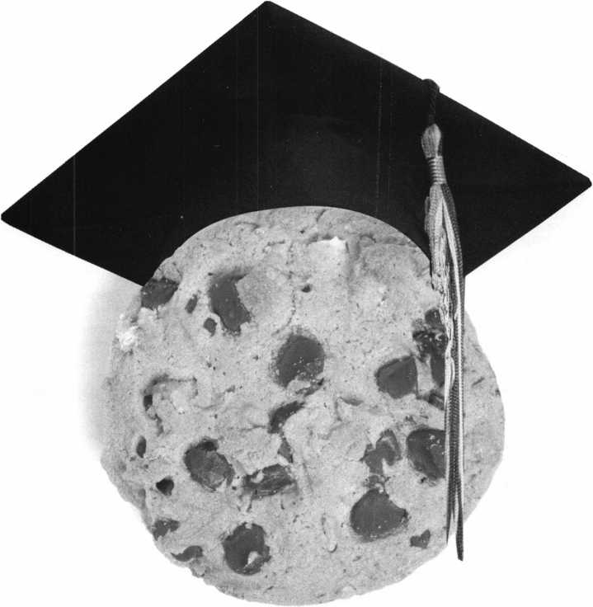

Class Preview’99

By Patanya Johnson

Education is the foundation to every good career, especially locksmithing. In order to help future locksmiths and locksmiths already in the profession ALOA has strived to build an education program to help teach and certify individuals, so that they may further their careers.

Throughout the year and at ALOA’s annual convention, the education department along with regional chapters, manufacturers and distributors offer courses and seminars to better help locksmiths comprehend existing and new products. This year is no different, at the ALOA ’99 Interna­tional Convention and Security Expo several new classes and instructors will be introduced and students will have the oppor­tunity to take certain sections of the PRP examination at the end of some classes. Some of the new classes include:

* Ilco Safe Lock Certification
* Lagard Safe Lock Certification
* Hollow Metal Door & Frame Servicing
* Security Design Concepts
* Picking Techniques for Dimple Key Locks.

The LaGard Safe Lock Certification Class was designed to present informative and useful information that will prepare students for the PRP Exam, Section L-24 and L-33 and the STPRP Section-00. The class features hands-on training of the LaGard 3330 series and the Combogard locks and will preview the latest from LaGard. The instructor is Brian Lamb, CPS of Lockmasters. Brian has worked with LaGard products for over 12 years and is fairly enthusiastic about the class. “I am excited about this class,” he says. “I believe it will be interesting to anyone who wants to

learn more about LaGard products.” Each student will be given a mounted Mechanical Group 2 lock and a Mounted Combogard 33 lock, worth an estimated value of about $225. After completing the course, students will be able to properly service LaGard mechanical and electronic safe locks and receive LaGard factory certification.

The Ilco Safe Lock Certification Class

was designed to give students a thorough understanding of the design, construction, various functions, servicing and trouble­shooting of the mechanical safe locks offered by Ilco Unican Corporation. Each student will get a hands on experience of UL Group 2, 2M and Group 1 locks and learn about the UL requirements that caused each lock to meet the specific group. The class will briefly cover the history of mechanical safe locks, servicing and cleaning of those locks. The

July/August 1999

J Keynotes

students will also completely disassemble and reassemble an Ilco mechanical safe lock. The instructor is Charles Stephenson, CPS, product manager of the Safe Lock Division of Ilco Unican. “I expect a large turnout for this class,” he says. “I think thats because the interest at ALOA for basic safe classes seems to be of high interest. At ALOA, you have a bigger group of people looking for education and a larger group that are somewhat distant from the safe business, but have a curiosity or interest in doing safe work along side of their regular locksmithing business.” After completing this class, the student will be able to identify, diagnose malfunctions, service and retrofit Ilco mechanical safe locks and also be better prepared for the PRP Section L-24, L-33 and STPRP Section S-00.

**Hollow Metal Door and Frame Servicing** is also a new hands-on class. Students should take an assortment of screw­drivers and Allen wrenches with them to this class in order to experience the installation of locks, the repairing of hinges, the retrofitting of hardware, the cutting of doors and much more. Lecture, discussion and videos of trou­bleshooting and repair techniques will also be included.

Another new class that will be introduced

is **Security Design Concepts for Containers.** This basic class was designed to help students understand security container classification, design and construc­tion. The class will cover a wide range of safes and other types of containers, the history and design of safes, built-in security features and materials used.

**Picking Techniques for Dimple Key Locks** is also a new class for ALOA and it has a course prerequisite of Funda­mental Locksmithing and Fundamental Picking and Impressioning. The student should also be familiar with standard cylinder construction and common picking/impressioning techniques. This should be an interesting class for the locksmith wanting to brush up on selected models such as Keso®, Kaba®, Dom® and Mul-T-Lock® using picks and impressioning keys or perhaps learn the basic construction of these locks.

The aforementioned classes are just a few of the new and exciting classes that are being offered at the ALOA’99 Convention and Security Expo. The concept for the new classes came from the education department of ALOA, manufacturers, distributors and the feedback of students from previous

conventions. “This year, were really fortunate to have so many new courses” says ALOA’s Education Manager, David Lowell. “If anything, ALOA ‘99 goes to show how much we’ve accomplished with our expanded curriculum. I just hope next year proves to be just as fruitful.”

Marray Introduces... Factory Direct Prices

Electrified

Locks...as low as $142.00  
Hinges...as low as $64.80  
Panic bars...as low as $193.05  
Trim...as low as $270.00

WOW!!

Best Price Guaranteed!

What are you waiting for?

Call Marray Today  
1-800-500-1449

Marray. Your first source for UL listed & modified hardware.

*m* Marray *enterprises, inc.*

At Marray, we’re not just modifiers, we’re Master Hardware Modifiers™  
1128 Walsh Ave., Santa Clara, CA 95050. [www.marray.com](http://www.marray.com)

VISA, MASTERCARD, COD. OPEN ACCOUNTS A.O.C.

July/August 1999

Keynotes

**WE WANT TO SEE**

Tickets to the PGA Championship

Medina Country Club in Chicago *courtesy Rosemont Convention Cer ter*

Round-trip Airfare for Two

*courtesy Allstate Insurance*

Four Nights at the Rosemont Hyatt Regency

*courtesy Hyatt*

Rental Car

*provided by ALOA*

...Out in the ALOA Open, that is. The ALOA Open Golf Tournament,  
sponsored by Yale Security Group Inc., and benefitting the  
ALOA Scholarship Foundation, will be held Wednesday, July 28, 1999,  
during the ALOA '99 Convention and Trade Show.

Entry includes breakfast, green fees, a golf shirt and hat, and

the evening dinner event. Everyone who enters is eligible to win

one of many incredible prizes, including golf clubs, equipment

and clothing. And everyone who enters the tournament, or purchases a

$100 banquet ticket is automatically entered in the grand prize drawing -

A TRIP FOR TWO TO THE PGA CHAMPIONSHIP!

A $150 tax-deductible donation to the ALOA Scholarship Foundation  
reserves your spot. But SPACE IS LIMITED! Use the ALOA '99 Registration  
Form and sign up now! For more information, call or write:

**SIGN ME UP!**

ALOA '99 Open Golf Tournament  
3003 Live Oak Street  
Dallas, TX 75204



Legislative Updates

by Tim McMullen

ALOA IS WORKING HARD AT THE STATE HOUSES THIS YEAR!

As many state houses across the nation wind down their legislative session, you can be assured that ALOA was playing an active roll in helping get beneficial legislation passed and harmful legislation defeated. In Indiana and Missouri, we were able to hold at bay alarm bills that would have had adverse effects on the industry. And in Iowa we were able to make changes to the alarm bill that actually helped locksmiths! The surprising thing about that though, was there were only three alarm bills - the lowest number since ALOA’s been tracking legislation! In Illinois, we are very close in changing the current locksmith licensing law so police can only open cars in “life- threatening” situations. As a legislative side to show you how the process works sometimes, the original bill was actually scraped by the Illinois Speaker of the House. On the floor of the House, right before the final vote, he decided that the bill should exempt technicians at nuclear power facilities from the Private Detective, Private Alarm, Private Security, and Locksmith Act of 1993! Luckily, we were able to salvage the original language and amend it on to another bill (S453). In Nevada we were successful in passing a law that extends the date of expiration of permits to operate as locksmith or safe mechanic, thereby cutting down on cost and renewal time. In North Carolina, we’ve been working hard with the North Carolina Locksmith Association to pass an extremely fair locksmith licensing bill. In Louisiana, a bill was introduced that was even worse than any alarm bill you would have ever seen! Originally, the bill stripped the provisions allowing the Lou-Miss Locksmith Association and the Ark-La-Tex Locksmith Association to make suggestions of candidates for the licensing board, it stripped the provision for a background check of all applicants, it stripped the requirements for knowing building, fire and life safety codes. The bill also required that an examination be administered which is taken exclusively from the Foley-Belsaw course, and finally, the bill stated that the licensing board shall not adopt any rules requiring locksmiths to take continuing education. Except for the provision on the licensing board candidates, ALOA working with active members, was able to take out all the rest. In Arizona, ALOA lobbied hard to get a bill passed that would have defined our profession in the Code, and codified our Positive ID Policy. We fell just a few votes short in the Senate to get it passed, but are determined to double our efforts next year. In Connecticut, we came the closest we’ve ever come to getting a locksmith licensing bill passed. As you can see, ALOA was very active this year, and continues to work hard for the interests of all locksmiths!

LEGISLATIVE UPDATE

All bills that saw movement between 05/16/99 and 06/14/1999:

CONNECTICUT S**112**

AUTHOR: Gaffey

SUMMARY: Requires the licensing of locksmiths.

STATUS: 05/27/1999 Placed on Calendar Hold in HOUSE.

ILLINOIS H620

AUTHOR: Capparelli, Saviano

SUMMARY: Amends the Private Detective, Private Alarm,

Private Security, and Locksmith Act of 1993; law does not apply to, “a person employed as an armed security guard at a nuclear energy, storage, weapons or development site or facility regulated by the Nuclear Regulatory Commission.”

STATUS: 06/04/1999 To GOVERNOR.

ILLINOIS S452

AUTHOR: Burzynski

SUMMARY: Amends the Private Detective,Private Alarm, Private

Security, and Locksmith Act of 1993; provides that an agency may employ a person under the act if the person possesses a valid permanent employee registration card or if the person has a valid license under the Act. An Amendment to the bill provides that police, fire or other municipal employees may open a lock in a life-threatening when the location of a vehicle creates a danger to the public, or when a diligent effort has been made to contact a licensed locksmith who can provide the service in a timely manner as determined by the police, fire, or other municipal employee, who shall take into consideration the health and safety of the occupants of the vehicle. Amendment also added that the Department may issue temporary cease and desist order for perceived violations of the act.

STATUS: 05/06/1999 Rereferred to HOUSE Committee

on Rules.

LOUISIANA HI860

AUTHOR: Durand

SUMMARY: Provides for various changes to the laws governing locksmiths.

STATUS: 06/04/1999 To GOVERNOR

TEXAS S839 (Same as HI365)

AUTHOR: West SUMMARY: Relates to security bars on residential dwellings.

STATUS: 05/31/1999 To GOVERNOR

July/August 1999

Keynotes **I_L**

MUennium

Are you and your company ready for the new millennium?  
Does your marketing plan include strong advertising and  
promotions focused on the new millennium? Does your  
advertising target your new products and expanded services?  
Have you changed your attention-grabbing advertising  
headlines lately? What new products and services do you plan  
to introduce in the next year? Does your company image  
reflect products and services that your customers feel confident  
will take them securely into the next century? Many  
industries have begun to seize a marketing opportunity that  
comes along once every thousand years.

What do M&M’s candy and Korbel champagne have in  
common? They have used the new year/the new century/the  
new Millennium-to create a new concept, “millennium  
branding.” M&M’s are the “Official Candy of the New  
Millennium,” while Korbel is the “Official Champagne.”  
There are plenty of other products that hold the same honor.  
As of March 1999, over 1,300 applications have been filed  
with the U.S. Patent and Trademarks Office for the word  
‘millennium’ in some form. Of these, 82 have applied to be  
the ‘official millennium’ product or service.

Consider your company. Could your company be the  
“Official Locksmith of the New Millennium in (City)”?

Could you promote one of your products as “The Official  
(Security Device) for the New Millennium”? Could you be  
“The Lockout Specialist of the New Millennium”? Could  
your Company be “Your Key Headquarters for the  
New Millennium”?

One company dealing with consumer trends and  
psychology calls this “Millennial Fever”. This company feels  
that certain businesses that have a natural link to the  
millennium, such as clock or watch companies, and will be  
quite successful in millennium-related promotion. But those  
companies and products that don’t, might have to be slightly  
more creative in capitalizing on the Y2k craze. They will have  
to put on their corporate thinking caps to come up with  
imaginative slogans, advertising plans, etc tying in the  
Millennium theme. Hundreds of companies are striving to  
position themselves as an official millennium company or to  
include Y2K as part of their advertising plans.

Applications range from being the “Official Travel Destina-  
tion of the New Millennium” (South Carolina) to the “Official  
Air Freshener of the New Millennium” (Renuzit). Charles  
Schwab & Co. (investments) wants to be the “Official  
Retirement Planner of the Millennium.”

Some savvy companies aren’t even limiting the distinction  
to the year 2000. A & E, for instance, has applied for a patent  
to be the “Official Network of Every Millennium.” Some  
companies are enhancing the trademarks by developing their  
own millennial phrases.

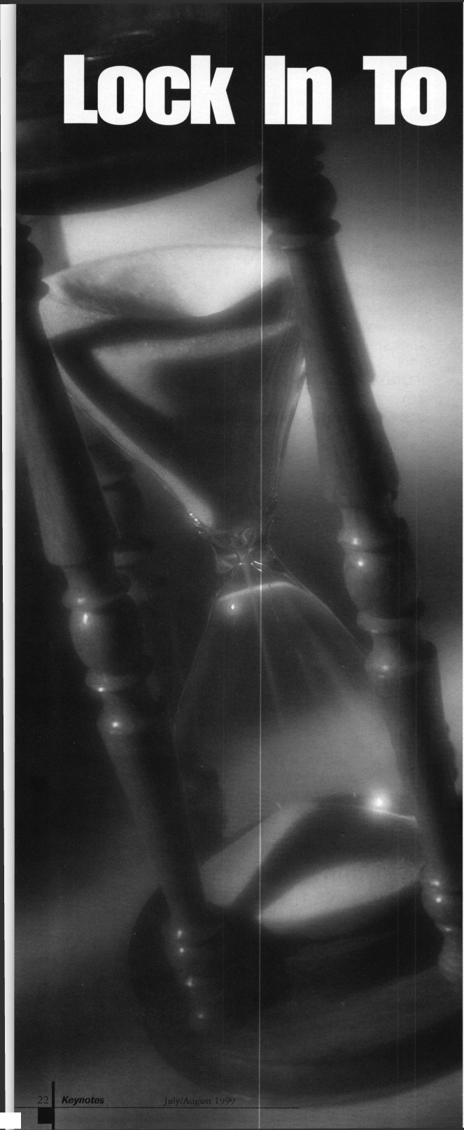

Fever!

By Claire L. Cohen, CML

Tying in with the millennium has given companies the opportu­nity to promote their products and services in an exciting new way. That’s why many are extending the trademark into other areas, including events and promotions. For example, one company launched a millennium essay contest. The company is also offering to sell a collector’s edition millennium watch.

Other companies also have busy Y2K schedules. Korbel, for example, is in the midst of a multi-tiered millennium promotion. The program includes events scheduled throughout the year.

The millennium is also springing up the licensing industry. Toyz n’ Treatz has debuted a Time Capsule Kit. The kit contains everything needed for a personal time capsule, including a record of what’s in the capsule, ID tags, and seal-on label. Licensing is also exploding in the clothing business: Y2K T-shirts and sweatshirts, socks and slippers, a line of luggage products, etc.

“Savvy merchandisers know that this is going to be an incredible phenomenon all over the world and they’re looking now to be part of it”, said the President of Planet Marketing, licensor of a Year 2000 logo.

Some companies have chosen to tie in with the millennium in a different way, launching nostalgic ‘meta-marketing’ campaign. Kellogg’s has revived its old Corn Flakes packaging; Mercedes rolled out footage from the Ed Sullivan Show; Exxon brought back its “Put A Tiger in Your Tank” slogans and Budweiser created a heritage campaign.

What a fantastic time to update your image to your customers and potential customers. Even if you do not want to use the Millennium theme, perhaps this is a time to think about updating your corporate image. It may be a time to re-work or revamp your advertisements, your business cards, your van lettering. Show your customers that you have the products and services that will take them securely into the next century. Put a spark of creativity and imagination in your new advertisements. Perhaps Millennium Fever may be made a part of your marketing plan. Perhaps not. Market your company as prepared for the future. You may want to Lock In to “Millennium Fever”!

New Mexico Locksmiths Association  
1999 Annual Convention

August 5 8, 1999

P. 0. Box 30956 • Albuquerque, NM 87190-0956 • (505)268-8663 • (505)435-9843

Classes in “Basic Electricity,” “Access Control,” “Safe Lock Servicing,” “Safe Penetration,” “Auto Lock Servicing”and “Interchangeable Core” are conducted by ALOA Continuous Education (ACE), instructors. A seminar in “Tricks of the Trade,” will be conducted by D. W. Dowless on Friday at 7 p.m. The trade show will be combined with a reception hosted by NMLA and the exhibitors. The 6th Annual Charity Golf Tournament will tee off at 9:00 a.m., Thursday, August 5th, at the Los Altos Golf Course. Thursday evening in the hospitality suite at the Ramada Mountainview Hotel, trophies will be awarded. The Awards Breakfast and Annual Membership Meeting will start at 8:00 a.m. Sunday morning and will be followed by the Proficiency Registration Program and the Safe Technician Certification Program. The Ramada Mountainview Hotel is located at 25 Hotel Circle NE, near 1-40 exit 165, at Eubank NE and Lomas NE in northeast Albuquerque.



July/August 1999

Keynotes

It will be a bit odd at the ALOA convention this year. It will be the first convention, in my recollection as a locksmith, that Bill Reed won’t be there.

In the year that has passed since last year’s convention, three giants of our industry have passed away: Bill Reed, Harry Miller and Gerry Finch. Their shoes are not easily filled. They were all very significant to the security industry, but in different ways.

In the relatively short history of the modern mechanical safe combination lock, Harry Miller would be found in rather select company. His knowledge of safe lock manip­ulation and his association with Sargent and Greenleaf, alone, assures his legacy. His importance to the industry, like Bill Reed and Gerry Finch, can be summed up in one word: education. A good number of highly skilled safe technicians can attribute a lot of what they are (either directly or indirectly) to the work of Harry Miller.

Gerry Finch taught a lot of locksmiths over the years. Two of his major specialties were interchangeable core locks and precision lock picking.

He taught the subjects and also wrote books about them. One thing that grabbed my attention about Gerry’s books or magazine articles was that he did his own illustrations. I don’t know if Gerry was an amateur artist and did paintings or sketches as a hobby, but the “art” work of his technical writings was always first rate. As a technical writer, that is one area that I would have liked to be skilled. I can draw legibly, but I usually end up having the magazine graphics department have to translate my rough sketches and hope that they know what details to leave as is and which details to clean up and improve.

I knew of Harry Miller and saw him on a number of occasions, but never had conversa­tions with him. I knew of his knowledge and talent, and respected it from a distance. I knew Gerry Finch, and though we weren’t

close personal friends, I spoke to him from time to time over the years and was able to benefit from his writing. When I teach my students lock picking, I emphasize the kind of precision (and scientific) technique that Gerry Finch promoted. I believe that my students learn faster and develop much greater skill using techniques that rely much less on the element of luck. Gerry was an educator of locksmiths, and his knowledge and talent will be greatly missed.

Then there is Bill Reed. I suppose Bill was the most dramatic of the three, and in certain ways may have impacted more locksmiths in a variety of ways. The Reed name brings to mind the subject of lock codes, and he may ultimately be most remembered for that and the code seminars he presented for many years. He did it solo at times, but over the years was widely connected with Frank Agius of Framon (known for code machines), and in more recent years had worked a great deal with Steve Young (best known for auto lock work and his car opening tools). I have known of Bill Reed from the time I started in locksmithing back in 1975.

My first locksmith magazine was the March 1975 issue of Locksmith Ledger. Although I didn’t know his significance at the time, his was the first prominent name in the security industry to which I was introduced.

He was the editor of the Ledger. My first contact with Bill was a few years later, when I received a note and check when my first technical tip was published in the Locksmith Ledger. I guess that would be the first time I was ever published. I could have never imagined, at that time, that I would one day be writing for a publication of Bill Reed on a regular basis, and would ultimately gain some prominence in the industry because of it.

It would be a few years before I actually had a full fledged technical article published. I think it was around 1984 for the National

Locksmith. Articles in general were few and far between until the early 1990s when I became an occasional contributor to the Guild Report, the second string quarterly publication from the Ledger. Soon before I knew it, I was writing for nearly every issue. Some time after ILCO bought the Ledger, the Guild Report was shut down, and Bill Reed decided to retire from the Locksmith Ledger in 1992.

An article I had written for the Guild Report was eventually printed in the Ledger, but a few months before the end of the year in 1992,1 received a phone call from Bill Reed. He told me that he was starting up an independent locksmith magazine, and he asked if I would write for the new magazine. He had indicated that he was contacting some of the better writers that he had worked with when he was still with the Ledger. I was honored to be considered in such company and I agreed to come on board.

A short time passed, and Dee Bucha (who was my direct contact when I wrote for the Guild Report) told me that Bill was starting a new magazine. She asked if I would write for the new magazine, and I told her that I had already spoken to Bill and had decided to do so.

The first issue of Reed’s Security Reporter came out in January 1993.1 started out as one of many contributing editors when I wrote my first article which appeared in that issue. Over the next six months or so, I started to develop my own style of writing. With a less restrictive editorial format than the other locksmith publications, I was able to write thorough and detailed technical servicing articles filled with step by step photographs and drawings. I tried to use whatever industry contacts I had made over the years to try and ferret out when new products were about to be introduced, occa­sionally getting a story first.

Bill was the publisher/editor and Greg

Keynotes

July/August 1999

Mango was the managing editor. Before the Reporter, I had no idea who Greg was. After working with him a few months, I found that he had written quite a few safe articles for the hedger. Over a very short period of time, the Reporter became the premier technical magazine in the industry. The Locksmith Ledger and The National Locksmith had become a bit stodgy and were shown up by the upstart publication, and locksmiths were starting to notice.

When Bill started the new magazine, there was some criticism among various people in the industry. It was thought that the market couldn’t support all three publi­cations. Bill Reed was bold and a man of action.

He didn’t let the criticism stop him from his venture. His magazine followed the adage “a picture is worth a thousand words”, and articles in the Reporter were consistently more thorough and easier to understand than those found in the competitor magazines. Articles ran in order, so you didn’t have to flip to the back of the magazine to finish reading it. Plus, there was a greater ratio of articles to ads. It was a factor that made the magazine easier to read, but it was ultimately the financial downfall of the magazine. Adver­tising is the life’s blood of most magazines.

My technical articles were starting to gain some attention. At the ALOA trade show in 1993, Bill told me he was promoting me to one of the Technical Editor positions. Reed’s Security Reporter made it to it’s first anniver­sary. It continued to improve and the big two (magazines) of our industry started to take notice. Those who told Bill Reed that the industry wouldn’t sustain a third locksmith technical publication, may have been right. At this point, however, conventional wisdom was considering the possibility that the odd man out might be one of the original two.

Bill’s magazine made it to the second anniversary, but increased circulation could not overcome the fact that advertising

scattershooting

While Remembering Bill Reed

by Sal Dulcamara, CML

July/August 1999

***Keynotes***

revenues seriously lagged behind both **The National Locksmith** and the **Locksmith Ledger.** The financial crunch became serious in the third year. At the ALOA show in 1995, the July issue of **Reed’s Security Reporter** did not leave the printer’s facility. Part of my disap­pointment was the fact that I had the cover story for that issue, and we had scooped the competition again. We would have been the first lock magazine to show the new ASSA Twin V-10 lock cylinders. Nobody ever saw the July 1995 issue of **Reed’s Security Reporter,** and no further issues of the magazine followed.

At the 1995 ALOA show, Bill was still trying to arrange financing in order to keep the magazine afloat. Before the final decision to close shop, rumors suggested that the magazine had already gone out of business. Marc Goldberg of **The National Locksmith** asked me if I’d be interested in writing for his magazine if the **Reporter** didn’t survive. I indicated that I owed some loyalty to Bill, and I told him that I’d consider it only after confirming that the **Reporter** was gone for good.

Ultimately, **Reed’s Security Reporter** faded into the sunset. Marc agreed to replace the balance of magazine subscriptions (owed by the **Reporter)** with matching issues of **The National Locksmith.**

I suppose the **Reporter** was one of Bill’s finest efforts. The fact that it didn’t make it to the third anniversary and beyond, might make some think that it was ultimately a failure. I suppose from a business standpoint that might be correct. The bottom line just didn’t add up, and if you don’t pay some attention to the bottom line, you may no longer have a business. It was, however, a success in other ways. Bill Reed became the element of competition to force the estab­lished publications to look and see if they were serving their readers.

That didn’t presume that the other magazines were purposely trying to give

their customers an inferior product. That’s just basic human nature. We as locksmith business people have to deal with the same thing. If we don’t have competition, we can sometimes get away with being less polite or slower to getting to the job or completing it. Our customers might not like it, but they may not have anywhere else to go.

Now, we don’t get up one day and say we are going to treat our customers badly. We get busy and overworked, and sometimes we don’t even realize that our quality is declining. But when somebody is new on the block and treats our customers better, we better get our houses in order or pay the consequences.

I owe a good portion of whatever prominence (as a technical writer) that I have attained to Bill Reed. It was while I wrote for the Reporter that people started to take notice of my writing. No matter what talent one may have, without a provided forum, nobody else knows. A great idea locked in a drawer is just a secret. If it is never revealed, it disappears.

Bill Reed was a man of vision. He wasn’t always practical, and met with unsuccessful results sometimes. But even a ball player that has a phenomenal hitting percentage of .400 doesn’t get on base more than 50 percent of the time. Bill was sometimes controversial and occasionally rocked the boat. He didn’t operate in a vacuum, though. He consulted with people that he considered knowledge­able in a variety of specialized areas to help him make decisions. I feel honored to know that over the years Bill respected my opinion enough to occasionally ask for my input on various issues. I am proud to be affiliated with **Reed’s Security Reporter,** which was one of the finest publications our industry has ever seen.

Bill Reed was born on October 8,1940. He died in his sleep on September 30,1998. He was a little more than a week away from his 58th birthday. It had been known that he

had heart problems, but most of us were still stunned to hear of his death at such an early age.

I had spoken to Bill on the telephone just the week before. Bill told me that he was going to be in Detroit the first week of January 1999 for the Auto Show. He asked what I thought might be the likely weather that time of the year in Michigan. He was thinking about putting on one of his traveling lock shows on the weekend that he would be in the Detroit area. I offered that Michigan weather was notoriously unpre­dictable, and it could be just about anything. He said that he would be in touch with me sometime soon afterward with more informa­tion. I wrote a note to myself indicating (September 24, 1998) the day that he called, and to be prepared to put the information in my local association newsletter when the information could be confirmed. It would never be.

Every once in a while, I’ll hear a story about some older guy who worked hard all his life only to sit around and do nothing when he retired. Then the next thing you know, he drops dead in his easy chair from inactivity. Bill Reed did the work that he loved to his dying day.

Locksmiths should know that he was working hard for their interests to the very end. Bill Reed, wherever you are, we salute you.

July/ August 1999



When It Comes To  
Electronic Locks, LESS  
Than Just Isn’t Secure.

|  |  |  |  |
| --- | --- | --- | --- |
| FEATURE | COMPETITOR  A | COMPETITOR  B | SARGENT & GREENLEAF |
| UL TYPE 1 | ✓YES | ✓YES | ✓YES |
| RELOCKS  AUTOMATICALLY | MAYBE | NO | ✓YES |
| PREVENTS  DAY-LOCKING | NO | NO | ✓YES |
| ONE-STEP  OPERATIONS | MAYBE | NO | ✓YES |
| “NO SPINDLE” DESIGN | MAYBE | NO | ✓YES |
| USER ACCESS  IN 5 SECONDS | NO | NO | ✓YES |
| REMOTE MOUNT CAPABILITY | MAYBE | NO | ✓YES |

'ONLY ON SOME MODELS

before you specify an electronic safe lock, take a close look at the competition. You’ll  
quickly see that, YES, no other lock provides you the same level of security as the  
Comptronic™ from S&G. And, YES, the Comptronic is easier to install and can be  
mounted anywhere on the container door. And, YES, only S&G has over 140 years of  
security experience providing superior customer service and a high level of confidence.

YES , when you check the facts, the choice is simple. Accept no less than the best  
security solution. Comptronic Electronic Safe Locks. Security...Technology...Tradition.

**fl —**

^aic locks. Securit

COMPTRONIC

ELECTRONIC SAFE LOCKS

**by Sargent & Greenleaf**

cMm

o-r-* •

s»^RKNLeaF



**MORE**

**ELECTRIC**

**STRIKE**

**OPTIONS**

FROM H-E-S.

**Paul F. Chandler, CRL**

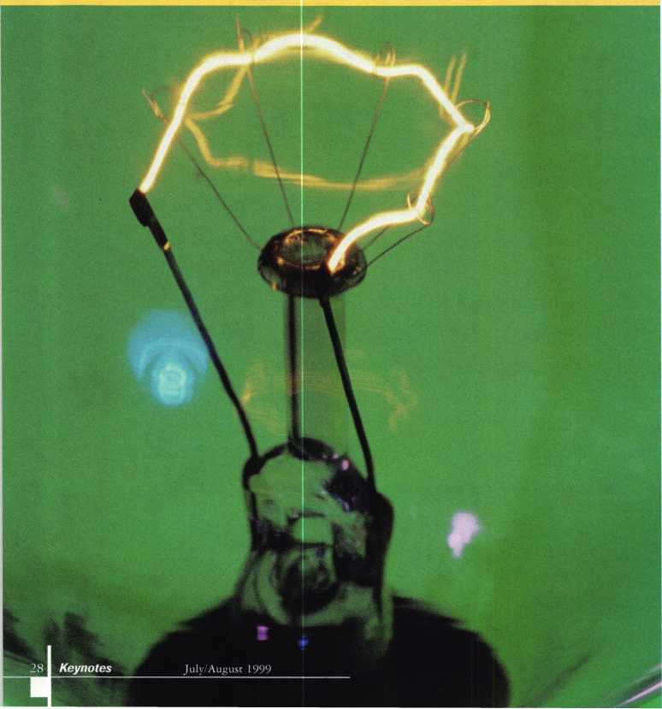

Last year, the big news in the electric lock business was the purchase of Hanchett Entry Systems of Phoenix Arizona by the German industrial giant EffEff. HES had built a solid reputation for innovative electric strike designs and everyone wondered what their merger with the world’s leading strike manufacturer would mean.

According to Michael Webb, now the president of HES, Inc., the relationship would allow his company to continue to introduce improved strikes but with the manufacturing efficiency of a large company. Evidently the new 5700 Series strikes are an example of what we can expect.

Each HES product has been designed in response to the needs of the market­place and with lots of input from the guys who actually install and service electric strikes. The 1003 Series addressed the need for strikes that would work with mortise locks by various manufacturers and with diverse functions. The 7000 Series introduced a design that can be released under a preload (outward pressure exerted against the strike keeper). The 5000 Series addressed the need for an extra thin strike body to fit in shallow door frames.

The new 5700 Series is the first HES strike with a horizontally adjustable keeper. Once this strike is installed, you can loosen three screws and slide the keeper in or out for better alignment with the deadlatch. Up to 1/8 inch of adjustment is possible. It may be that no adjustment is necessary at first, but a few months later, when the building has settled or the door has swollen, a quick correction in latch alignment might be called for.

Another special requirement with certain strike installations is some form of latch position monitoring. While you

can easily monitor door position with a  
magnetic contact switch, this does not  
assure you that the latch has seated in  
the keeper. Perhaps someone has taped  
the latch or otherwise disabled it. A  
latch position switch provides a better  
indication that the door is both closed  
and secure. Many access control systems  
require a door input switch to monitor  
for a door forced open or a door propped  
open condition and this option could be  
used. Other manufacturers have long  
offered monitored strikes as an option,  
but HES has developed a field-installed  
upgrade kit for the 5700 Series. You  
may add the monitor switch at the  
time of the original installation, or  
come back and add it later if it becomes  
necessary.

Like all HES strikes, the 5700 comes  
without a faceplate. It has been  
designed to utilize the same seven  
faceplate options, which are already  
available for the model 5000. These  
include the 501, for 4 7/8" ANSI preps,  
as well as the 502, 503 and 504 extra  
long faceplates for use in wood or  
aluminum frames. The 5700 can also  
use the stackable lip extensions in the  
5000 Series lineup. Since many distrib-  
utors and installers already stock a  
good selection of 5000 Series options,  
this was an intelligent design choice.

The 5700 is 1 1/2 inches deep. You  
may choose between a 12VDC version  
or a 24VDC strike. You must also  
choose between Fail-secure or Fail-safe  
operation. (This strike is not field  
changeable.) The strike has been tested  
to 1,000 pounds of holding force and a  
half-million cycles. It is U.L. 1034  
Listed for Burglary Resistance. The  
Fail-secure strike with the 501 faceplate  
option has a list price of $104.00,  
Fail-safe $23.00 more. The Latch Bolt  
Monitor option lists for $45.00.

Another new product from HES is

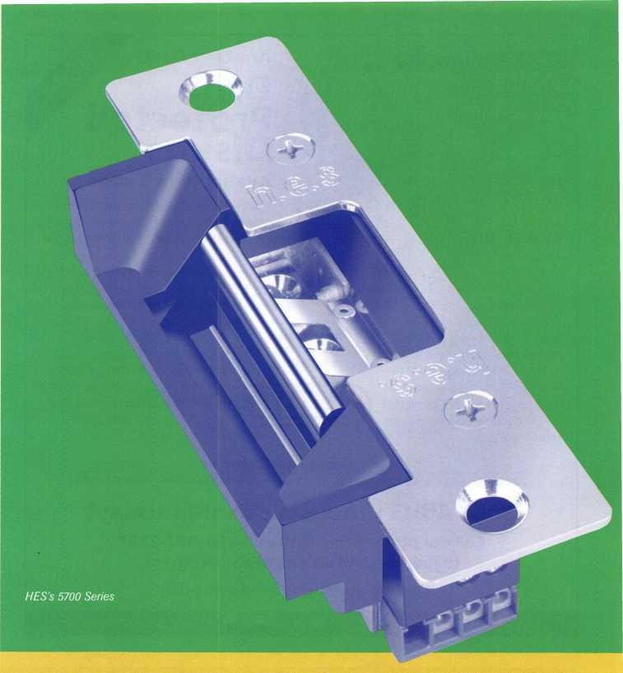

649 Cabinet Lock

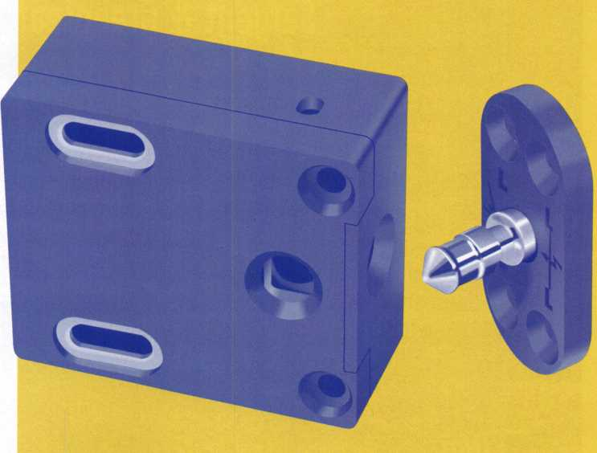

July/August 1999

Keynotes



Diskus® is avail

able with a

steel key way drill gua

is virtually impossible to drill this  
lock's cylinder, making it the "go to"  
padlock for absolute maximum security.  
Its 5-pin tumbler paracentric ABUS

keyway cylinder, stainless steel con-  
struction, and concealed boron steel  
hardened shackle provide maximum  
break-in protection.

Available in 3 sizes

This new 26-series Diskus® is available in three  
popular sizes. The 70mm size is appropriate for  
everyday maximum security applications. The new  
80mm size has an increased shackle opening,

which is useful for truck latch, storefront, and other  
heavy-duty applications. And the super-size 90mm  
version is already in use by long-haul truckers for  
coast-to-coast protection.

Hardened steel

free-spinning (jse ^ new Djs|<us® protect your

customers' payload, inventory, and other

high-value assets. For ultimate security,

recommend they complement their  
Diskus® with the ABUS "Shackle

Shield Hasp System."

drill guard!

(jETTTO

Another First!

Drill

Protected  
Diskus*

Made in Germany • ISQ-9000 certified

ABUS Lock, USA 3555 Holly Lane North Plymouth, MN 55447-0507 800-352-2287

Your ABUS products can ship today!

Call our professional staff at 1-800-352-2287  
to join the **"ABUS EXPRESS"** program.

All orders are shipped the same day!

**Call toll-free: 1-800-352-2287 Visit our Web site: <http://www.abus.com>**

the model 649 cabinet lock. This consists of a small rectangular box which is mounted to a stationary surface and a little locking bolt that attaches to the door or drawer. When the drawer is closed this bolt slides inside one of two openings in the locking unit and is trapped until you release it electrically. The 649 can be installed to operate in either Fail-secure or Fail-safe modes and may be powered by 12 or 24 volts, AC or DC. Bank teller drawers, jewelry display cases and hospital narcotics cabinets are just a few of the possible uses for this product. The 649 lists for $85.00.

Many of us have come to think of HES as the ultimate problem-solvers and these new products are no exception.

THE SOURCE FOR...  
Sargent & Greenleaf

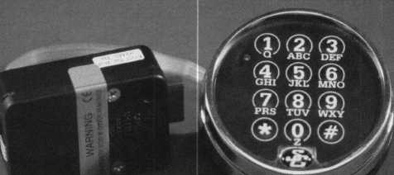

**\* requires an optional module and Time Commander D timelock**

**Comptronic Model 6123  
Features:**

**multiple user**

**dual custody 0-99 minute time delay  
timelock interface\***

**Regular price $187.40**

Sale $134.95

IME Time-Master.com (web) •[TIMSTR@aol.com](mailto:TIMSTR@aol.com) (email)

ASTER 888 798 8464/Fax 800 798TIME(8463)• 785 232 8705/Fax 785 232 2603

Keynotes

July/August 1999

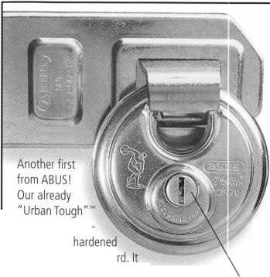

:

f

|

I

I

1

i

(Dealer) ACCESS SYSTEMS (Job) 200 POST PLACE FLOORS 18-3

300VSA.1

~ -"j

of Ip

IK DlfiTRIRI

THE IN DEPTH DISTRIBUTOR OF  
LIFE SAFETY AND SECURITY PRODUCTS

Phone: 1-800-847-5625 • Fax 1-800-878-6400  
e-mail: [info@seclock.com](mailto:info@seclock.com)  
Web: [www.seclock.com](http://www.seclock.com)

BOSTON, MA • POMPANO BEACH, FL • LAS VEGAS, NV

I tnh

(Dist.) SECURIT

300VSA.2

uoc uo — wc don t mind. Here at Security, we’re ready to pro­pel you into the world of advanced security technology with exceptional electronic products, ranging from intricate access control systems to electronic locking devices.

4./

-- -0

: In addition, our technical staff is  
ready, willing and able to assist you in  
all aspects of security detailing, from  
hardware specifying to system layout.

Of course, we still offer overnight  
delivery, nationwide service centers,  
the best catalog in the business, and  
the largest inventory in the country.

So why not take advantage of us?  
After all, everyone else does.

0)0

|  |  |
| --- | --- |
| 0 | 0|0 |
| ... | PI& |
|  |  |

$

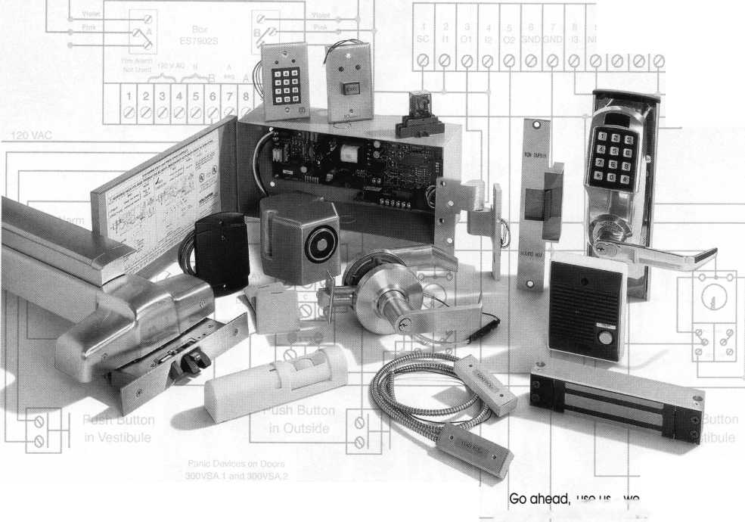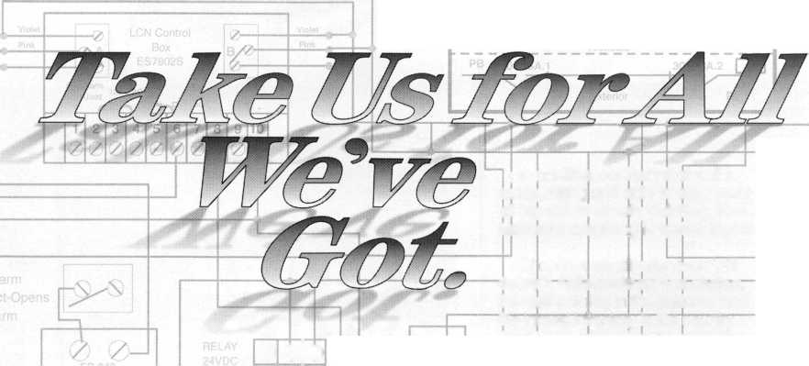

rn:4mt

* »-u> a

***Keynotes***

July/August 1999

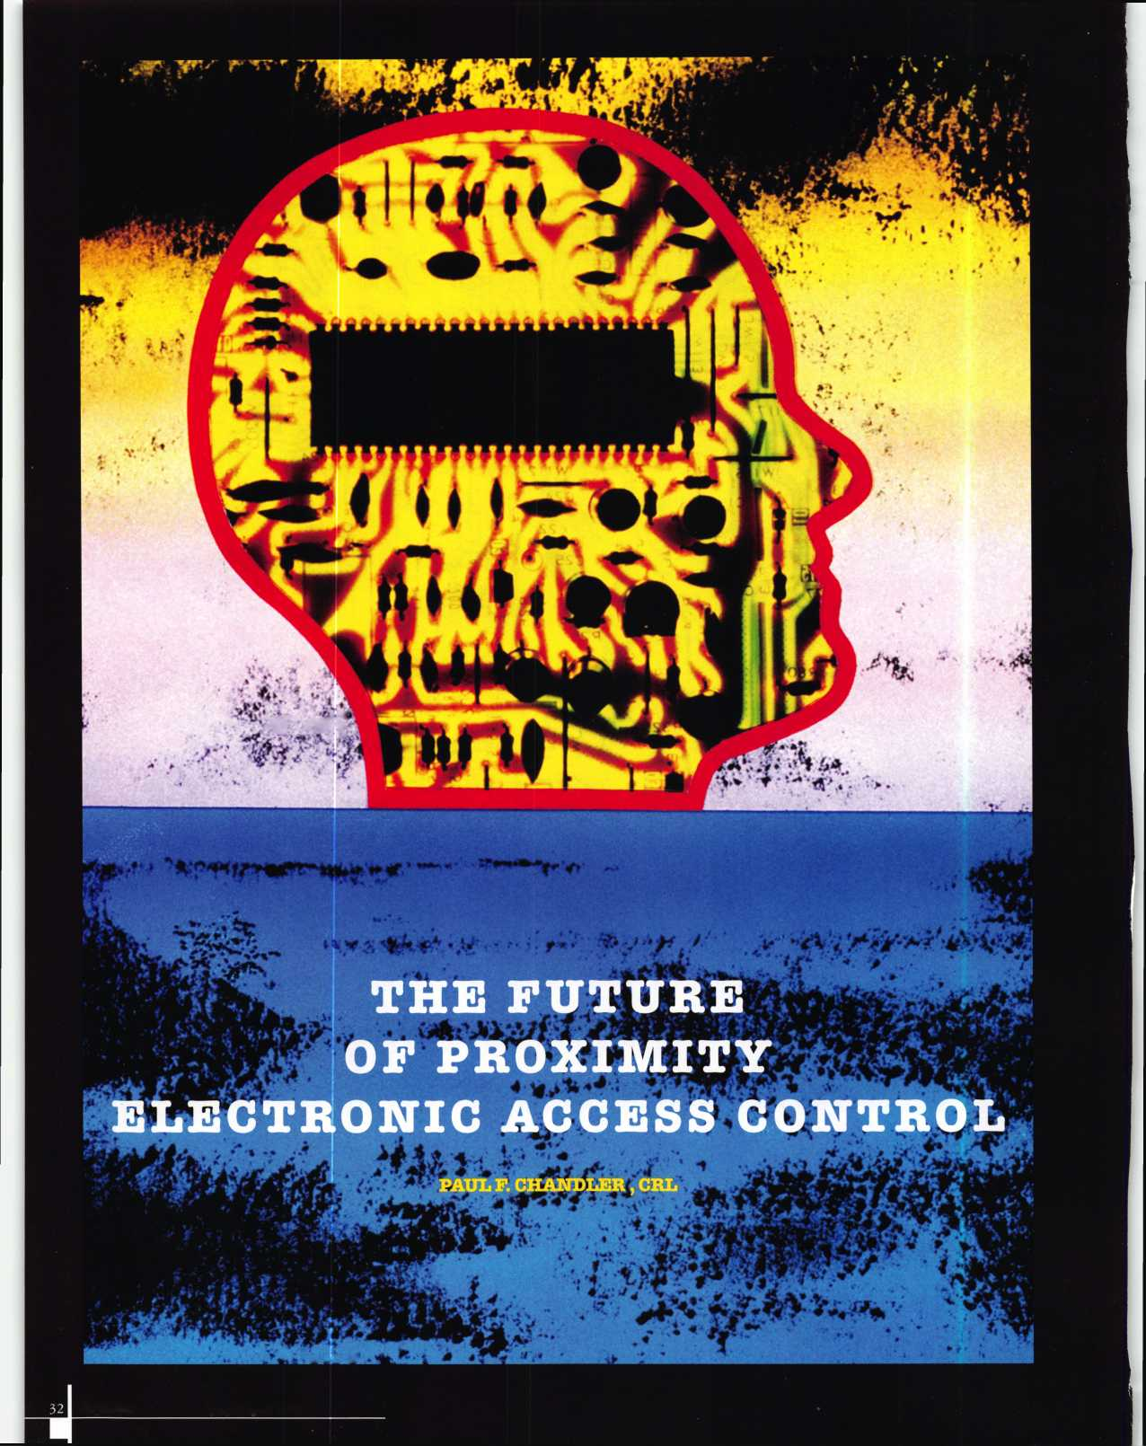

Proximity, noun:

1. ) Access control technology that uses transponder cards or keys, which do not need to physically touch the proximity reader to be recognized.
2. ) The access control technology everybody wants until they see how expensive it is.

Electronic Access Control, noun: a.)

The use of electronic systems and microchip intelligence to replace mechanical devices for locking doors to achieve higher security and greater accountability, b.) The field most locksmiths want to get into but don’t because it is too complicated and besides, their customers won’t spend that much money.

All of these definitions were true in the not-so-distant past. Not anymore. Proximity access control prices have plummeted in the past two years with the introduction of a new generation of readers, cards and control systems. More and more locksmiths are taking the electronic access control plunge and finding that their customers are ready and willing to pay for real security.

One manufacturer who has shaken up the access control world is Keri Systems.

Founded by some of the pioneers of proximity technology, Keri continues to introduce technologically sophisticated products at unheard of prices.

For simple, single door applications where easy adding and deleting of users is required, Keri “Intelliprox” is available. Users are programmed in and out of the standalone reader with a handheld device that resembles a TV remote. Various reader sizes are available; from the tiny mullion-mount “MicroStar” to the giant “MegaStar” with its 24-inch read range. Intelliprox models start at just $198.00 suggested dealer cost.

True electronic access control, however, includes more than adding and deleting users quickly and easily. Most businesses also need a system with audit trail capabilities; a record of each attempted entry showing user, time and date. Many also want to limit the days and hours when an employee may gain access, a feature known as user time zones. What about automatically locking and unlocking certain doors at a specified day and time? This is often referred to as a door time zone. For systems with these features Keri offers the “PXL250 Tiger” controller.

The PXL250 is a single door distributed intelligence controller. “Distributed intelli­gence” means that each controller contains all the instructions for managing the associated door without relying on a computer. A computer need only be used to teach the controller new instructions, for example, to add or delete a user, and to extract the audit trail from the controller for viewing or printing. This means that a dedicated p.c. is not required. You may connect your PXL250 to a desktop computer that is usually used for other tasks, you may plug in a laptop when you want to commu­nicate with the system or you may attach a modem and do your programming over

phone lines from halfway around the world.

The computer you decide to use has to be an IBM compatible with a Celeron or Pentium chip, have 16 MB of RAM, 20MB of hard disk space, an SVGA monitor, a CD- ROM drive and be running Windows ’95, ’98 or NT operating system. The software for managing your system is called “DOORS 32”. It is a true 32-bit Windows program with features like “drag-and-drop,” window resizing and relocation and multiple windows open simultaneously. The program is Year 2000 compliant. Learning to use “DOORS 32” is very easy, even for the likes of me. And the best part of all, its FREE! That’s right, no charge, complimentary, on- the-house.

Back to the PXL250.1 described this as a single door controller, and it is. However, by adding an economical expansion board (P/N SB293) it becomes a two-door controller. In addition, you can network up to 128 PXL250s, making possible a 256-door system. Controllers are linked via an RS-485 network using a single shielded pair cable. Only the number one controller needs to be connected to the computer, either by RS-232 serial connection or via modem.

Each PXL250 can remember 10,000 users and the last 3,600 audit trail events. 32 time zones can be defined as well as 3 different holiday schedules. The PXL250 includes its own attractive white plastic enclosure or an optional locking metal cabinet may be ordered.

The MS-Series readers are used with the Tiger system. MS3000 is 3.4" x 1.4" and suitable for mounting right on a doorframe. MS5000 is about the size of a light switch plate. MS3000 can read cards up to 4 inches away, while MS5 000 has a maximum read range of 7 inches. Larger readers with 15- and 24-inch ranges are also available.

These are usually required for parking access applications.

Keri offers a choice of access credentials, too. The KC10X standard card offers the best range and the lowest price. The PKT10X key tag is very tiny, about the size of the plastic head on most car keys. Both of these carry a lifetime warranty. For facilities that want to print photo I.D.s directly on their access cards the MT10X cards can be

July/August 1999

Keynotes

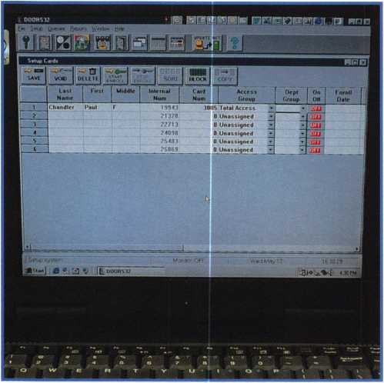

Keynotes July/August 1999

ordered, either with or without a magnetic stripe on the back for use with other reader systems. (If your customer is interested in a new badging system, Keri offers a complete package, including the video camera, a computer and a badge printer.)

I told you Keri had broken the proximity price barrier. To give you an idea, a two-door system: controller, expansion board, two prox readers and software is only $847.00 (suggested dealer price). Throw in 75 cards and you’re still under $1000.00.

Okay, the price is right, but how difficult is it to install? Do I need a degree in computer science to program the thing?

Installation is as simple as most electric locking systems and easier than some. Use six-conductor shielded cable to connect the readers to the controllers. I recommend that you buy the ready-made cable from Keri for connecting controller number one to the computer or modem so you don’t have to solder a DB9 or DB25 plug.

If you have several doors to network you may want to locate the PXL250s throughout the building, near the doors they control.

On the other hand, you may prefer to mount all of the controllers in a central location such as a telephone or electrical closet. The layout of the site will determine which makes most sense. However, you will need to locate controller number one within 50 feet of the host computer unless you are using a modem.

All wiring associated with a particular door is terminated at the PXL250. Specifically, you will have wires running from the controller a.) to the power supply, b.) to the electric lock or strike, c.) to any request-to-exit switching device(s), d.) to a door contact switch (to monitor door status) and, e.) to the proximity reader. Only the reader cable and the cable between controllers needs to be shielded 22 gauge. I usually recommend 18AWG plenum-rated cable for everything else.

Once you connect everything and power up your system you simply set an address on each controller and tell the software to auto- configure the system. The network is polled and “DOORS 32” knows what equipment it has to work with. Now, you can set up the door time zones and the user access groups and begin enrolling cards and users. Most people who are familiar with Microsoft Excel, or similar spreadsheets, will find this very easy.

A standard door control system is that simple. Of course, some projects have specialized requirements. Keri has the ability to program user-defined inputs and outputs for a truly custom system. Naturally, using these options can make the project a bit more complicated. If your customer wants his access control system to do some fancy extra stuff call Keri and let the technical wizards tell you if and how it can be done.

Definition: Proximity access control, noun: a.) Convenient, intelli­gent security that you can install and your customers can afford.

Top photo: Keri PXL250P

Center Photo: Keri Proximity Readers

Bottom photo: Keri “Doors 32” software

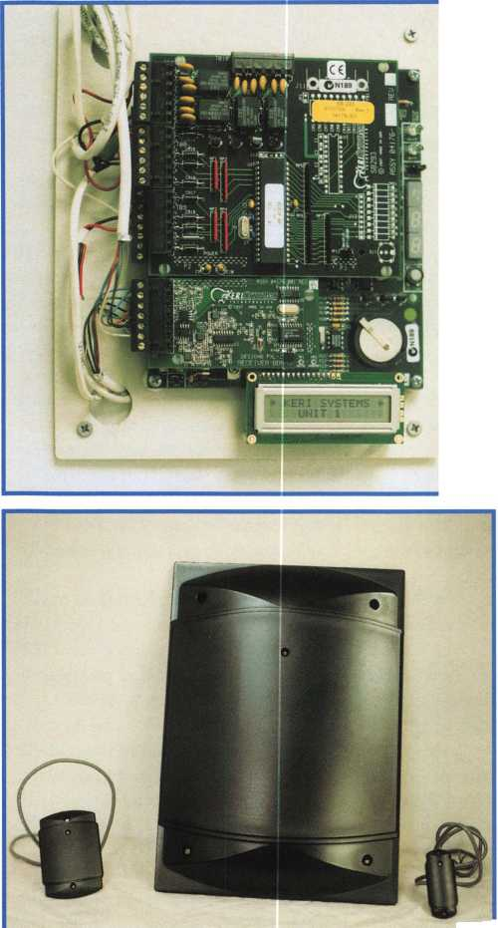

When your truck is down, your business stops cold. We can help get you fixed up and back in business fast.

Better order that coffee to go. Call I-800-669-67II. Being in good hands is the only place to ber

9

[www.allstate.com](http://www.allstate.com)

**Allstate Insurance Company is Exclusively Endorsed by the Associated Locksmiths of America (ALOA).**

**/instate**

**\bure in good hands.**

© 1998 Allstate Insurance Company, Northbrook, IL. Allstate New Jersey Company, Bridgewater, NJ. Subject to availability and qualifications. Other terms, conditions and exclusions may apply.

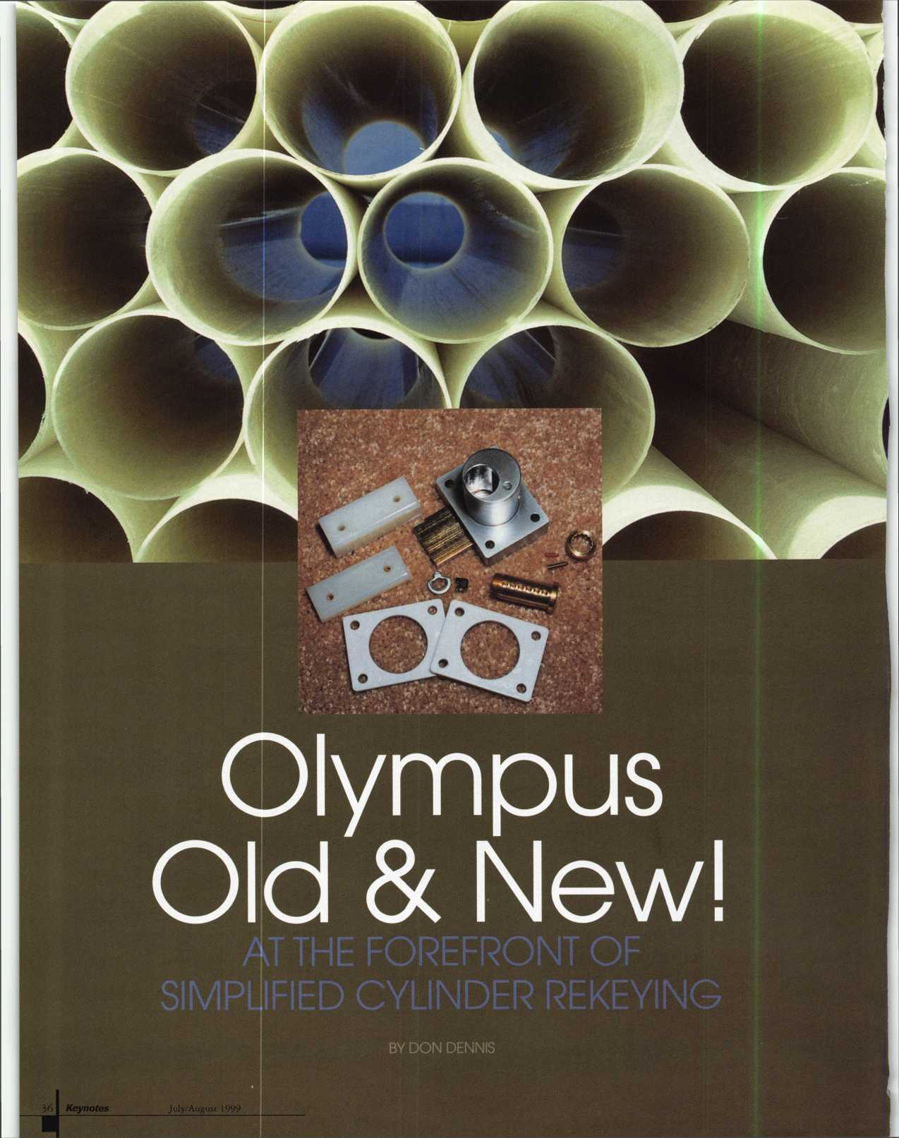

The Beginning

For some time now, manufacturers have been continuing to improve the capabilities of cabinet locks. One of the primary concerns was the capability of rekeying cylinders in these locks easily. Olympus Lock Company has gone to the forefront in making cylinder rekeying simple. You might say that Olympus Lock Company is revolutionizing the cabinet lock industry.

When you look at the catalogue offered by Olympus Lock, there is a conversion chart showing more than 60 different locks. They are all pin tumbler replacements for some of the market’s top lines. There are identical replacements for National Cabinet Lock,

CCL Security Products, Schlage, Best and Corbin/Russwin. The line of products is impressive, as is the design, which promotes ease of rekeying. The keyways offered are those of National, CCL and Schlage. In dealing with the I.C. lock bodies that the company manufactures, the keyways that these bodies will accept are Best, Arrow, Falcon, KSP and Corbin/Russwin.

National Cabinet Lock Company began many years ago to produce small ‘L’ brackets for use as a surface mounting strike for locking a drawer in place. The lock bolt would connect with the bracket and made surface mounting a faster consideration in making new installations. Olympus has not let us down here either! They make available a variety of blocks that can be used as strikes and also spacers for use in shimming flush mounted installations.

Olympus originated out of a need for rekeying institutional cabinet lock applica­tions. They have targeted schools, banks and hospitals with their products since 1985. With a successful history, they entered the winter of 1988 with the production of the 700/800 series locks. This series began the attempt at incorporating popular cylinder keyways that are utilized in the commercial and home markets. The 700/800 series incorporates a Schlage ‘C keyway into a cabinet lock format. This format is larger than most cabinet locks in its size but has a very useful role to play in securing cash drawers and drug drawers/cabinets. It is also used easily in new installations where a lock

Facing page center: Olympus 800 Series lock less the cylinder housing. Notice the space shim plates and the blocks that can be used as strikes to secure the drawer or cabinet door.

has not existed before. I should mention here that the difference between the 700 series and the 800 series is in the relationship between the locking deadbolt and the position of the lock cylinder in the lock’s case. Both the 700/800 lock series can be ordered with or without a cylinder.

Working with the Cylinders

Cylinder replacements must be similar to a Schlage cylinder that is utilized in Schlage’s deadbolts and knob locks. The 700/800 locks will come with the needed drive pieces if they are ordered without a ‘C’ keyway cylinder. You need a cylinder like Schlage that uses a nut to fasten the driver unit and plug in place. The driver is a flat stem like Schlage’s deadbolt tailpieces which allows the cylinder plug to rotate 360 degrees while the cam makes a rotation of only 180 degrees. A good replacement is the Lori 1531.

The 1531s are only plugs. They will fit into the cylinder housing of the cylinders supplied in the purchase of a complete 700/800 lock. We all know that the spacing varies with different keyways. The Schlage keyways has spacing from the shoulder to the first cut of .231" and from cylinder chamber to cylinder chamber a distance of .156". Russwin ‘D’ series keyways has spacing from the shoulder to the first cut of .250" and chamber to chamber a distance of .156". All of the cylinder plugs that are manufactured as part number 1531 by Lori has the chamber spacing of .156" or .155". I am aware that they also show in the Lori catalogue a Kwikset 1531 plug. Kwikset’s chamber to chamber measurement is .150". I was unable to find a distributor that had one of these in stock. It is easy to see how the 1531 will fit into the cylinder housings since the shoulder to first chamber measurement is governed by the thickness of the plug’s facing. As long as the chamber to chamber measurement is in the range of .156" it will fit and work well.

Out of curiosity, I tried to make a Lori 1569 cylinder fit into a lock that came without a cylinder and failed miserably. First, the plug retaining nut furnished on the 1569 is too thick. When seated into the 700/800

locks the retainer bottoms out and sits much too high to get the locks face plate back in place. If I tried to use another type of nut plug retainer, such as the ones that come with a 700/800 complete lock, I still miss a flush setting by about a 1/32". The moral is simple—use the 1531. If you have difficulty in finding the 1531 from your current distributor, the listing that accompanies this article contains suppliers that stock 75% to 90% of the Lori product line and maybe your luck will improve. I found all of my cylinders for this article at Stone & Berg.

The New Spring Latch Lock

There is a lot happening at Olympus! A new deadlocking spring latch lock and a new catalogue! Both of these items, if the current plan at Olympus is not deterred, will be on the market by the ALOA Convention and Security Expo. They are hoping to have the new catalogue at the show and of course samples of the new deadlocking spring latch lock on display.

This new cabinet/drawer lock is called the 850. The cylinder is retrieved from the lock in the same manner as the 700/800 series. By removing the Phillips head screw on the barrel, the faceplate will slide out along with the cylinder. Do the combination change on the cylinder and slide everything back in place. There is, however, a difference between the key function of the cylinder in a 700/800 lock and that of an 850 lock. The 850 key rotation is only 45 degrees. The key will move from the twelve o’clock position to the three o’clock position to retract the latch. When the key is released it will return to the twelve o’clock position for extraction. It is because of this function that the tailpiece on the back of the 850 cylinders is rigid.

The manufacturer’s choice of cylinder plug replacement is still the Lori 1531.1 am sure that in a pinch you could get a Lori 1596 cylinder to work by modifying the cylinder housing. This would be only in a pinch due to the work that would be involved. The available keyways for the Lori 1531 are as follows: Arrow, Corbin 59A1-2, Corbin 60, Corbin/Russwin L4, Dexter (Master), Falcon, Harloc (SE-1), Kwikset, Lori 80, Lori 90,

July/August 1999

Keynotes

At right: 850 lock with deadlocking spring latch lock disas­sembled.

At far right: Notice the black cam at the bottom of the cylinder chamber that accepts the cylinder tailpiece.

It rotates 45 degrees to retract the latch. Also note the dead­locking feature is engaged on the side of the locking latch.

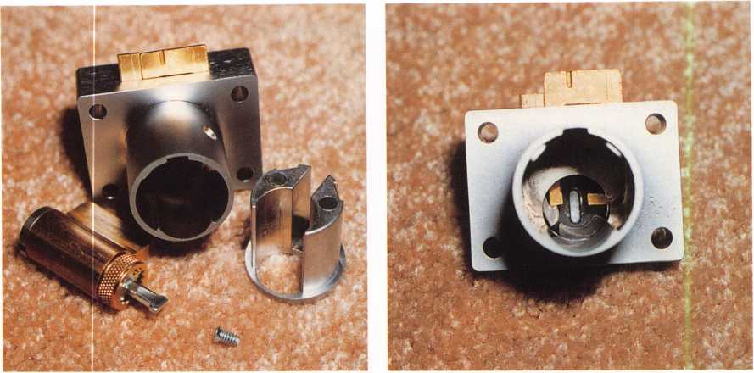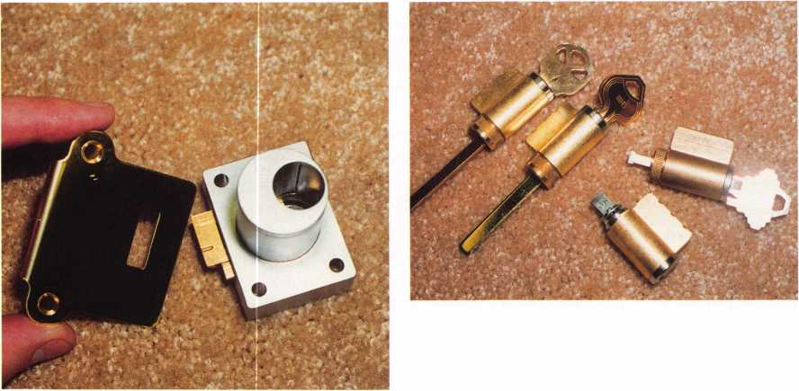

At far left: 850 lock  
with deadlocking fea-  
ture engaged and its  
matching strike plate.

At left: The top two  
cylinders are Lori  
1569's with the Kwik-  
set and Russwin keys.  
The Lori 1539 with  
modified tailpiece is at  
the bottom without a  
key in its cylinder. The  
last cylinder is the one  
that comes with the  
850 and has the fixed  
tail piece.

Lori L200, Russwin 981/852, Russwin Dl, Sargent ‘S’ Composite, Sargent ‘U’ Composite, Schlage ‘C, Schlage ”, Schlage ‘P’ (C-L),

Segal 9, Weslock and Weiser.

One of the things that I always battle is my inventory. It only makes good sense to find ways to make what you do stock really count. On my shelf are a lot of Lori 1539 cylinders that are used in door locks as well as padlocks. I found that they would fit the 850 lock very nicely once you adapt the tailpiece. If you are not using the Schlage ‘C’ keyway and do not have a 1531 plug to make a proper replacement, take a 1539 cylinder with the ‘SD’ tailpiece. Cut the tailpiece to match the original cylinder and tailpiece in overall length. On a grinding wheel take a little off of each side of the ‘SD’ tailpiece blade until it slides into the lock’s interior rotating cam. It will work very nicely. I do not know about abuse to the lock and the slamming of the drawer in relationship to its effects on the stability of the 1539 tailpiece. I have made a recommendation to Olympus that a longer tailpiece that would snap into the back of the 1539 that would protrude further into the cylinder would not only lend strength but also would keep the tailpiece from popping out of place. This is something we see when we use the 1539 in door locks and the doors

are slammed shut repeatedly. The tailpiece will pop out of place leaving the lock inoperable by use of the key.

The 850 lock is a welcomed addition to our arsenal. The lock with its deadlocking latch has a matching strike that engages the dead­locking feature. While this feature improves the security of the drawer or cabinet, it also allows the operator to close the container without the use of a key. The 850 is available in US3 and 26D finishes. It will fit materials with a thickness of 7/8" to 1 3/8". It has a diameter of 1 1/8" on the barrel and its footprint is the same as the 700/800 series.

This article is showing you only a small fraction of what Olympus Lock has to offer the Locksmith. When you are at the ALOA show take the time to visit their booth and see for yourself the innovation and quality of the Olympus product line. Look at their product rekeyability and keyway compatibility. Also take a good look at the new 850 deadlocking spring latch lock. It has the versatility, the strength and keyability that the industry has been looking for. It has been a long time in coming and deserves your inspection.

Keynotes

July/August 1999

**There is nothing**

ORIGINAL

T4/

*n-ca*

for more information, call 800-849-8324  
or visit our website at [www.ilcounican.com](http://www.ilcounican.com)

**It's patented inside and out.** It might look like all  
the others, but the electro-mechanical SAFELOCK 515  
is exceptionally engineered. Its patented design  
includes Convert-A-Bolt™ technology for field-selectable

deadbolt / springbolt. **It's packed with features.** UL

listed Type 1, the SAFELOCK 515 features include four security levels and  
programmable dual custody, time delay, open window, tamper shutdown,  
and lockout. **And it costs less.** The SAFELOCK 515 is fully programmable  
from the keypad, requiring no distributor programming fees, expensive  
modules, or hand-held programmers. With more security for less investment,  
the SAFELOCK 515 is the ideal choice.

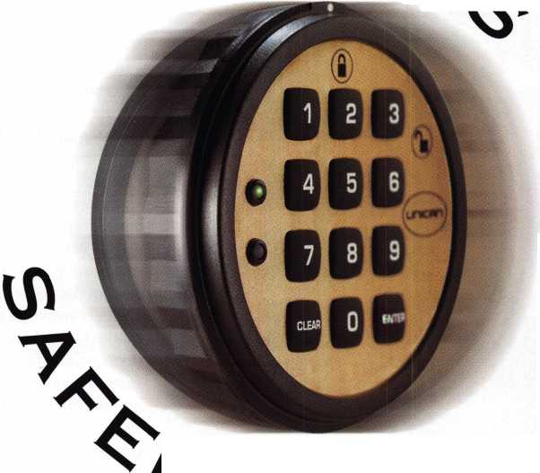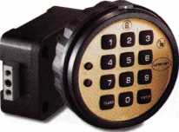

Souber (.Tools

DBB MORTICER

|  |  |
| --- | --- |
| mm m |  |
| IIILlJil iiilAj | r jj |gf |

There is a rather interesting installa­tion jig available for installing mortise locksets. It is called the DBB Morticer, and is shown in photo 1. In front of its plastic carrying case is the jig itself that clamps onto a door for installation, the boring shaft that can be quickly changed from one cutter to another, an adjustable depth stop and an assortment of cutters. The instruction booklet is illustrated and is written in English, French and Spanish. The DBB Morticer is available from Souber Tools of London (England), although, it will probably be marketed through Pro-Lok in the United States. “Morticer” is the British spelling. We would normally substitute the “c” with an “s” in the American spelling of the word.

The jig is shown in photo 2. The aluminum housing is designed to move up and down, while the shaft (with cutter) guided by the bronze bushing can move in and out to cut depth. The jig is designed to attach to the door with the clamps at the top and bottom. Stop surfaces are adjustable to control the overall height of the cutout (or pocket) for the mortise lockset to fit into the edge of the door. The cutters and cutter shaft are shown in photo 3. Those marked “WB” are designed for wood doors, while the one marked “AB” is intended for installations in hollow aluminum doors. The cutter sizes are indicated as Metric measurements (millimeters). There are 25.4 mm per inch, so the 25 mm cutter is approxi­mately one inch. A depth control collar can be attached to the cutter shaft, to control how deep the cutter will cut into the edge of the door.

A closeup of one of the wood cutters is shown in photo 4, with its two cutting teeth. The cutter for aluminum doors, in photo 5, has three cutting teeth. Photo 6 shows the end of the cutter shaft where the cutters install. The outer ring is eccentric in relation to the rest of the depth of the shaft opening.

Attaching Cutters

The end of the cutter (where it is meant to mount to the shaft) is a hexagonal shape, shown in photo 7. The ring at the end of the cutter shaft must be moved slightly so that the circular openings of the cutter shaft and the moveable outer ring are in alignment. The insertion of the hexagonal end of the

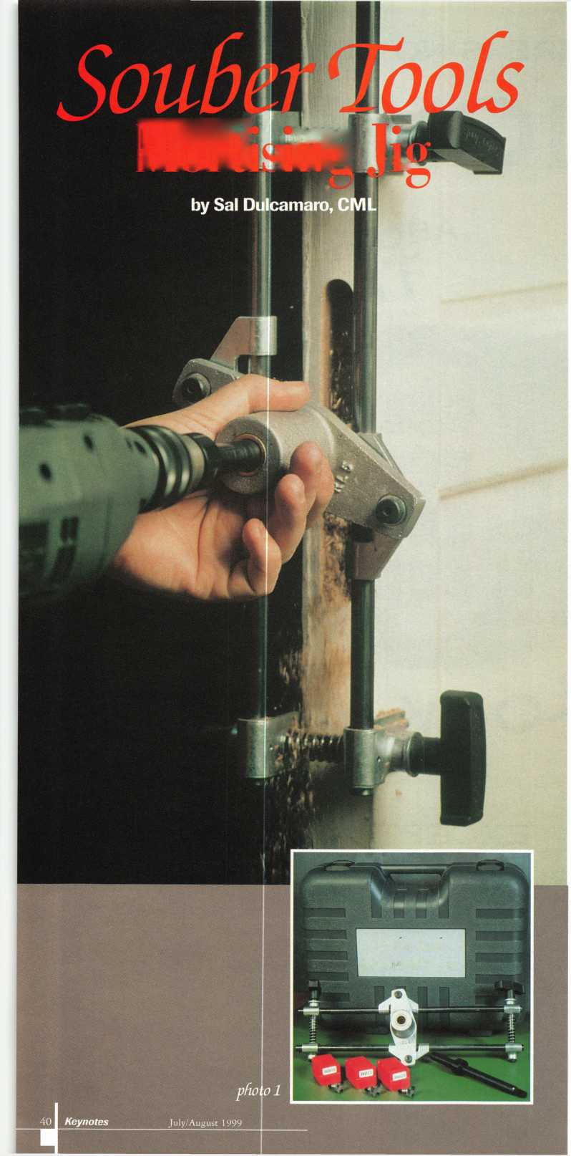

cutter can take place when they are aligned. Photo 8 shows how the outer ring remains shifted until the cutter is fully inserted. When the cutter enters deeply enough, the outer ring shifts back. The internal circular surface of the outer ring acts to trap the cutter, as in photo 9- The cutter can only come off by deliberate action.

The attachment and detachment of cutters to the cutter shaft is fast, precise and secure. The cutter can be changed very quickly and with a minimum of hassle. The cutters should be attached or detached when the long cutter shaft is within the opening of the bushing inside the aluminum housing. Some of the larger cutters are larger than the inside diameter of the bushing, and it would be physically impossible to push or pull through the cutter shaft when a cutter was attached. Photo 10 shows the shaft fitted through the bushing. If the jig had been attached to a door, the front face of the cutter could be pressed up against the edge surface of the door to set the cutting depth. The body of the mortise lockset (to be installed) could be used to set the position of the depth control collar.

The lock body would also be used to mark the location on the door for the installation. Once the door was marked, the clamps would be positioned at upper and lower limits, as stops, to control how far up and down the aluminum housing would travel. The up and down stop positions and the depth control collar on the cutter shaft would ultimately determine the position and size of the pocket cut out of the door to allow space for the body of the mortise lockset.

Cutting Into the Door

The large photo on the previous page shows the jig attached to a door. With a drill motor attached to the cutter shaft, both height and depth can be cut into the edge of the door. The cutters slightly resemble router bits and actually cut during up and down motion and in a plunge cut style motion. They are attached to a shaft which allows them to go much deeper into the edge of the door than a typical router bit. These bits ought to be used with a fairly high speed drill motor. A half inch chuck and 2000 to 3000 rpm is recommended.

The cutting action involves slight inward pressure and moving the

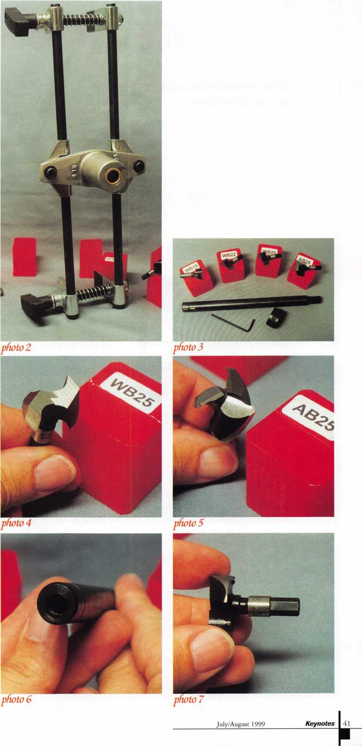

* Super bearing construction.
* Superior rigidity and accuracy.
* Shipped with carbide cutter.
* 2 year parts and labor warranty.
* Increased cut rates:

Laser mode 8 sec

Standard mode 12 se

Bi Axial 6 pin 17 se

* New Medeco Autoswing head option.

mmmmm

mromsB

ID GO ®[It0

bbbbS

WEAR EYE PROTECTION

* Up to 800 built-in manufacturer depths and spaces.
* Works with most popular Master key systems.
* Serial port to communicate with user systems.
* Repeatable accuracy of l/1000th inch.
* Dependable heavy duty construction.
* 1 year parts and labor warranty.
* Cuts Medeco™ High Security keys with angled cuts.

The ITL 9000 was built by locksmiths — we know what you wanted so we built it. When a new lock comes out you add the space and depths immediately. No Mechanical adjustments. All sealed and prelubricated bearings.

ITL -9000

mmmmm

0GDGEOD

00GDE3D

□&)©□□

* Uses either 12 or 120 volts.
* All manufacturer depths and spaces built
* Heavy duty construction.
* 12 month warranty.
* Built in Master key System.

**TOOLS LIMITED**

— **Now Distributed Throughout USA, Canada & Australia** —

2639B Progressive Way • Abbotsford, BC Canada V2T6H8  
**USA:** 562-699-0060 • **Canada:** 604-852-8904 • **Canada Fax:** 604-852-8938 • **Tell Free:** 1-888-264-6627

. . mmMm Mt $mssm an . .

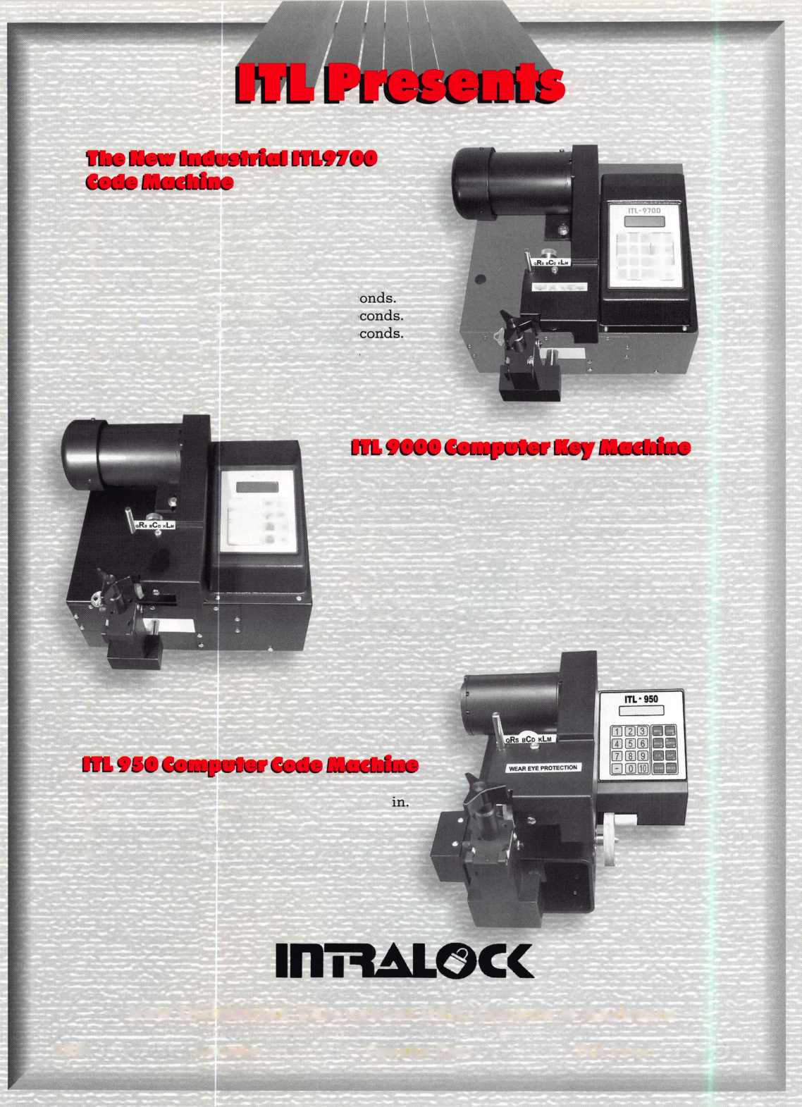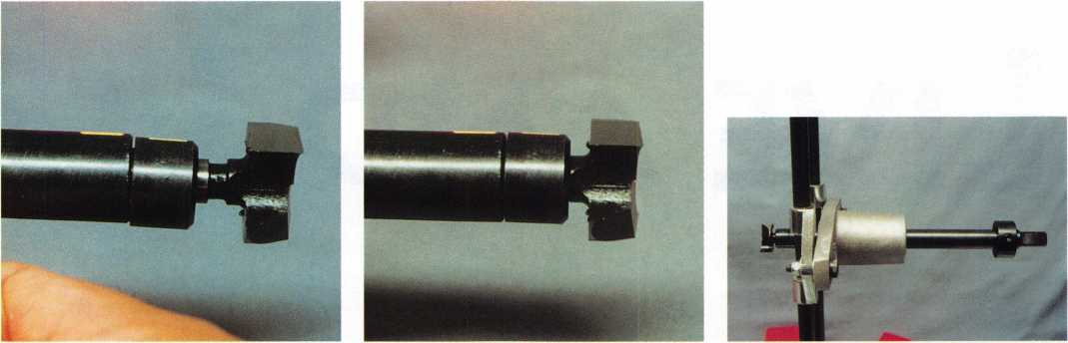

*photo 8 photo 9 photo 10*

aluminum housing (which contains the bushing and controls the motion of the cutter shaft) up and down from stop to stop surface. Each time the drill is pushed a bit deeper into the edge of the door, and the up and down motion shaves another layer until the pocket is cut to full depth. A larger cutter would be required for the edge plate mortise, which would only penetrate a fraction of an inch. The clamps and upper and lower stops would have to be reset, and the depth control collar reset on the cutter shaft. After that mortising operation was completed, the rounded cut ends would be squared off with a chisel.

The DBB Morticer can also be used on storefront style hollow aluminum doors. The process is not quite the same, with procedures described in the instruction booklet. The aluminum style (3 tooth) cutter would be used instead, plus only a thin layer would be cut through because the door would be otherwise hollow. WD-40 is recommended (in the booklet) as a cutting fluid when cutting through aluminum. Other cutters and accessories are available in different countries where the mortise lock designs are different. If you install standard American designed mortise locks, you may not need the different cutters.

The DBB Morticer may be marketed through Pro-Lok in the US. If so, it should probably be available where you currently buy Pro-Lok brand products. Otherwise, you can contact Souber Tools, 6 Dagmar Court, Hurls tone Road, South Norwood, London (England)

SE25 6JA. Phone: 0181-771 7596.

FAX: 0181-653 8173.

IBsillSlliiS

SBKMasSi

Family of Access Control Products

Stand-Alone Self-Contained | Keypads * Two Part Controller-Based Systems

USER FRIENDLY

HIGH-TECH

KEYPAD PROGRAMMABLE I

NO MOVING PARTS

SOLID METAL HOUSING

VANDALPROOF TAMPER-PROOF WEATHERPROOF WATER PROOF (IP68 Rated) ANODIZED GRAPHICS

MEETS MIL STANDARDS

(keypad)

PERFORMANCE GUAR!

KEYPADS SO INDESTRUCTIBLE WE DON’T WARRANTY THEM, WE GUARANTEE THEM!

BAR AIMj TEC , INC.

777 Passaic Avenue, Clifton, NJ 07012 (973) 779-8774 Fax (973) 779-8768 [www.barantec.com](http://www.barantec.com)

•Call for details on this special offer.

July/August 1999

Keynotes L_

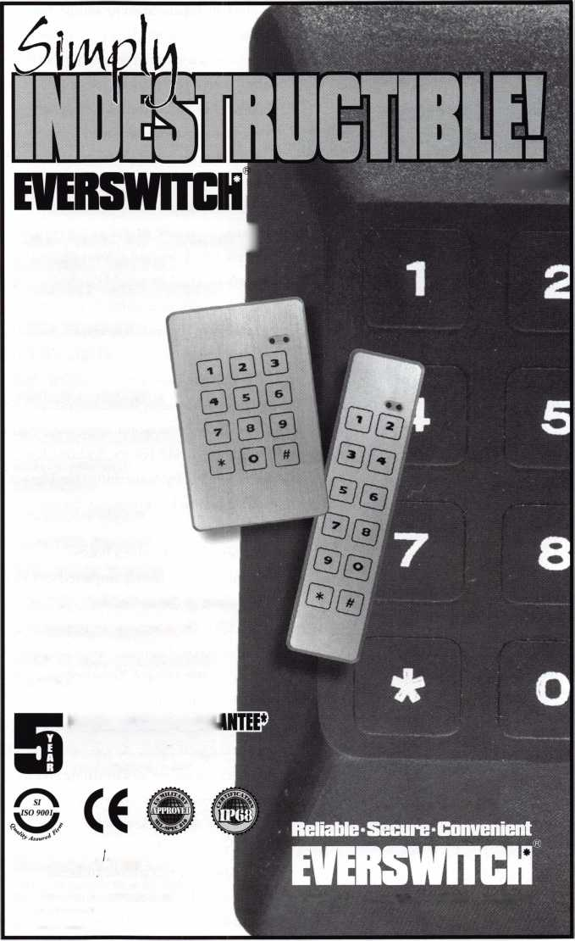

Live and Leai

SrSKES

Above: There's a lot to^mile about at SecureTech. Ted (second from left) and Kristin (third from left) Brickler

UTILIZE THEIR TEACHING SKILLS TO BUILD A STRONGER SECURITY COMPANY.

Opposite: Swimming with sharks!

The family that plays together

ALSO WORKS TOGETHER. SlX'YEAR-OLD

Jeremiah Brickler (left) already

HAS HIS OWN WORK BENCH AND

16-year-old Joel is a trained EMPLOYEE OF SECURETECH.

The old adage, “a mind is a terrible thing to waste” certainly doesn’t apply to Ted Brickler.

The Cincinnati-based locksmith has amassed four masters degrees. Of course, none of which are even remotely related to his current profession as locksmith and owner of SecureTech. Likewise, his previous occupations (as a marriage and family therapist, psychiatric social worker ) were equally disconnected from the security industry.

It may seem odd that after receiving a diverse education and a non-technical career path, Brickler would suddenly turn his attentions towards locksmithing. According to the man himself, it’s really not that strange.

“I’ve always been a mechanic,” he explains. “I have a high mechanical aptitude, so I’ve always looked for things that I could do with my hands. For me, locksmithing started as a hobby. Something that I began tinkering with, but eventually became much more.”

Although it was once a hobby, locksmithing has largely impacted Brickler’s personal and professional life.

In 1990, Ted and his wife, Kristin (a former school teacher) started SecureTech as a pet project of sorts. Together, they created a business plan to construct an operation that would differentiate themselves from other lock shops. Around that time, the Bricklers researched locksmithing and its various facets through correspondence courses and other locksmiths.

“It was originally a mobile service,” said Brickler. “I had started tinkering around with Foley-Belsaw courses and other correspondence classes, but in 1992,1 came

across ALOA. I started taking ACE classes and attending conventions and have been a member ever since.”

As his knowledge in the trade grew, so did the Bricklers’ pet’ project. The first year, they focused strictly on residential accounts, installing high-end hardware. The second year, they branched out into automotive work. By the third year, the mobile service brought in a significant amount of income, which prompted he and Kristin to pursue locksmithing full-time.

Once they opened SecureTech as a full-time venture, both Ted and Kristin utilized their skills in education to effectively train employees.

“We have a different training approach rather than just pushing them out in the field,” he says. “We take them with us to see what we do, then take them out again, so they can actually help us. Progressively, we build them up, so that they’re out there doing it, and we’re helping them. Then, they’re eventually doing it on their own. That’s been a trademark with us. We try to provide quality work.”

“Our education background has helped. It’s helped specifically in our training, in setting clear objectives and the methodology of how to bring a technician from not knowing to knowing.”

The current SecureTech staff includes the Bricklers 16 year-old son, Joel. Presently, their other son, six year-old Jeremiah is still in training.

“He likes to take locks apart,” says Ted. “He has his own work bench in our service center, so that he can work on his locks and keys while we do the same. He takes a lot of interest in it.”

The fact that SecureTech is a family affair

Keynotes

July/August 1999

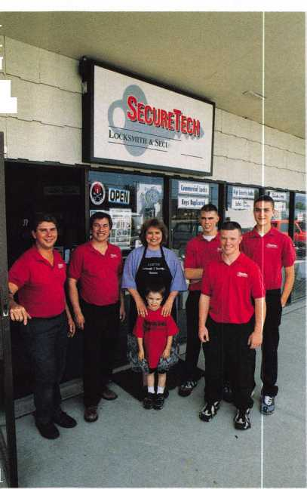

**BY MIKE EMERY**

IN

has obviously factored into its success.

Still, working with relatives can often present challenges when it comes to on-the-job- expectations.

“My nephew works for us. My sister-in- law works here in the office also. That can be challenging,” says Ted. “The expectations are different than someone who’s not family, so there tends to be more flexibility perceived. That’s where employee manuals come in as well as clear, concrete rules and procedures.”

A strong family relationship is important to both Ted and Kristin. Outside of working with relatives, it’s apparent that their location in Mason, Ohio (just adjacent to Cincinnati) is due to long-standing family ties.

Ted was born and raised in Cincinnati and Kristin has also lived there for most of her life. With that, it shouldn’t seem odd that they’ve elected to remain firmly implanted in the area they’ve called home for so long.

In their spare time, the Brickler family enjoys long distance bike riding and has participated in the Multiple Sclerosis 150 mile Bike Rides. Ted says that one of the most scenic rides is through Rails to Trails, 50 miles of bike trails that extend through the city.

The Bricklers also enjoy downhill skiing and get to practice on a 500 foot slope in Lawrenceburg, Ind., although they tend to head to Michigan for ski vacations.

Another reason, the Bricklers are pleased to be based in Cincinnati is the arrival of ALOA ’99- Ever since Ted and Kristin realized the educational benefits of the ALOA conventions, they’ve encouraged and helped their employees attend past shows.

“A few of our technicians have received

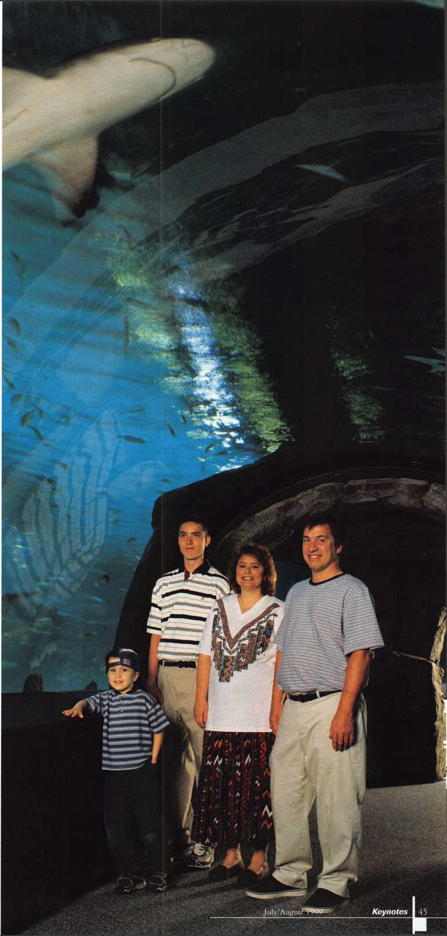

scholarships,” says Ted. “And we’ve helped send them to shows. We expect them to be as involved as possible, so in their absence we handled the slump in business.”

As supportive as they are towards their employees, most people were not so approving of Ted and Kristin’s transition into locksmithing. According to Ted, the decision caused many of their colleagues to turn up their noses.

“Some people look down on this,” he says. “We actually had someone in advertising ask me why I stooped to doing lock work or why was I peddling locks? We don’t perceive it as that. The public needs to be more educated in terms of what lock work really entails, the craftsmanship that goes into it and how locks function correctly.”

Nonetheless, the Bricklers remain unweathered by such snobbery and are immensely proud of SecureTech. Most importantly, they’re extremely pleased with the added educational benefits provided by ALOA, and hope to learn even more at ALOA ’99.

“That’s my favorite aspect of this business,” he says. “I like the fact that there’s constantly new discoveries, new products and improvements. You know, being able to sort through the problems and seeing a security device work the way it should. It’s the consistent learning that I like about this job. I’m just happy to have the opportunity to do that and teach to others as well.”

Sales, master keying, automotive, residential work and more. SecureTech specializes in numerous areas. According to Ted Brickler, the company supports its

EMPLOYEES WHEN THEY ATTEND ALOA CONVENTIONS AND TRY TO HELP THEM GET INTO THE NECESSARY CLASSES.

It's just one way of remaining diverse and well-staffed.

Keynotes July/August 1999

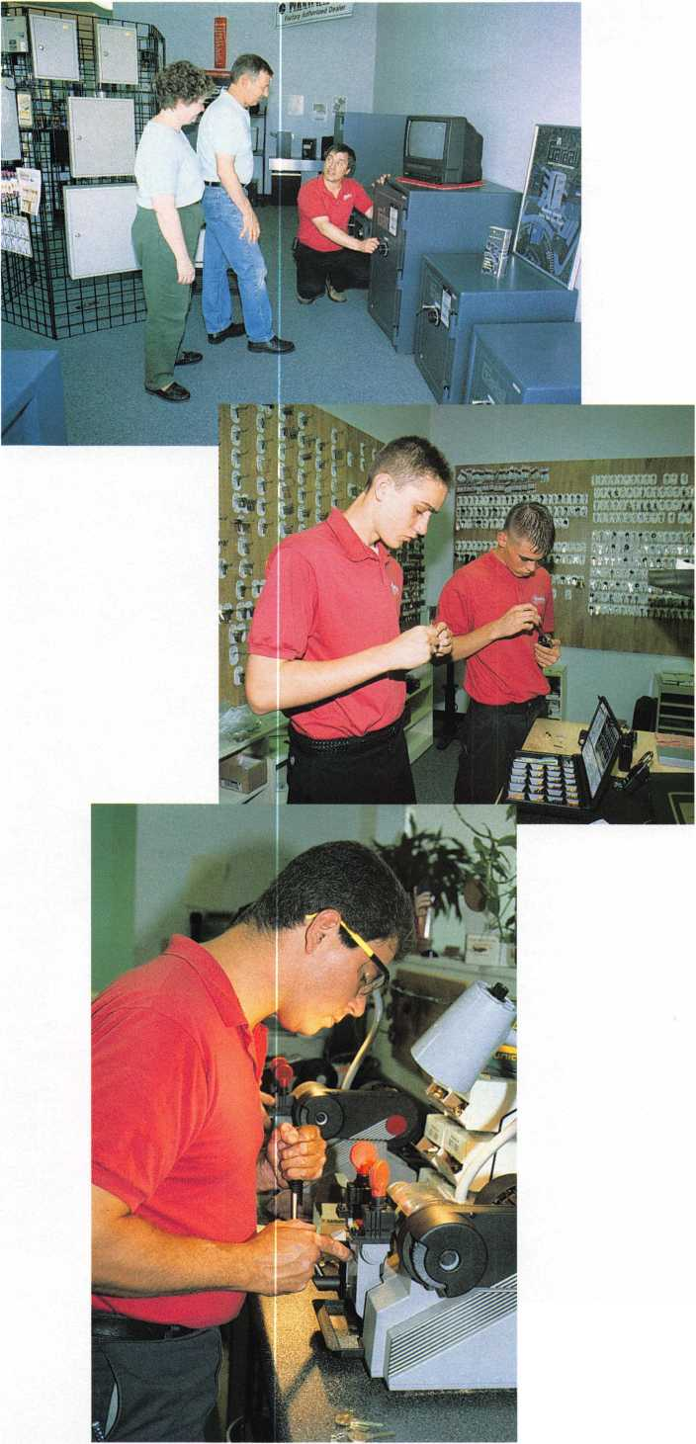

I



**BE A PART OF 1-800-LOCKSMITH!  
USE THIS NUMBER IN YOUR CITY  
& OWN THE MARKET!**

We are looking for qualified locksmiths who want to expand their business

and develop themselves into one of the largest locksmith operations

in their city. You will be authorized to use our logo and name

and we will advertise for you on radio and television.

Interested locksmiths will be able to "secure"

as large or as small a territory as they

desire. Territories will be based

on zip codes.

**Call today for  
more information  
or to sign up!**

THERE ARE 50 REASONS WHY YOU SHOULD JOIN US THIS YEAR.



THE FIRST 49 ARE ALREADY OVER. DON'T MISS THIS ONE!

GPL A 50 th Anniversary Convention

September 15th-19th, 1999  
Radisson Philadelphia International Airport

Free Clinic

Key Squares Breakfast  
Hands-on Training Classes  
President’s Reception

Product Exhibit  
Lock Picking Contest  
Black Tie Awards Banquet  
Friday Night Social

For Further Information:

Reservations Exhibitors

Jack Magee Don Amole

Phone: 609-384-1538 Phone: 215-288-5588

Fax: 609-845-3024 Fax: 215-288-2511

Or visit our website at: [www.gpla.org](http://www.gpla.org)

47

July/August 1999

Keynotes

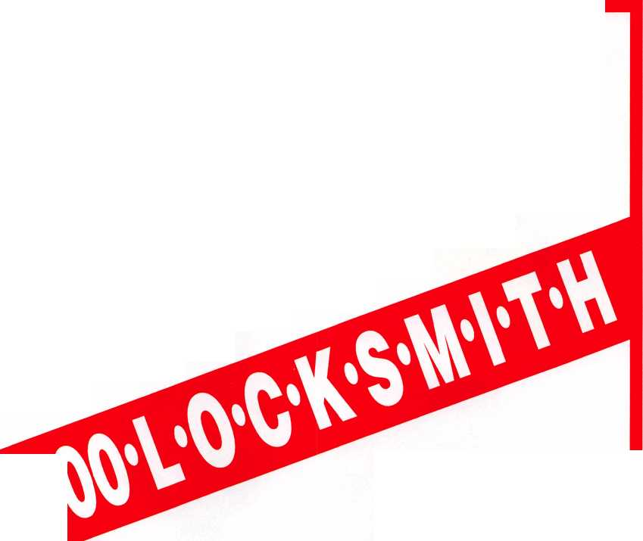

What's The Difference  
Between This Uncoded Lock  
And All The Rest?

No pinning kit required!

That's right. BWD's LockcraftTM brand Premium Pack Lock Kits come complete - lock, lock components, tumblers, tumbler springs, tumbler caps. Just add the customer's existing key and, voila, you have a quality coded lock without purchasing an unwanted and sometimes expensive service kit.

While costing a bit more than their coded and uncoded cousins, Lockcraft^ Premium Pack Lock Kits reduce inventory and eliminate the unwanted purchase of seldom used pinning kits. No more running out of parts while on the job! No more ordering small, expensive bags of replacement parts! All this while meeting the keying needs of every customer.

For a list and pricing of currently available Lockcraft^ Premium Pack Lock Kits contact an authorized BWD distributor, or BWD at (800) 647-4926.

Automotive Corporation - Selma, Alabama

See us at booth 433

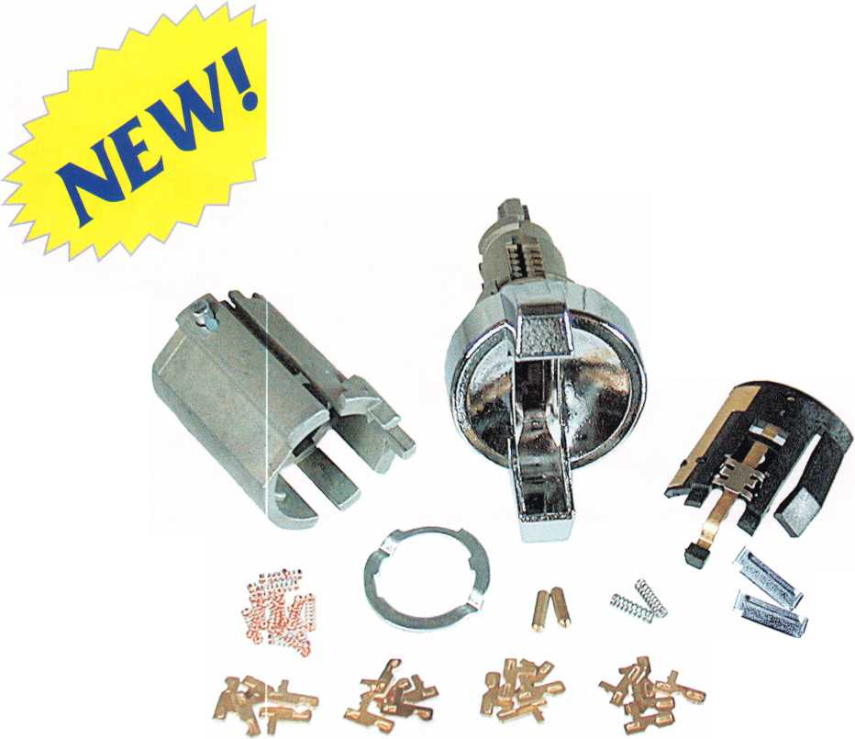

Meilink’s

**by Anelia M. Banda**

This past April, Meilink got “all gussied up” to celebrate its 100th Anniversary at the Derby in Louisville, Kentucky.

In anticipation of this momentous event, Meilink went on a shopping spree. First, it purchased NKL/Gary Safes which catered to the retail market. Secondly, it incorporated the new line into the Meilink family.

Next, the company designed a commemorative anniversary safe, then, pulled out all the stops in preparing a marketing, advertising and merchan­dising program.

The BIG question still remained, “How to effectively introduce the new line and have it stand out from the

competition?” So, in addition to introducing a new product, Meilink is unveiling a new labeling method for rating and comparing safes based upon United Laboratories (UL) rating system and industry standards. According to Van Carlisle, president and CEO of Meilink Safe Company, this new approach “simplifies things.”

Targeting retail shops and store owners, Meilink enlisted long-time customer Larry Smith, owner of Larry’s Locks Safes and Security in Cincinnati, Ohio, as a consultant to help Meilink better understand the ordeal of selling a safe to the consumer.

Larry’s displays over 100 safes. With

each product line are signs, posters and literature. Sometimes this point- of-purchase material overwhelms the consumer to the point of confusion.

“Is the higher priced product better?” “Does the ‘tougher’ name safe offer better security?” “Does the cost equate to the security provided?” “Do I need a big safe for papers and jewelry?”

“Can the kid down the street break into the safe with a crowbar?” “What if there’s a fire, will the contents be protected?” “Which is the right safe to buy?” All are questions sales people have fielded.

**How do you tell the difference?**

Meilink’s labeling method is easy to

|  |  |
| --- | --- |
| Burglary Ratings | Fire Ratings |
| Q designates the safe's ability to protect against unauthorized entry and theft. The number represents the increasing level of burglary protection within the safe line. | Q designates the safe's ability to protect contents against fire damage. The number represents the time frame of the UL test the safe has passed. Icons with a (+) represent that the safe has earned UL's impact rating. |
| Theft resistant | Fire resistant unrated insulated safe |
| (?) UL RSC label | UL class 350 1/2-hour fire label |
| ^) Non-rated anti theft | UL class 350 1 -hour fire label |
| (?) ULTL-15 label | UL class 350 1-hour fire & impact label |
| 0) ULTL-30 label | UL class 350 2-hour fire label |
| (?) ULTL-30X6 label | ^ UL class 350 2-hour fire & impact label |

July/August 1999 Keynotes

read, understand and see. All Meilink safes incorporate at least one of the two basic characteristics in its security performance: theft resistance and fire and impact resistance.

Each feature has a specific icon. The theft icon is a padlock, while the fire and impact resistance symbol is a flame.

**Meilink Labels Safes**

Further delineating rating and performance within each feature are numbers. “For instance,” Carlisle says, “in theft-resistance, T’ indicates minimum security. A ‘6’ means the

safe has been UL tested to resist a break-in using industry tools, such as a torch or diamond-tip drill bits.

“For fire, the number in the flame corresponds to how long the contents will be protected. ‘FR’ is fire resistant, but not UL rated; the icon with ‘lh’ has been UL tested and approved for one hour, and so on.”

But what if the safe isn’t on the ground floor? “In that case,” continued Carlisle, “Meilink fire- resistant safes have impact ratings.

A ‘lhr+’ or ‘2hr+’ symbol means that after one hour or two hours (respectively) of being exposed to

fire, the safe will withstand a 30-foot drop.”

What does Smith think of the new labeling system? “I think it’s excellent! Now I can discuss needs and performance before price.”

For additional information, call Meilink at 1.800.MEILINK.

Go On Safari will  
SERLAC ‘99

Bag your limit on educa-  
tion August 18-22,1999

at tfie "Orlando Marriott"

Downtown

17 Classes & Seminars  
l day & 2 day classes

Al oa Ace classes - Basic electricity w/ Paul  
chandler; Life Safety w/ James Glazier; Access  
Control wl Paul Chandler; CCTV w/ James  
Glazier; Masterkeying I & II w/ Jerome Andrews  
(2-day).

Lockmasters Safe Servicing w/ Brian Lamh; Business Financials  
w/ Virl Mullins; Lockmasters Electronic Safe Locks w/ Brian  
Lamh; High Security Auto & Transponders w/ Michael Hyde;  
Domestic Auto/BWD w/ Tom Seroogy and Basic Locsmithing &  
Installation w/ Larry Patton & Norm Ritz (2 day)



“srRtas"

TDH I-UU (Aitor

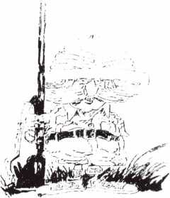

Trade s&ow on Saturday witli oyer 80 bootts &

5 - $1,000. giveaways plus many otter door prizes.  
Sat. nite banquet - TRe Premiere” Mystery Dinner tteater.

6tb Annual Golf Tournament I

For a registration packet call-1-800-845-5294

Keynotes

July/August 1999

**We've Unlocked the Secret to Selling Safes!**

**Introducing Meilink's New Sales Promotion Program.**

**Secure more sales and increase profits with Meilink’s sales promotion program, the safe industry’s first comprehensive dealer**

**marketing package. It starts with a Meilink**

**exclusive. A fire and burglary rating system that**

**simplifies comparison shopping for consumers**

**Meilink follows through with promotional**

**materials, attractive displays, and other**

**persuasive marketing tools that practically**

**push Meilink safes into your customer’s hands**

**Put Meilink’s marketing power to work and**

**watch our complete line of composite, plate,**

**and cash-handling safes leap to the top of**

**your best-seller list**

**Come visit us at ALOA Booth #305**

**For more information contact Grant Hart at:**

**1-800-MEILINK**

**111 Security Parkway**

**New Albany, IN 47150**

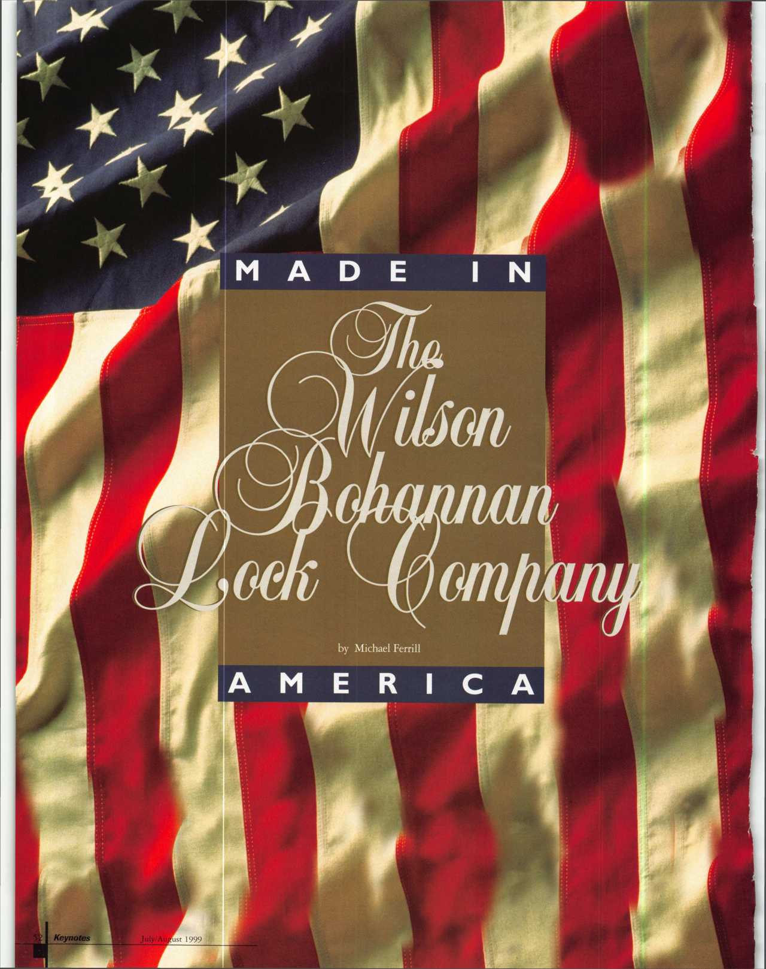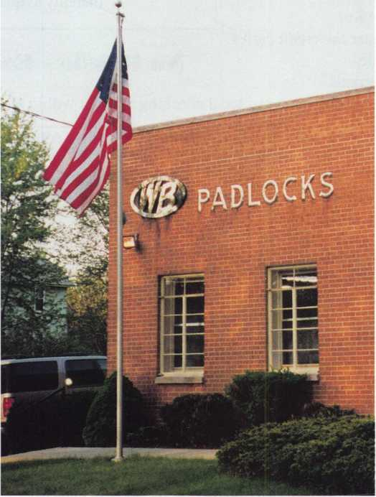

was crossed with much difficulty. After  
sailing back to the city of Baltimore, their  
partnership was soon dissolved.

Wilson Bohannan took his family to New  
York City where he took a position in the  
experimental department of the manufac-  
turing company of worldwide reputation. In  
I860, after years of hard work, Mr.

Bohannan decided to erect a small workshop  
in the rear of his Brooklyn home, and form

his own lock company. With the  
assistance of his 14 year-old son,  
Wilson Todd Bohannan, he laid  
the cornerstone of the present  
corporation.

The venture was successful  
and enjoyed a slow steady  
growth, until it became necessary  
in 1870, to move to larger  
quarters at the corner of  
Broadway and Kossuth Place in  
Brooklyn, New York, where  
“Locksmithing” was practiced on  
a more pretentious scale.

In 1888, the company found it  
necessary again, to move to larger  
quarters. This time on Lexington  
Avenue in Brooklyn, where the  
first of several buildings were  
built including a brass foundry.  
The company began to acquire a  
solid reputation in America as a  
company that produced a fine  
quality solid brass padlock.

With the death of Wilson  
Bohannan on February 22, 1896  
at the age of 68, the leadership of  
this company passed on to Todd  
Bohannan. In 1901, the company  
became incorporated in the state  
of New York. Todd realized that  
the future growth of the company

depended upon the American people buying  
his padlocks for safety and security. Quality,  
reliability, and dependability of his padlocks  
would be the capstone upon which the  
American people would test and use his  
padlock. From the Mill towns of New  
England, to the railroad centers of Chicago,  
St. Louis, and Kansas City, to the farm towns  
in the Midwest, and Great Plains, to  
California and beyond, the American people  
continued to buy and use his padlock. He  
endeavored to stress the importance of  
producing the finest padlocks, made in  
America based upon exceptional quality and

t’s hard to imagine that an

original padlock company still exists in  
America today. With so many foreign  
reproductions of manufactured padlocks  
flooding the hardware section of the local  
supermarket, American manufacturers are  
somewhat scarce.

But as rare as such companies are, one  
domestic padlock manufacturer is still  
thriving (and actually, has done so for over

100 years). That would be Wilson  
Bohannan based in Marion, Ohio.

Before we take a look at this  
organization’s rich history, lets  
examine some of its current  
product offerings.

Wilson Bohannan s standard  
bolt padlock, double ball padlock  
and interchangeable core padlock  
have all of the following features:

1. Solid brass construction that  
   eliminates rusting or corrosion
2. Custom monogramming of  
   company names and logos
3. Restricted key ways for  
   additional security
4. Flexibility of shackle sizes  
   ranging from 5/8" to 8"  
   in clearance (available in brass,  
   steel and stainless steel)
5. Color coding for quick  
   recognition within safety  
   lockout programs and
6. Mortise and rim cylinders  
   to compliment the full  
   padlock line.

Long before it manufactured  
these contemporary goods,

Wilson Bohannan, like so many  
other American institutions  
started from humble beginnings.

In fact, many other successful

Lock Companies were first started in  
America near the turn of the 19th century.  
The legendary entrepreneurs that founded  
these companies grew up in several small  
towns across America. One such skilled  
inventor and successful businessman was  
named Wilson Bohannan. In I860, he  
started the company that bears his name  
today. The Wilson Bohannan Company is  
the oldest family owned lock company that  
still manufactures all of its component parts  
for their locks in America.

Wilson Bohannan, was born in 1828, in Montpelier, Vermont. At a young age,

Wilson Bohannan, possessed a unique and gifted ability in both mathematics and mechanical applications. At the age of 20, he was a partner in a company called Bohannan and Gibson, located in Baltimore, Maryland. Its sole activity was the invention and manu­facturing of lock and bolt devices of all kinds. In 1849, the lure of the golden treasure in California beckoned Mr. Bohannan and Mr. Gibson to close their shop and seek their

fortunes on the west coast. They made the journey on a merchant sailing vessel, which took a long, slow, route around Cape Horn.

Shortly after arriving in the territory, the young adventurers began prospecting and thought they were standing on the threshold of wealth when Gibson was taken seriously ill. Unfortunately, the mining camps of 1849 offered little that could aid a man stricken by a serious illness.

The return from California gold fields was made in a very small vessel to the Isthmus of Panama, where the wilderness

July/August 1999

Keynotes

VISA

ATM

DEBIT

fe CARD

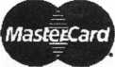

Diners Club International*

Accept Credit Cards  
and Increase Sales and Profits  
by 30% - 50%

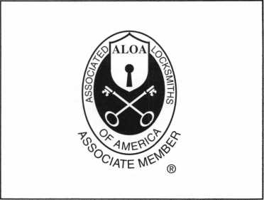

There are three reasons why people don’t accept credit cards:

Through Association Benefits **^** 1. Too expensive.

These Concerns Are Eliminated 2. The paperwork hassle.

3. Inability to qualify.

Here’s how it works:

* Simply swipe or enter the credit card #.
* Enter amount of sale. Hassle - Easy Qualifying
* Approval within seconds.
* Funds wired electronically into your local checking account within 48 hours.

Because of your association membership, nearly 100% of all retail and home based applicants

will be approved even with past credit problems.

Currently Processing Merchants Please Read

Monthly Lease To Own Set-Up Options

Special Low Discount Rate and Transaction Fee: 1.59% + 20<t

Plus Monthly Statement!Customer Service Fee: $10

Package A: $29.95 Terminal

Package B: $39.95 Terminal & Printer In One

Deluxe Package C: $49.95 Portable Terminal/Pnnter/Pin Pad  
Debit acess fee Ability to Accept Visa/MC “Check Cards”

$ 10/mo. & ATM Cards at a FLAT 25*

Totally Himinating the 1.59 % Rate

(All lease terms 48 months • Monthly minimum $25)

**|** I authorize Universal’s sales office to print and deposit a check  
in the amount of $49 (normally $125) for my application fee which  
covers initial materials, application processing, equipment warranty,

shipping & handling, programming, installation and training.

* Fill out a check, tape here above mini form and then fax.

Fax Express Mini Form Now To 1 -800-439-7773

P'Wa*

vou»r rate'°

*°** "* &&?> TO 3SV „

Company Name.

Contact Name

Address

City

OK'.)

State-

Zip.

Phone

Best Time

Signature

New Account Set-up Options (Check)

Package A 3 Package B □

Deluxe Package **C □**

Free Pin Pad Program For Currently Processing Merchants □

A subsidiary of Universal Savings Bank, F.A.

Marketing Office *1-800-836-4295*

Universal Payment Processing Provides 24 Hour Live Customer Service.

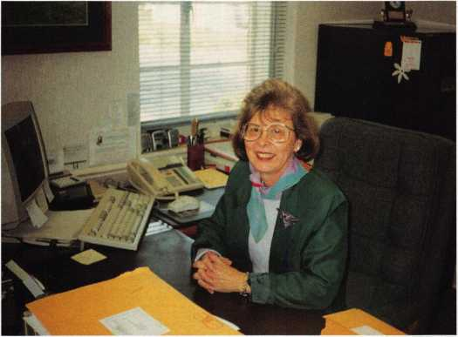

Nancy Walters, VP Marketing & Sales

individual craftsmanship. This continues to this day to be the standard the Wilson Bohannan company sets for every padlock it manufactures.

Wilson Bohannan’s grandson, Wilson Bohannan Tway, saw a need to locate his factory in the middle of America to centralize and enhance the distribution of their products to their customers. In 1927, after several years of searching for the ideal location, the company moved to Marion, Ohio where it is presently located .

Marion was chosen for two reasons. First, it was a railroad hub in the Midwest and their locks were then shipped by rail and second there was a malleable casting company in this city to cast their brass padlocks.

Its continued growth secured, the success of this company passed to the capable hands of Mr. Tway s son-in-law, Stewart Norris, after World War II and a number of years later to his son Dick Tway. Mr. Norris’ son-in-law Howard Smith, is the current President and Chief Executive Officer. Mr. Smith started working in the accounting department in 1973. His sound business practice and natural leadership abilities have enhanced the further development of the Wilson Bohannan Company.

The assistance of Dick Tway’s son Bill Tway, as regional sales manager for the eastern United States, this sixth generation family run business continues to prosper and grow today. In fact, the management team is dedicated to customer service and satisfaction, first and foremost. Starting from the President Mr. Howard Smith , to Nancy Walters, Vice President of Marketing & Sales in the front Office, to the men and women on the manufacturing and assembly floor, the employees pride themselves in their craftsmanship of quality American made products.

This quality is sought by its customers throughout the world. Their locks can be seen in factories, government facilities, military installations, utilities, railroads, refineries and numerous major world corporations where solid brass padlocks are needed.

The story of the Wilson Bohannan Company is a tribute to the legacy of its founder Wilson Bohannan, that has endured for almost 140 years. The Wilson Bohannan company’s total commitment to customer satisfaction, quality construction and precision engi- neering-the values of its founder-remain unchanged today.

A Product Catalog can be obtained from the Wilson Bohannan Company by writing to: Wilson Bohannan Company, PO Box 504, Marion, Ohio, 43301-0504, or by calling 1-800-382-3639, (Fax) 740-383-1653, or by access on the Internet at: [www.padlocks.com](http://www.padlocks.com). The Wilson Bohannan Company is indeed an “American made” lock company.

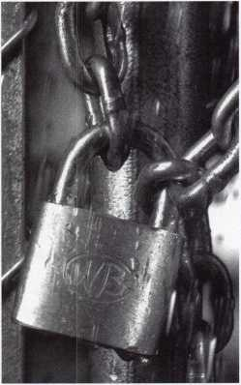

Not to worry it's

RUSTPROOF

And that's why American industry has depended on WB padlocks since 1860

•Available with brass, steel or stainless steel shackles

The all weather, all brass Wilson Bohannan Model #921

•Select from a wide variety of body and shackle sizes •Keyed alike, keyed differently, master keyed-your choice •Regular pin tumbler, removable core locks and double ball locking available •Lockouts, chains and other accessories including color coding also available •Made in America since 1 860 •Backed by a lifetime guarantee •And they're competitively priced

Call 800 382-3639

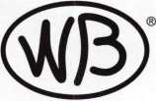

The Wilson Bohannan Company

621 Buckeye Street • Marion, OH 43302 FAX: 740 383-1635

PER YEAR!

LOCKSMITH SCHOOL

me show you how to make a

substantial above-average income by  
training men and women to become  
professional locksmiths.

We offer Administrative, Marketing,  
and Instructional assistance to ensure  
your complete understanding of how  
to start and maintain a profitable

"Hands-on Locksmith School.

Included with the information are  
comprehensive lesson plans and  
instructional video's that thoroughly  
detail every aspect of locksmith  
training.

YOUR INQUIRIES

GOLDEN GATE SCHOOL  
OF LOCK TECHNOLOGY

3722 San Pablo Ave., Dept. A

Oakland, CA 94608  
Phone (510) 654-9425

Fax (510) 654-9429

July/August 1999

Keynotes

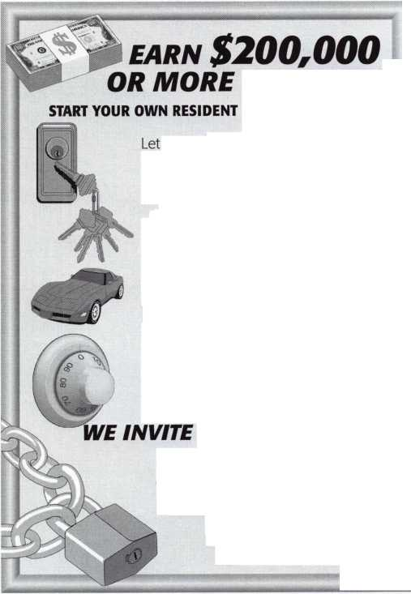

**The Ultimate in**

**Control and Quality**

Visit us at Booth  
#11987

**at the National Hardware Show**

★ 100 Year

[sunt®

***imm***

gH

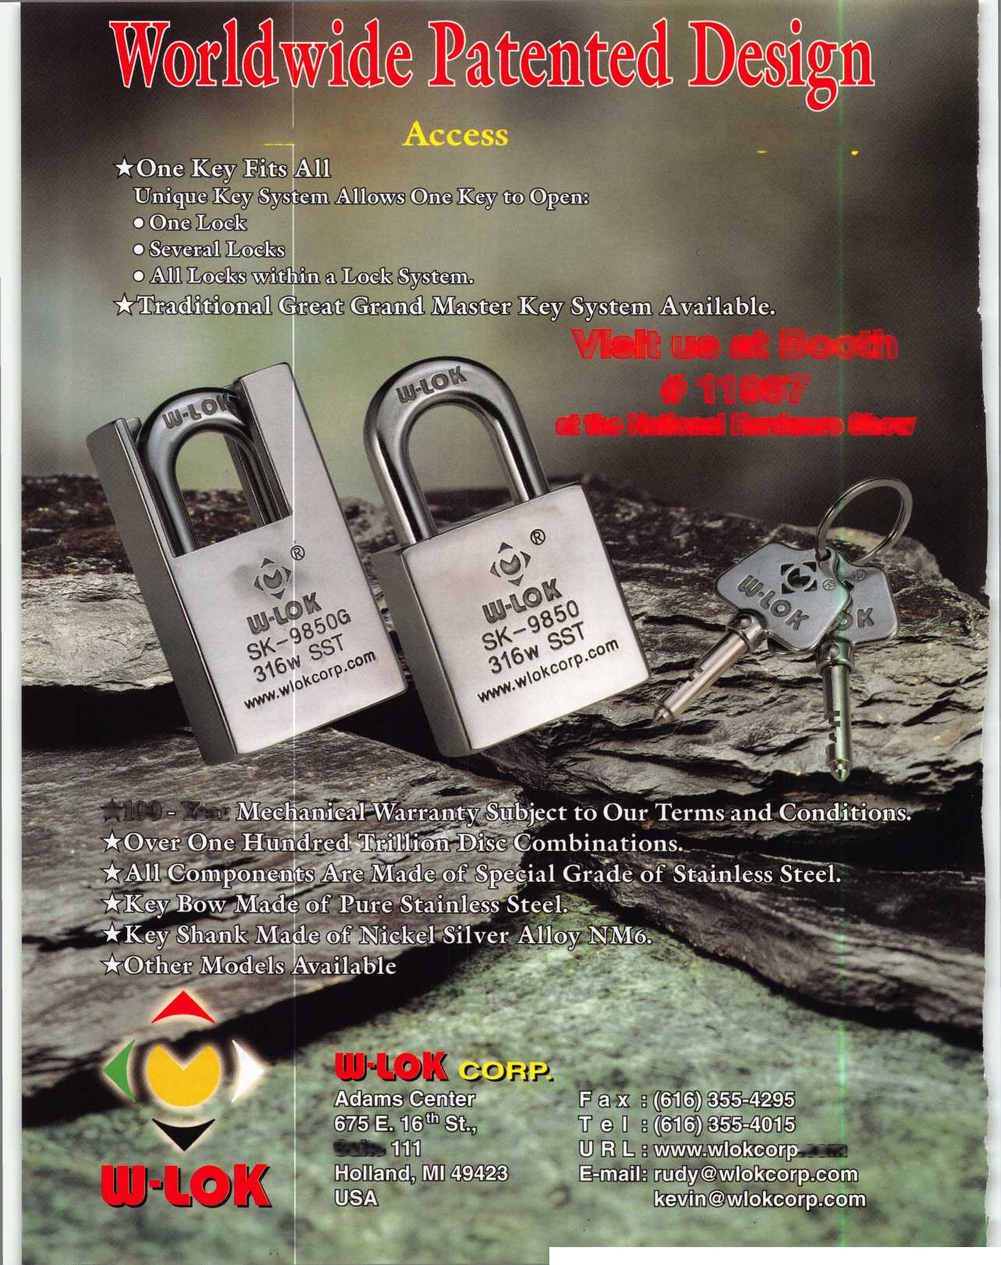

**Igor Ansuevich**

**Stephen E. Barnett**

**Jeffrey A. Chappell**

**Gretar Eiriksson**

1999 ALOA

Scholarship Recipients

By Patanya Johnson

The ALOA Educational Scholarships are granted each year by the Scholarship Foundation to selected individuals who want to enter the locksmithing field or to selected individuals already in the field who wish to advance their professional skills through continuos education.

This year there are 10 ALOA Scholarship recipients. These 10 individuals were awarded the River City Package and a Bonus Sunday Class at the ALOA Convention and Security Expo in Cincinnati, OH, July 25th through August 1, 1999- This package includes four full-day classes, any lab fees, food during breaks and lunches for the classes, half day classes, three days of exhibits, evening seminars and the ALOA Dinner Banquet. These recipients will also be introduced at the Membership Meeting and class lunches.

The following are the 1999 ALOA Scholarship Recipients.

Igor Ansuevich lives in Riga, Latvia.

He has been in locksmithing for 20 years and is currently the president of Anko Ltd. He is a member of ALOA and Latvia Brotherhood of Locksmithing. He would like some education in safe opening and maintenance.

Brian T. Ballotta lives inWoodbridge,

N. J. He is currently employed part-time at Avenel Locksmith in Avenel, N. J. He has been in locksmithing for three years and is a member of ALOA. He wants more education in auto, business and doors.

Stephen E. Barnett is a Certified

Registered Locksmith who lives in Middles- boro, Ky. He is the proud owner and manager of Heartland Lock & Key and has been a locksmith professional for 16 years.

He has been a member of ALOA for nine years. He hopes to gain more knowledge in auto, high security and safes. Stephens outside interests are photography and nature.

Jeffrey A. Chappell lives in

Morristown, Tenn. He is currently taking a bite out of crime as a Loss Prevention Officer for Wal-Mart. He has been in locksmithing for 15 years and hopes to continue his education at ALOA '99-

Gretar Eiriksson is a Master

Carpenter who lives in Reykjavik, Iceland. Both Gretar and his wife are self-employed as carpenters and are the proud parents of four children. He is a member of the Union of Master Carpenters of Iceland. He is interested in the fundamentals of lock­smithing and fundamentals of master keying.

Jeremy Hall lives in Rockyface, Ga. He

is currently employed at A-l Lock & Security in Dalton as a Tech. He has been in lock­smithing for two and a half years and is a member of ALOA. Jeremy desires more education in all the aspects of locksmithing.

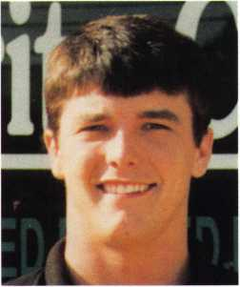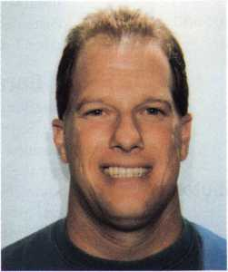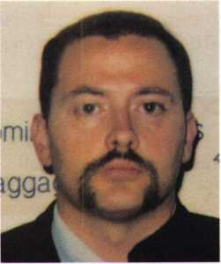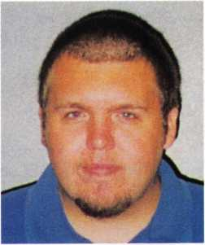

**Jeremy Hall**

**Mark Shaw**

**Brian Wiley**

**Adam Wilson**

July/August 1999

Keynotes

Mark A. Shaw along with his wife and

one child live in Huber Heights, Ohio. He is currently employed at Shaw's Lock & Key where he works as a Locksmith -On the Road. He has been in locksmithing for one year and is a member of ALOA and the Pennsylvania-Ohio Locksmith Association.

Bobbi S. Smith is a locksmith who

lives in Plymouth, Wis., She is currently employed at Plymouth Locksmith. She has been in locksmithing for seven years. She is a member of ALOA as well as the Fox Valley

Chapter of ALOA and the Association of Investigative Locksmiths.

Brian Wiley lives in Princeton, W. Va

along with his wife and four children. He is currently employed by Colgan Air as an Airline Agent. He also works part time as a Weather Observer. He has been in lock- smithing for two years. Brian is eager to take all the classes he possibly can in the field of locksmithing.

Adam Wilson is a Certified Registered

Locksmith who lives in Knoxville, Tenn.

He is employed at Knoxville's oldest locksmith company The F.M. George Safe & Lock Company as an Apprentice Locksmith. He has been in locksmithing for two years and is looking forward to attending an ALOA Convention for the second time. Adam has been a member of ALOA for two years and hopes to further his knowledge and experience as a locksmith.

He hopes the chance he's been given as a recipient will bring him closer to taking the PRP. He also is on staff at the Hidden Valley Group Home for 16 foster children. Away from work Adam enjoys spending time with his one year old son Micah Job and his wife Mary. He also studies film and video, he enjoys making freelance videos and watching and participating in sports.

**Where Are They Now?**

Here’s a look at some past scholarship recipients and what they were able to accomplish with the education they received at ALOA conventions.

Jane, Steve, and Ronald

Raban I Husband and wife, Steve and Jane received their scholarships in 1988. Jane received another one last year along with son, Ronald. Currently, mother and son, are overseeing S&J Security Lock & Safe in Flagstaff, Ariz. while Steve still lends a hand providing technical advice. “My son has learned a bunch of things thanks to the scholarship,” says Jane. “He’s running a van by himself and learned a lot about the motorcycle stuff. And I took a lot of safe classes. The classes last year were very beneficial for us.”

Robert DeWeese, CPL,

a locksmith for 18 years, was the proud recipient of a scholarship in 1993. He is very active within the Maryland Locksmith Association and plans to mn for president this year. He’s also a contributing author for Keynotes. “The classes I took taught me to improve my business and better serve my customers,” he says. “That was at a time when I needed help to do that.”

Gordon Racine, CML,

is serving on ALOA’s board as Director for the Southwest division and runs his own business. “I was just starting out when I got the scholarship,” he says. “I really didn’t know much about anything. The classes I had previously taken weren’t enough, so I was trying to get all the education I could. And at that time, I really didn’t have that much money, so it really did help me get a good start.”

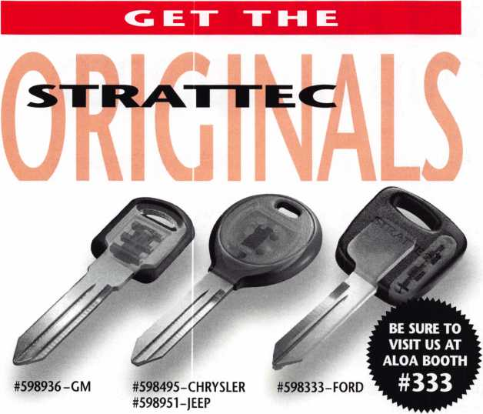

OEM KEYBLANKS.

When it comes to automotive locks and keys, look no further than STRATTEC: the original original. STRATTEC is the innovation leader in vehicle security, and we've been at it since 1914. STRATTEC continues to hold a big lead as the OEM supplier for almost all North American production. 62% of Ford, 92% of GM, and a whopping 100% of Chrysler vehicles come off the line and hit the road with genuine STRATTEC parts. For security, reliabilty, and unmatched service and support, you can't beat STRATTEC parts. The original originals.

jl| **STRATTEC"**

For more information, please call  
your STRATTEC authorized wholesale lock distributor



Keynotes

July/August 1999



**Dedicated to Excellence  
Expert Direction**

**Knowledge of Codes and Standards  
Technical Expertise  
Professionalism  
Experienced Advice  
An Industry Resource**

To be certified as an Architectural Hard­ware Consultant (AHC) or Certified Door Consultant (CDC), individuals must dedi­cate many years to the architectural open­ings industry. Their knowledge of the total openings industry within the commercial construction arena is unparalleled, giving them an edge over the competition. Use of the official Seal signifies the consultant as being required to maintain his or her knowledge through continuing professional education. Look for this Seal on hardware schedules, door schedules and drawings, letters and other documents. It indicates commitment, expertise and quality.

For a copy of a brochure listing consultants in your area, contact the Door and Hardware Institute, 14170 Newbrook Dr., Suite 200, Chantilly, VA 20151-2232; 703/222-2010; fax 703/222-2410; e-mail [techdept@dhi.org](mailto:techdept@dhi.org); or access the information through the Institute's website: [www.dhi.org](http://www.dhi.org).

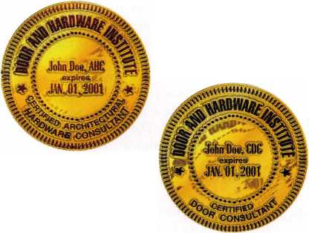

GPLAT

**By Evelyn V. Wersonick, CML, CPS**

GPL A celebrates:

* 50 years of education and the sharing of technical information.
* 50 years as leaders of the industry.
* 50 years of fellowship with all locksmiths.
* 50 years of service to the locksmiths of the area and of the world.
* 50 years of recognition of service to the industry.

How did this all start? Recognizing the need for locksmiths to band together in an effort to enable education and advancement in the trade, the Greater Philadelphia Locksmiths Association was founded on October 5, 1949 at a meeting at the shop of Joseph Carson, who became its first president. The other members present at that very first meeting were: E. Daniels, Edward Pfeil, Sr., William Rhoads, Sr., William Rhoads, Jr., Louis Jay, Abe Kroll, A1 LaBoda, Herb Shenker, Robert Nelson, William Stute, Eugene O’Brien and Samuel Zeldin.

These men had the following goals for the organization:

* To promote and to further the interest of the locksmith craft in Greater Philadel­phia and its vicinity.
* To inspire in the public, confidence in and reliance upon the locksmith craft.
* To give moral, social and public support to fellow locksmiths.
* To exchange technical information and data with other members of the Association.
* To render to its members reasonable aid, technical assistance and cooperation whenever called upon for such assistance. These ideals later became part of the by­laws and are adhered to conscientiously by its members today.

The history of ALOA is closely tied to the GPLA as members of that association helped in the organization of ALOA and have continued to support our national association over the years. In fact, the first public display of ALOA’s charter took place at a Philadelphia meeting.

Part of the success of the Greater Philadelphia Locksmiths Association is due to its constant recognition of individuals who have contributed to the progress of the profession of locksmithing. The Hermann Henssler, Jr. Award, which recognizes those members who have contributed to the growth and stature of the GPLA, was established in 1962. The Lee Rognon Award, sponsored by the Philadelphia Forum, is presented to individuals who have fostered cooperation among the associations of the world. GPLA has not neglected our Manufacturers and Distributors, either, as they present the Industry Award and Distinguished Distributor Award to firms or individuals who have served notably in their categories. The newest award, the Gerald J. Connelly, Jr. Pioneer Award is presented selectively to a firm and/or individual for innovative contributions to the craft in the categories of leadership and education.

The coveted and prestigious Philadelphia Award was established in 1953 and annually recognizes “an individual who has made a commitment to the craft by showing leadership and inspiration to others; a person who shares his or her talents through education or by writing related articles or books; an individual active in Industry Associations, local or national, in an on-going relationship; or who has designed and/or manufactured items that have improved our profession.” A Philadelphia

Award recipient must exemplify one or more of these criteria, be nominated in writing and be recognized nationally, and at times internationally, for continuing devotion to the craft.

Having skipped over the Fellowship part,

I would like to expound on that for a bit.

The social functions connected with the annual Philadelphia Convention may well be the most beneficial part of it all. What more pleasant way to learn the craft than by associating with some of the most prestigious and learned security people in the world? Anyone who has a banquet ticket is also invited to the Friday night social-loads of fun and plenty of opportunities to meet the greatest of the great.

The cocktail party preceding the Awards Banquet is among the most impressive I’ve attended. I am especially impressed with the number of handsome men (you know how great they look in those tuxedos, which are not required but certainly desirable as far as I’m concerned). Could these possibly be the same guys who were in class yesterday? Anyway, you get the picture, they know how to throw a good party! And you learn a lot at the same time.

As they prepare to celebrate 50 years of service to the locksmiths of the Philadelphia area, and, indeed, the world, the members of the Greater Philadelphia Locksmiths Association cordially invite all to attend their 50th Anniversary Convention September 15th through 19th. There will be three days of classes, a product exhibit which has grown to be one of the best in the country, and the gala Awards Banquet.

Let’s all help them greet and honor the 1999 recipient of the Philadelphia Award. God willing, I’ll be there and I hope to see you there, too.

Keynotes

July/August 1999



mmm

**A duplicate key can come back to bite you.**

**^EVEREST. Introducing a new patented key control system from the industry leader in life safety and security. Schlage's Everest™ family features a distinctive new key and includes a complete line of open and restricted keyways, allowing you to select the level of key control you desire. The Everest product line is protected by new utility patents to prevent the manufacture and distribution of aftermarket key blanks by anyone else but Schlage. A full range of Everest cylinders and locksets are available to retrofit into your existing door hardware or for new construction. Find out how Schlage can assist you in**

**managing your key system to improve security. Call us  
at 1-800-847-1864 for more information.**

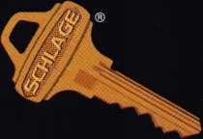

SCHLAGE

***Qain control. Keep control.***

**INGERSOLL-RAND**

**ARCHITECTURAL HARDWARE**

Ingersoll-Rand Architectural Hardware Group, Schlage Commercial Lock Division ©1999 Ingersoll-Rand

**Schlage Redefines the Patented**

**Key for**

Having spent so much time in  
commercial locksmithing myself, it gives me  
great pleasure to announce Schlage’s new  
cylinder with patented keys that locksmiths  
will love.

Why would you love a key? The main  
reason is, you don’t have to lose the majority  
of your key duplication business to dime  
stores, home centers, etc. Furthermore, your  
end user customers are guaranteed of sturdy,  
original Schlage quality key blanks for all  
keys and they won’t be getting keys made at  
the shopping mall where key machine  
accuracy is questionable and there are no  
trained locksmiths.

I’m talking about Schlage’s new full size  
Everest™ cylinder which is hitting the streets  
for new Schlage master key systems as you  
read this. The blanks are patent protected  
but one family of keyways is sold openly, the  
same way C and E keyways have been sold by  
Schlage for decades. However, Schlage is  
limiting the sale of Everest cylinders and key  
blanks to its commercial channel.

Residential and retail Schlage customers  
do not have access to Everest cylinders or key  
blanks. Furthermore, Schlage commercial  
distributors are not permitted to sell Everest  
into residential or retail channels. The new  
keyways are strictly for contract hardware  
dealers and locksmiths.

What could be better news than that?  
Quality and value. Since they are the new  
default keyways, locks and cylinders with  
Everest open keyways don’t cost any more  
than their Classic keyway counterparts! They  
are now the default keyways for new Schlage  
commercial master key systems. That means  
you better contact your Schlage distributor  
to order a supply of blanks and cylinders

right away!

**What is Everest?**

Everest " is the name  
given to a growing  
family of patented key  
products being  
introduced by Schlage.

Everest products are

distinguished by the patented undercut  
groove milled into the right side of the  
key blade.

The first product in this family was the  
small format interchangeable core (SFIC)  
introduced in December 1998 to retrofit  
7-pin Best style IC products. See my article  
in the December 1998 issue for that product.

The article at hand covers the full size  
Schlage Everest cylinder, available in mortise,

i Ul c

r

Patented

Undercut

Groove

j

!

!

4

I

j

/

I

I

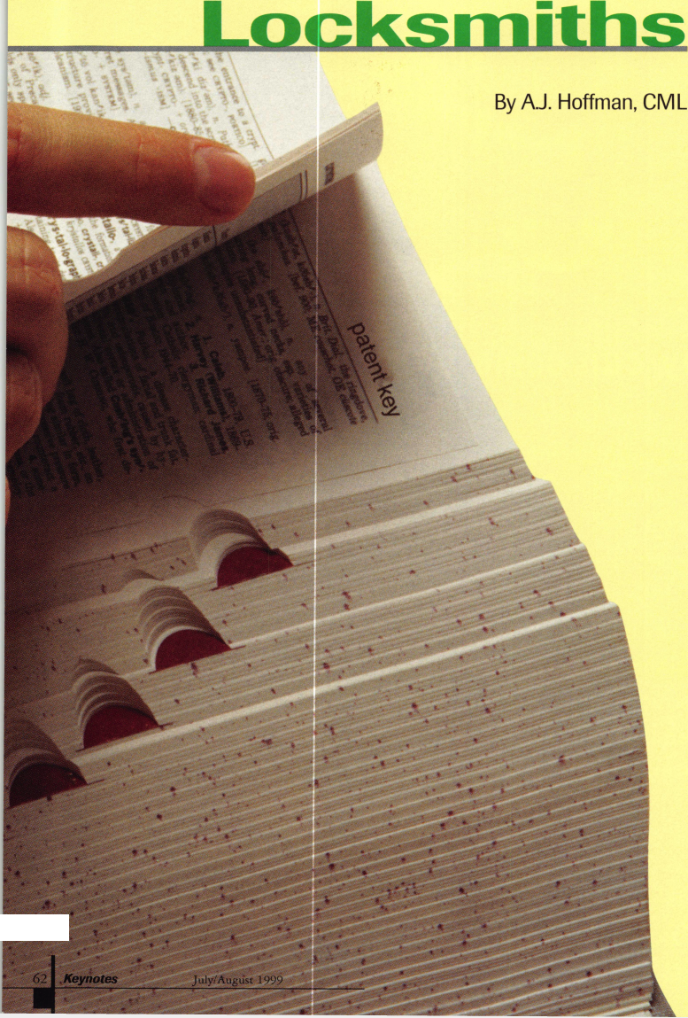

rim, key-in-knob/lever versions as well as Schlage’s 23-030 full size interchangeable core. Schlage has adopted the term “full size” to distinguish its traditional cylinders with a .505" diameter plug from the small format Best-style core.

Except for the keyway and special pin which checks for the lip on the side of the key section, Everest full size cylinders are virtually identical to Schlage Classic cylinders which have been around since the 1930s. “Classic” refers to all the older keyways and corresponding cylinders.

**Key Control**

Since the late 1960s patents on keys have been used primarily to prevent unauthorized key duplication. Schlage’s new Triad-D Series keyways are no exception but the Triad-C Series open keyways are a major departure from this tradition. The name Triad was chosen because the names of these keyways all start with a letter followed by three digits.

**Open Keyways**

Schlage Triad-C Keyways are protected byU.S. utility patents 5,715,717 and 5,809,816 against unauthorized manufacture and distribution. However, they are sold where the end user wants fast and easy key duplication without a letter of authorization. They are considered “open” keyways which can be stocked and sold by all locksmiths. The purpose of these keyways is to guarantee the end user of strong, genuine Schlage quality replacement keys. These are the new default keyways for new Schlage master key systems. You can cut these keys on a Blue Punch, but you will probably have to replace the top jaw.

**Restricted Keyways**

For end users who want restricted keys with patent protection, Schlage offers its Triad-D Series keyways. These are protected by the same patents and require a letter of authorization from the end user. The difference between the Triad-C and the Triad-D Series is just the keyway. Key cutting and other servicing are identical, as covered in this article. However, Triad-D Series restricted keys cannot be cut on a key bitting punch. A rotary cutter machine is required.

The keyway for each restricted Triad-D Series job is selected by Schlage Lock and registered to the end user. Everest restricted key blanks, cut keys, cylinders and plugs are drop shipped directly to the end user. This creates positive key control by preventing

Here are the distinguishing  
features of the full-size  
Everest keys and cylinders.  
Larger key bow and ring  
hole

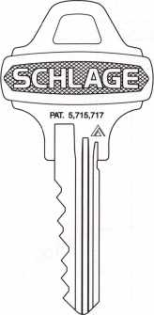

Undercut groove Hole in cylinder shell where keyway and Everest check pin locks into place

logo on plug face

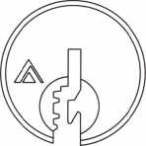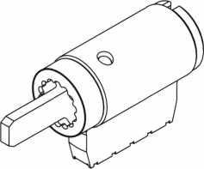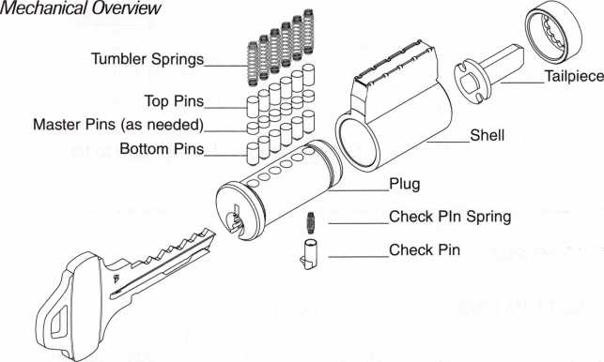

Cross Section

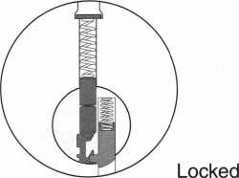

Key-in-knob type cylinders use Primus tailpieces because of the location of the cap pin. Mortise cylinders also use the Primus cam with one screw.

Classic

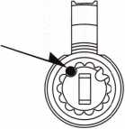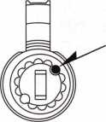

Everest  
& Primus

July/August 1999

Keynotes

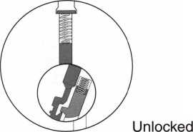

KEY BITTING SPECIFICATIONS:

These specs are the same for Schlage Classic and Everest™ full size keyways.

1.012"

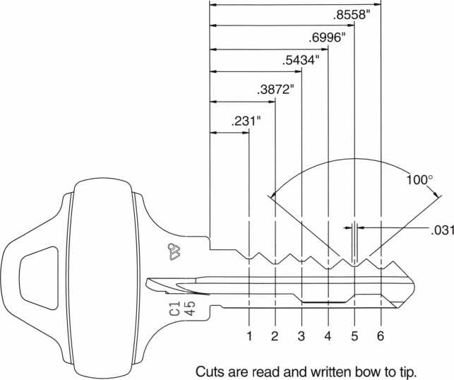

MACS = 7

Increment: Progression: Blade width Depth tolerance Spacing tolerance

.015" Two Step .343"

+ .002" - 0 **±.001"**

Root Depths

1. .335"
2. .320"
3. .305"
4. .290"
5. .275"
6. .260"
7. .245"
8. .230"
9. .215"
10. .200"

PINS & SPRINGS

BOTTOM PINS

MASTER PINS

TOP PINS

|  |  |  |  |  |  |
| --- | --- | --- | --- | --- | --- |
| SIZE | LENGTH | PART NO. | SIZE | LENGTH | PART NO. |
| 0 | .165" | 34-200 | 2 | .030" | 34-302 |
| 1 | .180" | 34-201 | 3 | .045" | 34-303 |
| 2 | .195" | 34-202 | 4 | .060" | 34-304 |
| 3 | .210" | 34-203 | 5 | .075" | 34-305 |
| 4 | .225" | 34-204 | 6 | .090" | 34-306 |
| 5 | .240" | 34-205 | 7 | .105" | 34-307 |
| 6 | .255" | 34-206 | 8 | .120" | 34-308 |
| 7 | .270" | 34-207 | 9 | .135" | 34-309 |
| 8 | .285" | 34-208 |  |  |  |
| 9 | .300" | 34-209 |  |  |  |

|  |  |  |  |  |
| --- | --- | --- | --- | --- |
| SIZE | LENGTH | PART NO. | APPLICATION |  |
| 1 | .235" | 34-101 | Plug total = | 0,1,2,3 |
| 2 | .200" | 34-102 | Plug total = | : 4, 5, 6 |
| 3 | .165" | 34-103 | Plug total = | ■ 7, 8,9 |

OTHER PINS AND SPRINGS

|  |  |
| --- | --- |
| DESCRIPTION | PART NO. |
| Tumbler spring | C503-113 |
| Check pin | 34-007 |
| Check pin spring | C603-951 |
| Cap pin | C503-116 |
| Cap pin spring | C503-115 |

Keynotes

July/August 1999

dealers and distributors from having access to keys and cores without the end user’s permission.

**Primus Integration**

Primus cylinders will be available with Everest keyways in the future. The Primus Everest keys will be downward compatible with the cylinders covered in this article.

The finger pin combination will be milled into the lip formed by the undercut groove. A portion of this lip is milled away on non-Primus Everest keys to prevent them from operating a Primus cylinder in the future.

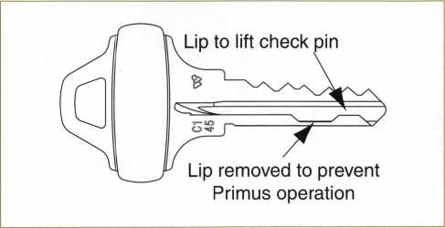

**Master Keying Capacity**

The master keying capacity of full size Everest™ cylinders is identical to that of Schlage Classic cylinders: 4,096 theoretical changes per keyway using two step progression. The MACS is 7.

TouchAccess Lock

**Access Control System**

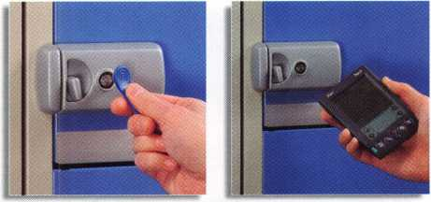

**TouchAccess features:**

* Mechanical lock-activated ONLY with authorized keys
* Programmed with up to 300 authorized keys
* Programmable access times and days
* Authorized entry-records ID number, date, and time
* Stores the last 650 events
* Data retrieved with the Palm III
* Circular bolt for multi-directional installations

**Call for a free information packet today!**

1105 N.E. Circle Blvd., Corvallis, OR 97330 541-758-0521 • Fax 541-752-5285 • [www.videx.com](http://www.videx.com)

**Keying Procedure**

Keying Everest cylinders is very easy, since the only thing different about them is the check pin and spring which go in the special chamber on the bottom of the plug toward the back. If you are using a key to remove the plug, the key will hold these parts in place.

When master keying Everest cylinders, Schlage recommends using a setup key to reinstall the loaded plug.

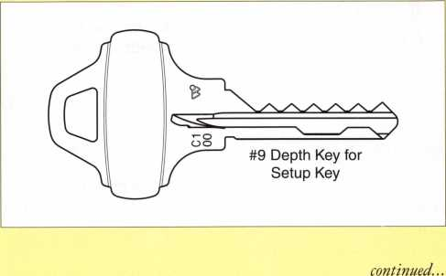

You could roll on out of Cincinnati in this  
1999 Chevrolet Astro Cargo Van  
with locksmith interior courtesy of Adrian Steel!  
One complimentary ticket entry with your convention  
registration. Additional tickets available from the  
ALOA Scholarship Foundation at the Silent Auction.  
Drawing to be held on the show floor during  
the last hour of the last day of the show.

**MUST BE PRESENT TO WIN!**

July/August 1999

Keynotes

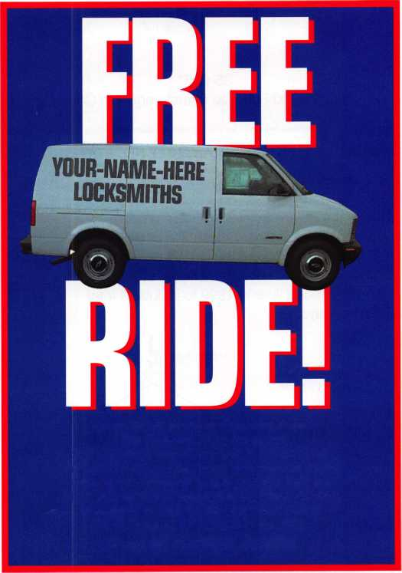

EVEREST™ OPERATING KEY BLANKS

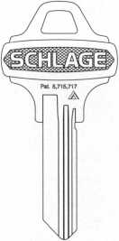

35-009*  
Standard for  
Triad-C  
Open Key  
Sections

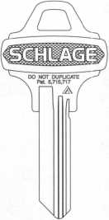

35-002*  
Optional for  
Triad-C  
Standard  
forTriad-D

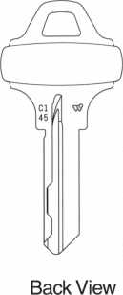

EVERESTM CONTROL KEY BLANKS

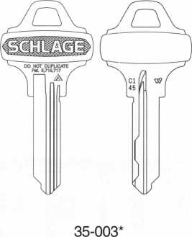

For 23-030 Full Size Interchangeable Core

TRIAD-C OPEN KEYWAYS AND KEY SECTIONS

*Specify key section, e.g. 35-009 C145

Cl 45 is the default keyway for new master key systems, so that’s where most of your demand will be. The keyways toward the left will be somewhat less common. This four keyway multiplex system will be expanded later in 1999 to include a total of ten keyways.

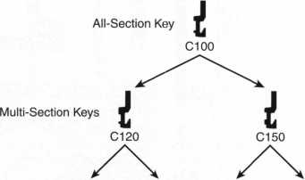

Keyways and Single Section Keys

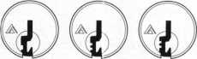

Cl23 Cl24 Cl35



Cl 45

You can make a setup key by cutting a 9 depth in all positions of a key blank. If you remove the steeples between the cuts, the setup key can also hold the check pin in place when removing the plug of a cylinder you had to shim open.

1. Insert any operating key and turn it slightly in either direction. Push the plug out gently with a plug follower.

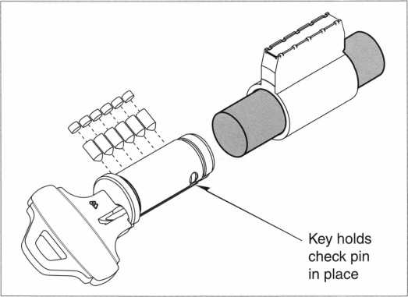

1. While the old key is still in the plug, discard the old pins.
2. Hold the check pin in position with your finger or thumb.

Remove the old key and insert the setup key. If you are certain that the cylinder was not master keyed when you started, skip to step 5.

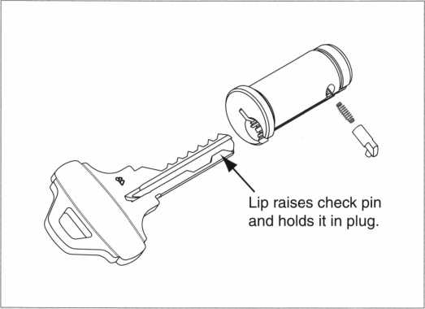

1. Clear the cylinder shell of any remaining master pins. This is extremely important. If master pins remain in the shell, you may experience the following problems:

* A key cannot be inserted or removed.
* One or more springs will get crushed and cause a future lockout.
* Additional keys will operate the cylinder.

1. Install the new bottom and master pins in the plug.
2. Orient the plug so it is turned slightly with respect to the shell

and push it back in.

1. Test all keys for smooth operation. Reinstall the cam, tailpiece,

etc. and you’re finished.

Keynotes

July/August 1999

Rekeying When You Have No Keys

When no key is available you can use standard locksmithing techniques to shim the cylinder open. However, when all six pins have been neutralized by the shim, the check pin still locks into the shell to prevent the plug from turning or being pushed straight out.

You could just depress the check pin through the hole in the cylinder shell, but then you have to worry about it flying out of the plug as soon as the plug is far enough out of the shell to expose it.

Schlage recommends a modification of the setup key described earlier. If you remove all the steeples between the cuts, the setup key can enter the plug while the shim is in place.

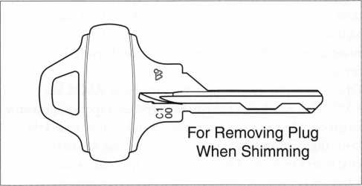

1. Use the setup key to turn the plug slightly in either direction and remove the shim.
2. Push the plug out gently with a plug follower.
3. While the setup key is still in the plug, discard the old pins and clear the cylinder shell of any remaining master pins.
4. If you are master keying, leave the setup key in the plug. Otherwise, hold the check pin in position with your finger or thumb while you remove the setup key and insert the new operating key.
5. Install the new pins, push the plug back into the shell, test the keys and fasten the retainer.

Schlage Everest spacing and pin dimensions are identical to the Classic keyway specs your key coding machines and pin kits are already set up for. If you are using a Blue Punch, remember to obtain the new top vise jaw.

Be ready for the first customer who brings you an open Everest key for duplication. Order your supply of these key blanks from your Schlage Preferred Wholesaler today.

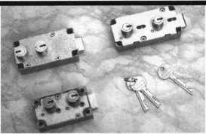

NINGBO WEIGHT

manufactures and exports locks and  
hardware products from China including:  
safe deposit box locks (UL approved),  
tubular latches, gun locks, full series padlocks,  
mortise locks, related hardware, and more!

Join our world-wide customer base.

For more information, please contact us at:

NINGBO Weight Lock Products Co., Ltd.  
FAX: +86-574.7129473 or 7243469  
EMAIL: [gaolei@public.nbptt.zj.cn](mailto:gaolei@public.nbptt.zj.cn)

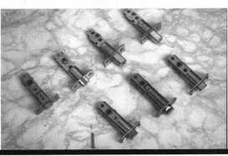

WE’RE KEYED TO

YOUR NEEDS

Our brass key blanks are available in all  
popular numbers. Order 1000 - mixed or  
matched. Packed 50 to a box. $102 per  
1000 (Ford $14 per 100) F.O.B. Detroit.  
Prices subject to change.

*Instock:*

Key Blanks Key Machines Locksmith Tools & Supplies Locks of All Types American & Foreign Automobile Locks Security Hardware (Wholesale Only)

AM1-41C-1041C 'AM3-J41-1046 AR1-135-1179 JR3-N1179A AR4-135A-1179A B1-98M-1098M "B2-H98M-H1098M B5-98DB-1098DB B10-H98LA-H1098LA B11-098LA-01098LA "B24-H98X-H1098X B44-X98E-P1098E "B45-098H-S1098H "B46-X98J-P1098J 'B47-098K-S1098K "B48-P91A-P1098A B49-S91B-S1098B “B50-P91C-P1098C B51-S91D-S1098D B52/B4-98X-1098X BE2-A114A-A1114A BN1-L54P-K1122D -B01/HL2-22B-R1003M CG1-41G-1041G CG2-41GA-1041GA 'CG4/CG3-41GR-1041GR CG16-41R-1041T CG17/KP1-41Y-1041Y CG22-41RB-1041E *C01-20-1000* C03-21EB-1001EB C07-21EN-1OO1EN 'C010-20G-1000G C026-20V-1000V C068-20VS-S1000V C087-22Z2-1001EH JC088/C066-A22Z2-A1001 EH C089-A22GM-A1001ABM C091-A22A1-A1001AH C097-K22-1001GH ~C0106/HL 1-R22B-1003M DE6-54DR-D1054K EA1-61-1014 EA2PEA50-X61F-X1014F "EL10-C1096CN ER1-119-1119

JS8-1502 ~FA1-F54-1054WC JR2-L54G-L1054G H26-127ES-1127ES H27-127DP-1127DP “H50S27-S1167FD H51-P27-1167FD ~H54-PS23F3-1184FD _H60-1190LN H03-170-1170B ~HR1-X61FR-1014C IN1-54F-1054F JN3\ IN20-X54K-1054K IN8-L54B-L1054B JN18-X54F-X1054F IN28-54FN-1054FN JN29-1054UN IN33-54MT-1054MT ~IN35-1054DL K2-79HK-1079B ~_KW1-54KS-1176 LI-35-1004 L4-35A-1004A Ml-92-1092 M2-92B-1092B _M4-U92A-1092V _M10-92N-1092N "M11-92T-1092H "M27/M16-92NR-1092NR _NA12-174BN-1069LA NA24-1069LC NA25/NA6-N174D-R1064E NH1-N102-1177N _RA3-99B-S1970AM RA4-99A-1970AM "R01-62-1069 _R03-174J-1069N RU1-55-1011 _RU4-55P 101 IP RU16-57PA-A1011P _RU45-57-1D-1011D1 _RU46-A57-1D-A1011D1 SI-48-1009

1. 50-1010
2. 050-1010U S6-049KM-N1007KMA "S16-49KM-N1007KMB S22-043LA-01007LA S221/2-43LA-1007LA

'S32-48KMR-N1007RMB 'S68-51S-1010N S69-51SA-L1010N 'SC1-145-1145 SC4-145A-1145A 'SC6-307A-1307A 'SC7-145FS-1145F _SC8-145ES-1145E SC9-145E-A1145E SC10-145F-A1145F 'SC20-145L-A1145L "SC22-307W-1307W "SE1-102-1022 "SE8-102AB-1022AB SK1-R21EN-R1001EN T3-111E-1141E T7-111GE-1141GE WEI-133-1123 'WK2-175W-1175N WR3-54WB-1054WB WR4-54WA-A1054WB _WR5-54WC-N1054WB WR6/FA2-F54A-A1054WC _XL7-XL16-1180S Y1-14-999 'Y1E-E14-999N Y2-14A-999A Y3-14YM-C999 Y4-12GM-998 Y6-7X-997X Y11-7NX-01122 Y12-07NX-01122A Y13-R7NX-01122R Y14-R07NX-01122AR Y52-7E-997E Y54-07E-0997E Y103-07B-01122B Y149-S19-S1770U Y152-P19A-P1770U _Y220-X14S-999B

STOCKING  
DISTRIBUTORS FOR:

A-1 Security Mfg.

Abus Lock Co.

Alarm Lock  
All Lock Co.

American Lock Co.

Arrow Lock

Auto Security Products

B.E. Industries, Inc.

CCL Security Products  
Detex

Don-Jo Mfg. Co.

EMTEK

ESP Lock Corp.

Fort Lock Corp.

Framon Mfg. Co., Inc.

Harloc  
HPC, Inc.

Hudson Lock Co.

ILCO Unican Corp.

Keedex

Keystone Novelty Co.

Key Systems  
KSP

Kwikset Hardware Group  
LAB

Lori Corp.

Lucky Line Products Corp.

Mag. Engs. & Mfg. Co., Inc.  
Master Lock  
Morse Tools  
Multi Lock, Inc.

S. Parker Hardware  
Pro-Lok Co.

Quincy Mfg. Co.

Schlage Lock Co.

Silca

STFIATTEC

Supra

Trans-Atlantic Co.

Trine Mfg. Co.

Wilson Bohannan Co.



Send in order or

V

request order  
form.



1-800-445-KEYS (5397)  
313-931-7720  
Fax: 1-800-828-KEYS (5397)  
Local Fax: 313-931-7758  
9950 Freeland  
Detroit, Michigan 48227

July/August 1999

Keynotes

State of the Association and Financial Report

State of the Association

What a difference one year can make! So many things accom­plished within the last year and on so many fronts!

Perhaps some of our biggest bragging rights can be attributed to our organizations increased versatility. Considering the surge of high tech developments that have popped up within the last year, ALOA has steadily made improvements to remain current in all aspects of technology.

An example of that can be seen in our very own web site. Just a few years ago, no one would have imagined that ALOA would reach so many people via their computers, but now, everyone has an ample opportunity to discover our association.

Just as we’ve been able to adjust our outreach methods, we’ve also taken the time to consistently monitor ourselves and make improve­ments where necessary. The most simplistic illustration (not to mention one of the most effective) can be found within our Education program. The comment sheets that accompany each PRP exam are instrumental in telling us what we’re doing right and what needs to be addressed. Likewise, the class evaluation forms that are handed out during ACE classes have aided us immeasurably in developing effective and detailed curriculum. Those are only two examples, but ones that have allowed us to grow in the short span of one year.

One of the most vital enhancements made to ALOA was obviously our new voting system. Voting by proxy has not only made things more convenient for members, but also strengthens their voices within the organization. It has given everyone direct representation for the region they live and operate in.

As I write this, things also seem to be looking good in the Convention arena. Exhibitor enthusiasm is high and the Education department has been working around the clock to process registra­tions and last minute details.

Likewise, our efforts in legislative issues have grown immensely. Legislative Manager, Tim McMullen has kept busy promoting grassroots activities and maintaining a nationwide watch on laws and bills that can or will affect our industry.

I found myself on the road quite frequently attending an assortment of regional tradeshows, association meetings and chapter meetings. My most recent travels took me all the way to Holland to issue a new European charter. It was quite a cultural exchange and one I’ll never forget.

During my travels, I was also pleased to see an overwhelming sense of unity in our industry, particularly among ALOA members.

I only hope that these bonds continue to tighten in years to come,

so that we’re able to grow as an industry and an association.

Indeed, it’s been a long year. But what a year it’s been! So much accomplished and so much to look forward to. In conclusion, I must say that our association is headed in the right direction. From the quality of education to the loyalty of its members, this is good time for ALOA! With that, let’s continue to work hard, remain active and participate to our fullest potential.

*%SLc4*JL

Dallas C. Brooks

Financial Report

The Associated Locksmiths of America, Inc. (ALOA) engaged the firm of Sutton Frost, LLP to conduct the annual audit of the associa­tion’s financial records for 1998. The audit was completed and a report made on March 2, 1999- Part of the report, the Statements of Financial Position (Balance Sheet) and Activities (Profit and Loss) are included with this report. The auditing firm was of the opinion that the financial records of ALOA fairly and accurately portrayed the association’s financial position.

In spite of a slight increase in revenue for 1998, ALOA lost $170,521. This was due to greater than expected expenses, primarily at convention. The convention was well attended. It provided the excellent education and the quality trade show that was to be expected from this event. The cost of convention was, however, $126,590 greater than in 1997, with a reduction in convention income of $44,278. While the convention remained profitable, the level of profit was much less than needed.

As reported by the President, member services such as education and legislation are being provided faster, better and more frequently without a considerable increase in cost. The ALOA cash position is improving so far this year. Dues revenue is as expected. Convention registration and booth sales are good to date. Expenses for the convention in Cincinnati are expected to be more moderate than last year.

The Safe and Vault Technician’s Association, Inc. (SAVTA) did not make a payment on the principal of its debt to ALOA during 1998. SAVTA made a payment of $15,000 in June of this year. It may be that there will be an additional payment before the end of 1999-

In summary, the financial operations of ALOA for 1998 were not unusual.

The 1998 financial loss is significant, but does not place ALOA in an unacceptable position. It is important that this year, 1999, is profitable as ALOA, like any business, cannot sustain repeated years operating at a loss.

July/August 1999

Keynotes

Associated Locksmiths of America, Inc.

[A Nonprofit Organization]

Statement of Activities  
Year Ended December 31,1998

Revenues:

|  |  |  |
| --- | --- | --- |
| Membership dues and services | $ | 1,043,849 |
| Convention |  | 729,187 |
| Management fee |  | 124,400 |
| Advertising |  | 74,763 |
| Promotional programs |  | 43,303 |
| Interest |  | 14,599 |
| Educational programs |  | 96,086 |
| Miscellaneous |  | 33.328 |
| Total revenues |  | 2.159.515 |

|  |  |
| --- | --- |
| Expenses:  Administrative | 1,124,750 |
| Convention | 555,657 |
| Keynotes magazine | 287,476 |
| Building operations | 46,341 |
| Member services | 81,838 |
| Depreciation | 38,106 |
| Promotional programs | 26,281 |
| Education programs | 161,610 |
| Committee | L2ZZ |

Total expenses 2.330.036

|  |  |  |
| --- | --- | --- |
| Decrease in assets |  | (170,521) |
| Net assets at beginning of year |  | 318,700 |
| Net assets at end of year | $ | 148.179 |

Associated Locksmiths of America, Inc.

(A Nonprofit Organization]

Statement of Financial Position  
December 31,1998

ASSETS

Current assets:

Cash $ 251,078

Certificate of deposit 53,553

Accounts receivable 9,901

Inventory 29,585

Prepaid expenses 98,235

Total current assets 442,352

Property and equipment:

Land 79,836

Building and Improvements 302,516

Furniture and equipment 376,998

759,350

Less accumulated depreciation (516,138)

Property and equipment, net 243,212

Notes receivable from affiliate 258,128

fl 943.692

LIABILITIES AND NET ASSETS

Current liabilities:

Accounts payable $ 99,100

Accmed expenses 19,124

Current maturities of long-term debt 9,484

Prepaid dues 431,127

Prepaid exhibition fees 204,962

Total current liabilities 763,797

Long-term debt, less current maturities 31,716

Total liabilities 795,513

Net assets—unrestricted 148,179

$ 943.692

July/August 1999

Keynotes

Associate

Members

|  |  |
| --- | --- |
| Manufacturers | Arrow Lock Company  10300 Foster Avenue  Brooklyn, NY 11236 (718) 257-4700; FAX (718) 649-9097  99 99 |
| A & B Safe Corp.  171 S. Delsea Dr.  Glassboro, NJ 08028 (800) 253-1267; FAX (609) 863-1208  • • • • | Auto Security Products (A. S. P.)  P.O. Box 10  Redmond, WA 98073-0010 (425) 556-1900; FAX (425) 558-1205  • 9 |
| ASSA Inc.  10300 Foster Ave.  Brooklyn, NY 11236 (800) 235-7482; FAX (718) 257-2772  9 | BWD Automotive  900 Ravenwood Dr.  Selma, AL 36701  (334) 874-9001; FAX (334) 874-6011  9 9 |
| Abus Lock Company  3555 Holly Lane North  Plymouth, MN 55447-0507 (800) 352-2287; FAX (612) 509-9939  9 | Chicago Lock Company  10100 88th Ave.  Pleasant Prairie, Wl 53158-0069 (800) 445-3204; FAX (414) 947-7178  • |
| Adams Rite Manufacturing Co.  P.0. Box 1301  LaPuente, CA 91749-1301 (562) 699-0511; FAX (562) 699-5094  ^ ^ Q | Corbin Russwin Architectural Hardware  P.O. Box 25288  Charlotte, NC 28229 (800) 543-3658; FAX (800) 447-6714  • • • • |
| Adesco Safe Manufacturing Co.  web: [www.adesco.com](http://www.adesco.com) email: [sales@adesco.com](mailto:sales@adesco.com) (800) 821-6803; FAX (562) 408-6427  • | Curtis Industries  6140 Parkland Blvd, Ste. 300  Mayfield Heights, OH 44124-4103 (800) 555-5397  9 9 |
| Adrian Steel Company  web: [www.adriansteel.com](http://www.adriansteel.com)  Adrian, Ml 49221  (800) 677-2726; FAX (517) 265-5834  • | DETEX  302 Detex Dr.  New Braunfels, TX 78130 (800) 729-3839; FAX (830) 620-6711  • 9 9 9 |
| Alarm Lock Systems, Inc.  345 Bayview Ave.  Amityville, NY 11701 (800) ALA-LOCK; (516) 789-3383  9 | Don-Jo Manufacturing, Inc.  P.O. Box 929  Sterling, MA 01564 (508)422-3377; FAX (508) 422-3467  9 9 |
| Aiphone Intercom Systems  1700-130th Avenue, NE  Bellevue, WA 98005 (425) 455-0510; FAX (425) 455-0071  9 9 9 | Door Controls International  2362 Bishop Circle East  Dexter, Ml 48130  (800) 742-3634; FAX (800) 742-0410  119 1 |
| American Lock Co.  3400 West Exchange Road  Crete, IL 60417-2099 (708) 534-2000; FAX (708) 534-0531  • 9 | ESP Lock Products, Inc.  375 Harvard Street  Leominster, MA 01453 (978)537-6121; FAX (978) 534-9109  • 9 |
| American Security Products (AMSEC)  11925 Pacific Ave.  Fontana, CA 92337-6963 (800) 423-1881; FAX (909)685-9685  9 9 | Folger Adam Security, Inc.  16300 W. 103rd Street  Lemont, IL 60439  (630) 739-3900; FAX (630) 739-6138  • 9 |
|  |  |



Associate members of the Associated Locksmiths of America (ALO A) manufacture or distribute materials or equipment, or provide services, for the security industry. Many have donated money, services and equipment to ALOA in addition to their annual dues. Their support of ALOA projects enhances overall membership benefits and we encourage our members to patronize these firms. If you know of a potential candidate for associate membership, please contact the ALOA Membership staff at (800) 532-ALO A. Associate member dues are $500 per year and entitle the payor to use the ALOA logo, and selected discounts on ALOA products and services.

Legend

9 Alarms: Personal, vehicle, electronic, lire, burglar, and exit

V Automotive: Lockout equipment, key chains/rings

® Builders Hardware: Door closers, fumiture/decorative hardware, viewers, emergency exit devices

Books, reference guides, publications, computer software

9 CCTV/Photo Imaging: Cameras, monitors, photo ID equipment, cables

9 Electric/Electronic Security: Card access control and readers, surveil­lance, electric/magnetic locks and strikes, keypads

9 Lock Devices: Auto locks, cylinders, emergency exit/entrance control, locks (various types), strikes

9 Tools & Supplies: Key blanks, cutters, picks, rings/hooks, custom van/truck supplies



***Keynotes***

**July/**August 1999

|  |  |  |
| --- | --- | --- |
| Fort Lock Corp.  3000 N. River Rd.  River Grove, IL 60171 (708) 456-1100; FAX (708) 456-9476 | La Gard, Inc.  3330 Kashiwa Street  Torrance, CA 90505 (310) 325-5670; FAX (310) 325-5615 | Sargent & Greenleaf, Inc.  P.O. Box 930  Nicholasville, KY 40340-0930 (606) 885-9411; FAX (606) 887-2057 |
| •••••• | • • • | • • • • |
| Grobet File Co. of America  750 Washington Ave.  Carlstadt, NJ 07072 (800) 962-7242; FAX (800) 243-2432 | Lucky Line Products  7890 Dunbrook Rd.  San Diego, CA 92126 (619) 549-6699; FAX (619) 549-0949 | Schlage Lock Co.  1915 Jamboree Suite 165  Colorado Springs, CO 80920 (800) 847-1864; FAX (800) 452-0663 |
| • | • | • • |
| H.E.S., Inc.  2040 W. Quail Ave.  Phoenix, AZ 85027 (602) 582-4626; FAX (602) 582-4641 | M.A.G. Engineering & Mfg. Inc.  15261 Transistor Lane  Huntington Beach, CA 92649 (714) 891-5100; FAX (714) 892-6845 | Schwab Corporation  110 Professional Court  Lafayette, IN 47905 (765) 447-9470; FAX (765) 447-8278 |
| • • • | • • • | • |
| HPC, Inc.  3999 N. 25th Avenue  Schiller Park, IL 60176 (847) 671-6280; FAX (847) 671-6343 | MARKS USA  5300 New Horizons Blvd.  Amityville, NY 11701 (516) 225-5400; FAX (516) 225-6136 | Securitron Magnalock Corp.  550 Vista Blvd.  Sparks, NV 89434  (800) 624-5625; FAX (702) 355-5636 |
| • • • | • | • • |
| HID Corporation  9292 Jeronimo Road  Irvine, CA 92618  (949) 568-1600; FAX (949) 568-1680 | MUL-T-LOCK USA, Inc.  300-1 Route 17 South Suite A  Lodi, NJ 07644  (800) 562-3511; FAX (973) 778-4007 | Security Door Controls  3580 Willow Lane  Westlake Village, CA 91361 (805) 494-0622; FAX (800) 959-4732 |
| ® • | • • • | ® |
| llco Unican  400 Jeffreys Road  Rocky Mount, NC 27804 (252) 446-3321; FAX (252) 446-4702 | Master Lock Company  2600 North 32nd Street  Milwaukee, Wl 53211 (414) 444-2800; FAX (414) 449-3114 | Security Solutions  1640 W. Hwy. 152  Mustang, OK 73064 (405) 376-1600; FAX (405) 376-6870 |
| 9 ® ® ® ® | • ® | © ® ® |
| In Out Systems, Inc.  3650-B Matte Boulevard  Brassard, Quebec J4Y-2Z2, Canada (450) 444-5949; FAX (450) 444-4856 | Medeco Security Locks  P.O. Box 3075  Salem, VA 24153  (540)380-5000; FAX (540) 380-5010 | Sentry Group  900 Linden Ave.  Rochester, NY 14625-2784 (716) 381-4900; FAX (716) 381-8559 |
| • ® | • • • | • |
| Intellikey  551 S. Apolo Boulevard, Suite 204  Melbourne, Florida 32901 (800) 226-0703; FAX (407) 724-0811 | Meilink Safe Company  111 Security Parkway  New Albany, IN 47150 (800) 634-5465; FAX (800) 896-6606 | Sully Tools Inc.  3515 Nodding Pine Ct.  Fairfax, VA 22033  (703) 689-3416; FAX (703) 787-0869 |
|  | • | • • • |
| KABA High Security Locks  P.O. Box 490  Southington, CT 06489 (860) 621-3601; FAX (860) 621-9727 | National Cabinet Lock  200 Old Mill Road, P. 0. Box 200  Mauldin, SC 29662 (864) 297-6655; FAX (864) 297-9987 | Taymor Industries, Inc.  1586 Zephyr Ave.  Hayward, CA 94544 (800) 388-9887; FAX (800) 288-8133 |
| • | • | • ® |
| KEY-BAK; Div. of W. Coast Chain Mfg. Co.  1460 S. Balboa Ave.  Ontario, CA 91762 (909) 923-7800; FAX (909) 923-0024 | Newman Tonks  805 N Buckman St.  Shepardsville, KY 40165 (800) 826-5792; FAX (800) 777-8229 | Trine Products Corporation  1430 Ferris Place  Bronx, NY 10461  (718) 829-4796; FAX (718) 792-9127 |
| • • • • | ® ® | • • • |
| Knaack Manufacturing Co.  420 E. Terra Cotta Ave.  Crystal Lake, IL 60014 (800) 456-7865; FAX (815) 459-9097 | ROFU International Corp.  2004-B 48th Ave.; Court E  Tacoma, WA 98424 (800) 255-7638; FAX (253) 922-1728 | Videx, Inc.  1105 NE Circle Blvd.  Corvallis, OR 97330 (541) 758-0521; FAX (541) 752-5285 |
| • | • • • | • • • |
| LAB Security  700 Emmett St  Bristol, CT 06010  (800) 243-8242; FAX (203) 583-7838 | Rutherford Controls Inc.  2697 International Pkwy, Bid 5 #100  Virginia Beach, VA 23452 (757) 427-1230; FAX (757) 427-9549 | W-Lok Corporation  675 East 16th Street, Suite 111  Holland, Ml 49423 (616) 355-4015; FAX (616) 355-4295 |
| ® | • | • |
| LCN Closers (Division of Ingersol)  121 W. Railroad Ave.  Princeton, IL 61356 (815) 875-3311; FAX (815) 875-3222 | STRATTEC Security Corp.  3333 W. Good Hope Rd.  Milwaukee, Wl 53209 (414) 247-3333; FAX (414) 247-3329 | Weiser Lock Company  6700 Weiser Lock Blvd.  Tucson, AZ 85746  (502) 741-6338; FAX (520) 741-6363 |
| • | • • • |  |
|  |  |  |

**July**/August 1999

Keynotes *Ml*

|  |  |  |
| --- | --- | --- |
| Yale Security Inc.  P.O. Box 25288  Charlotte, NC 28229-8010 (800) 438-1951; FAX [800) 338-0965 | Dire’s Lock & Key Co.  2201 Broadway  Denver, CO 80205  (303) 294-0176; FAX (303) 294-0198 | Hardware Suppliers of America  P.O. Box 2208  Winterville, NC 28590 (800) 334-5625; FAX (800) 334-5635 |
| • • • • | ••••••••••• | • % |
| Zhongshan Hua Feng Lock Products  S Yongning Industrial Roaa Ziaolan Zhongshan Guangdong, China  86-760 227 82 63; FAX 86-270 227 80 63 | Direct Security Supply, Inc.  36 Lincoln Street  Boston, MA 02135 (800) 252-5757; FAX (800) 452-8600 | IDN, Inc.  1000 S. Main, Suite 280  Grapevine, TX 76051 (817) 421-5470; FAX (817) 421-5468 |
| • | ^ @ @ (0 (Q ^ | •••••••••• |
| Distributors | Doyle Lock Supply  2211 W. River Road N.  Minneapolis, MN 55411 (800) 333-6953; FAX (612) 521-0166 | Intermountain Lock & Supply Co  3106 South Main Street  Salt Lake City, Utah 84115 (800) 453-5386; FAX (801) 485-7205 |
|  | ••••••••••• | •••••••••• |
| Accredited Lock Supply Co.  P.O. Box 1442  Secaucus, NJ 07096-1442 [800) 652-2835; FAX [201) 865-5031 | Dugmore & Duncan Inc.  30 Pond Park Rd.  Hingham, MA 02043 (888) 384-6673; FAX (888) 329-3846 | JLM Wholesale, Inc.  3095 Mullins Ct  Oxford, Ml 48371-1643 (800) 522-2940; FAX (800) 782-1160 |
| ••••••• | ••••••• | • • • |
| Ace Lock & Security Supply Co.  565 Rahway Ave.  Union, NJ 07083-6631 [800) ACE-LOCK; (800) ACE-FAX4 | E. L. Reinhardt Co., Inc.  3250 Fanum Road  Vadnais Heights, MN 55110 (800) 328-1311; FAX (612) 481-0166 | Jo-Van Distributors Inc.  929 Warden Ave.  Scarborough, Ontario MIL 4C6 (416) 752-7249; FAX (416) 752-3845 |
| •••••••• | •••••• | ••••••••••• |
| Akron Hardware Consultants, Inc.  2579 South Arlington Road  Akron, OH 44319  (800) 321-9602; FAX (800) 328-6070 | Ewert Wholesale Hardware  4709 W 120th St  Alsip II 60658  (800) 451-0200; FAX (708) 597-0881 | Lockmasters, Inc.  5085 Danville Road  Nicholasville KY, 40356 (800) 654-0637; FAX (606) 885-7093 |
| • • • | • • • • • | • • • • |
| American Security Distribution  4411 E. La Palma  Anaheim, CA 92807 [714)996-0791; FAX (714) 579-3508 | Fairway Supply, Inc.  2631 Lombardy Lane  Dallas, IX 75220  (214)350-0021; FAX (214) 352-4299 | Locks Company  2050 N.E. 151 St.  N. Miami, FL 33162 (800)288-0801; FAX (305) 949-3619 |
| ••••••• | ••••••• | ••••••• |
| Andrews Wholesale Lock Supply  544 S. 9th St.  Lebanon, PA 17042-6608 (717) 272-7422; FAX (717) 274-8679 | Foley-Belsaw Company  6301 Equitable Road  Kansas City, MO 64120 (800)821-3452; FAX (816) 483-5010 | The Locksmith Store Inc.  1229 E Algonquin Rd. Suite E  Arlington Heights, IL 60005 (847) 364-5111; FAX (847) 364-5125 |
| • | • • • • | t 1 i 9 |
| Boyle & Chase Inc.  P. 0. Box 74  Accord, MA 02018-0074 (800) 325-2530; FAX (800) 205-3500 | Fried Brothers, Inc.  467 N. 7th St.  Philadelphia, PA 19123 (800) 523-2924; FAX (800) 541-3489 | M. Zion Company  69 Reade Street 4th Floor  New York, NY 10007 (212) 349-8677; FAX (212) 964-0495 |
| • • • | •••••••••• | ••••••• |
| Clark Security Products, Inc.  4775 Viewridge Ave.  San Diego, CA 92123-1641 (800) 854-2088; FAX (619) 974-5284 | HS&S Wholesale Distributors  12915 West 8 Mile Road  Detroit Ml 48235  (800) 521-2202; FAX (313) 342-7580 | McDonald-DASH Locksmith Supply  5767 E. Shelby Dr.  Memphis, TN 38141 (800) 238-7541; FAX (901) 366-0005 |
| •••••••••• | ••••••• | •••••••• |
| Cook’s Building Specialties  2441 Menaul Blvd. NE; P.O. Box 37320 Albuquerque, NM 87176-7320 (505)883-5701; FAX (505) 883-5704 | Hans Johnsen Company  8901 Chancellor Row  Dallas, TX 75247  (214) 879-1550; FAX (214) 879-1530 | McManus Locksmith Supply, Inc.  P.O. Box 9231,1309 Central Ave.  Charlotte, NC 28299 (702) 333-9112; FAX (704) 332-8664 |
| • ••••• | •••••••• | •••••• |
| DiMark International  3117 Liberator St, Unit A  Santa Maria, CA 93455 (800) 235-2435; FAX (805) 928-8034 | Hardware Agencies, Ltd.  1220 Dundas Street East  Toronto, ON M4M 1S3 (416) 462-1921; FAX (414) 462-1922 | McMaster-Carr Supply Company  600 County Line Rd,  Elmhurst IL 60126-2081 (630) 833-0300; FAX (630) 834-9427 |
| • • • • • | •••••••• | •••••• |
|  |  |  |

***Keynotes***

**July/August 1999**

*It is easy to impress one or two businesses.*

**LEADERSHIP**

*It takes long-term commitment,*

**IS NOT**

*innovation and dedication to earn over 4,000*

**ACCIDENTAL.**

*contracted relationships in an industry.*

Medeco has always been an innovator in the security industry, being the first to offer many industry changing products, programs and services.

* Superior quality products
* Enforced key control program
* Business development programs
* Superior mechanical training
* Huge retrofit capabilities
* State-of-the-art EAC products with dual function credential
* Consumer education programs on high security key control
* End-user sales tools and systems
* Member of the U.S. High Security Council

Be sure to visit the  
Medeco Booth atALOA  
in Cincinnati to see our latest  
electronics innovation!

medeco

**HIGH SECURITY LOCKS** Strong. Secure. Solutions;

An ASSA ABLOY Group company

It pays

to have new faces  
in the crowd.



During 1999  
each ALOA member  
who sponsors  
a new applicant  
will receive $40 in  
Convention Bucks  
(upon clearance,  
and payment of  
application fee and dues).



|  |  |
| --- | --- |
| Monaco Lock Co.  339-345 Newark Ave.  Jersey City, NJ 07302 (800J 526-6094; FAX (800) 845-LOCK | U.S. Lock Corporation  77 Rodeo Drive  Brentwood, NY 11717 (800) 925-5000; FAX (800) 338-5625 |
| • • • | (J) @ (Q 0 ^ |
| Omaha Wholesale Hardware  1201 Pacific Street, PO Box 3628  Omaha, NE 68108 (8003 238-4566 | Webster Safe & Lock Company, Inc.  3020 Millbranch  Memphis, TN 38116 (901) 332-2911; FAX (901) 332-2878 |
| •••••••• | ••••••• |
| Security Lock Distributors  40 A Street  Needham Heights, MA 02194 (8003 847-5625; FAX (8003 878-6400 | Service |
| • • • |  |
| Sentry Security Fasteners  8109 N. University  Peoria, IL 61615  (3093 693-2800; FAX (3093 693-2872 | Alarm Monitoring Service, Inc.  5021 Fairfield St.  Metairie, LA 70006 (504) 454-2163; (504) 456-8737 |
| m © | • |
| Southern Lock and Supply Co.  Box 1980,10910 Endeavor Way  Pinellas Park, FL 33780 (8003 237-2875; FAX: (8003 447-2299 | Allstate Insurance Company  2775 Sanders Road, Suite A5  Northbrook, IL 60062 (847) 402-8196; FAX(847) 326-7509 |
| ••••••••• | • |
| Stone & Berg Wholesale  99 Stafford Street  Worcester, MA 01603 (8003 225-7405; FAX (800) 535-5625 | Diamond Software  2952 N. Expressway  Griffin, GA 30223  (770) 227-7650; FAX (770) 227-1699 |
|  | • |
| Strauss Safe & Lock Company  1801 Second Avenue  Des Moines, IA 50314 (515)288-9571; FAX: (515)288-9752 | Locksmith Publishing Corp.  850 Busse Hwy.  Park Ridge, IL 60068 (847) 692-5940; FAX (847)692-4604 |
| •••••• | • |
| Hmemaster, Inc.  127 SE 29th Street  Topeka, KS 66605  (785) 232-8705; FAX (800) 798-8463 | The National Locksmith Magazine  1533 Burgundy Parkway  Streamwood, IL 60107 (630) 837-2044; FAX (630) 837-1210 |
| ••••••• | e |
| Top Notch Distributors, Inc.  3151 Goni Rd.  Carson City, NV 89706-7922 (800) 722-4210; FAX (800) 248-3620 | Pine Technical College  1000 4th Street  Pine City, MN 55063 (800)521-7463; FAX (320) 629-7603 |
| • • • | • |
| Turn 10  P. O. Box 746  Marietta, OH m45750 (800) 848-9790; FAX (800) 391-4553 |  |
| • • |  |

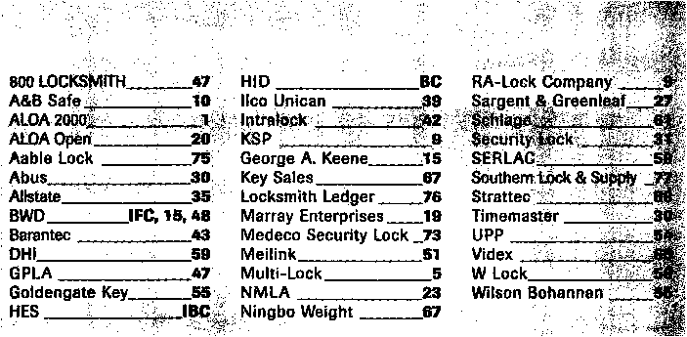

***Keynotes***

**July/**August 1999

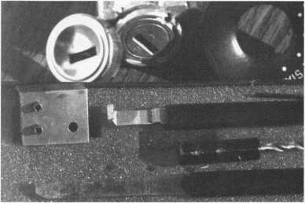

The Innovator

1998 and up GM in-dash ignition removal kit.

Patent #5.454.245.

Removes plastic ring and chrome cap in seconds; makes access hole to pick side bar in, turns cylinder to acc. position. Removes lock in less than five minutes with no damage to lock! Your first job will more than pay for the kit.

Introductory price: $65 (plus $3 for S&H)

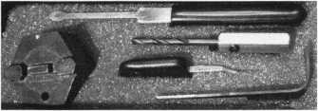

1996 and up 8 Waffer Ford Ignition

Removal Kit and Side Bar Breaker Tool

Patented 5,701,773

Turn ignition to "ON" position in less than (60 seconds) for fast  
removal or use kit to push side bar in. then turn cylinder to "ON"

position without any damage. Fit key, replace same lock. $90.00 + $3.00 S &H

FINISHED LOCK

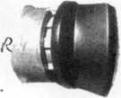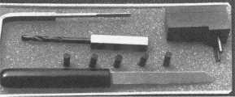

1994 and up 9 Waffer GM Ignition Removal Tool Kit

Patent 5,454,245

A new system for the future. These locks have side bars longer than the

old type and must be in the "ON" position to remove the cylinder. My  
tool will do this. Best of all, you will not damage the cylinder. You can

repair, kit key and replace the same cylinder. Do only one job and you will have the price of the kit paid  
for. A replacement cylinder costs about $22.00, VATS $45 our cost. Order one today at my special  
introductory price, and be prepared for these new locks. $60.00 + $3.00 S&H

‘UPGRADE IT FOR '95 BLAZERS, SUBURBANS, S-10 PICK UPS, ETC ... $20.00 + $3.00 S&H

|  |  |
| --- | --- |
|  | Jb.4 |
|  | r ■ J  / is  / * |

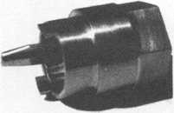

FORD QUICK-ON

PATENT 5,402,661

Now turn most 10 cut ignition  
cylinders to the "ON" position  
for fast removal—in less than

60 seconds. Sable, Taurus, all styles, even with airbags.  
No damage to housing. $65.00 +$3.00 S&H

The GM Persuader patented

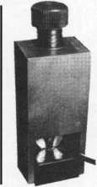

The No-Nonsense Squeeze Lock Plug Remover Patent 5,165,158

Now you can remove all squeeze lock plugs in 15 seconds or less, from all GM, Ford, Chrysler, AMC, Jeep, no more fumbling, gadgets, cut fin­gers, broken tabs, need for 3 hands for removal of lock. It's so easy, you can do it in the dark, while it's still in the glove box.

$45.00 + $300 S&H

This unique tool will open virtually all GM trunks and doors, through the current year, where tool fits into the  
cylinder core cavity, in less than 50 seconds. No drilling, pulling, picking, special tools, or electric needed.  
When customer's key does not open trunk because: Problem 1) spring retainer popped up into outer shell;  
Problem 2) one side of side bar sprung off side bar does not retract; Problem 3) key or cylinder worn side  
bar does not retract; Problem 4) key jammed in lock in "turned" position, etc. With The Persuader you will

open these locks in less than 50 seconds. No damage to lock, just repair and  
replace, nothing to wear out. Yes if needed, it will open with no key. Note:  
because of The Persuader's capabilities, it will be sold to locksmiths only.

$45.00 + $3.00 S&H

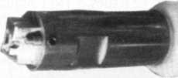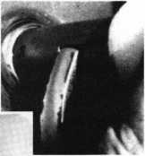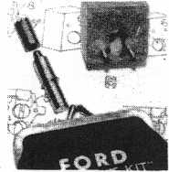

Ford Disc-Out Kit

Patent #4,682,398

A tool kit to remove those stubborn Ford pin ignition locks from 1 976 through  
the current year. These locks incorporate (2) locking devices and a hard steel  
disc across the shear line. They must be in the "ON" position, to release both  
locking devices, so as not to damage the housing. I guarantee the job to take  
5 minutes with my kit. Complete Kit $60.00 + $3.00 S&H

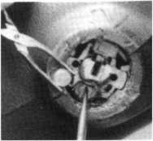

Aable Locksmith ▼91-10 Liberty Avenue ▼ Ozone Park New York 11417 ▼ 718 847 1377 ▼ Fax 718 847 0991

Frank Markisello guarantees all of his products to do as stated or your money back!

**ne f<jr the Security Professional**

OP1LNING  
A WORLD Or  
OrrORTLINiTIE.5

)Tu«ri

Please □ start Q extend my subscription to Locksmith Ledger International

**| 1**3 YEARS (includes 36 issues, 3 FREE Annual Directory* issues)

USA $90.00

"1 2 YEARS (includes 24 issues, 2 FREE Annual Directory* issues)

USA $64.00 Canada $93.00 International (air) $185.00 International (surface) $119.00

**J 1** YEAR (includes 12 issues, 1 FREE Annual Directory* issue)

USA $41.00 Canada $52.00 International (air) $100.00 International (surface) $65.00

’Comprehensive guide to industry manufacturers, distributors, products and services.

**CARD INVALID UNLESS COMPLETE DATA IS GIVEN**

You must indicate your locksmithing affiliation below:

1. Are you a locksmith or an individual involved in locksmithing? **Qyes Qno**
2. Your position is: QOwner/Pres. 3 Employee 3 Student (3 Other (specify)

3 Business classification (check one only): a □Locksmith Shop b QHardware c Q Wholesaler/Distributor d Q Manufacturer eQ Security or Maintenance

1. Q Consultant 3 Q Industrial sQ Government
2. Q Commercial 4 Q Institutional 6 Q Police

g Q Architect/Specifier z Q Other (specify)

4. Are you involved in purchasing or influencing the purchase of locksmith products?

**□yes Qno**

Send payment to: Locksmith Publishing Corp. • 850BusseHwy. • Park Ridge, IL 60068 • Phone:(847)692-5940 • Fax (847) 692-4604 • Website: [www.Ipc.simon-net.com](http://www.Ipc.simon-net.com)

Name:

Company:. Address: _

City:.

. State:.

_Zip:_

Phone: _

.Fax: _

Payment (US FUNDS ONLY): □Money order □Charge Card □Check#:

Complete For Charge Orders Only: QviSA QMaster Card QAmerican Express

Account # :Exp. Date:

Signature:

IM9

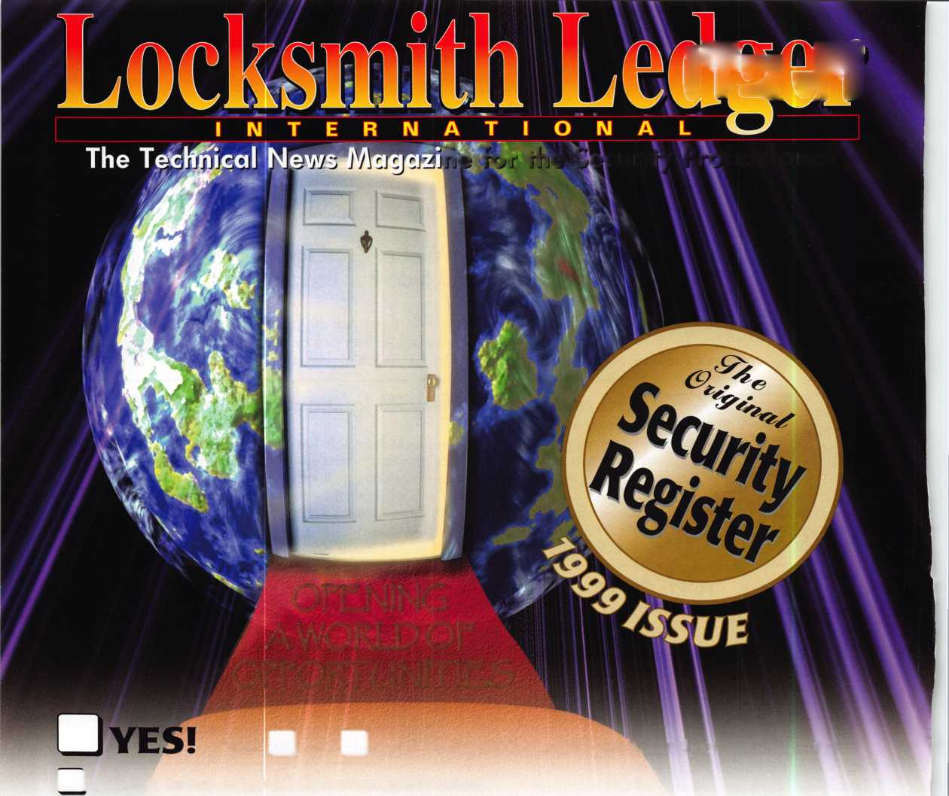

Keynotes

Authors



Dept

Anelia Banda is a freelance writer and security industry insider.

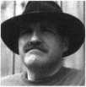

Paul Chandler,

CRL, is the manager of the Electronic  
Security Department for I.D.N. -  
ACME in Houston, TX. He was  
"Keynotes Author of the Year*’  
in 1998 and is currently a  
contributing editor.

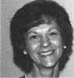

Claire L. Cohen, the

second woman to become a CML, has  
been in locksmithing since 1977 and  
has been in locksmithing since 1977  
and has been writing articles for  
Keynotes since 1987. She is also a  
contributing editor for Keynotes.

Donald B. Dennis, CPL has been dealing with the locksmithing profession since 1972 with a four year apprenticeship in Albuquerque, New Mexico. He founded and has been the

owner of Dennis Safe & Lock in Johnson City, Tennessee since 1977. He was the founder of the East Tennessee Locksmith Association in 1988 and is currently the Chairman of the Education Committee and editor ofETLA Newsletter.

I Sal Dulcamaro,

CML, has been in the locksmith  
business for over 24 years. He is the  
president of All Pro Security, Inc. in  
Michigan and has been an ALOA  
member for 17 years. A past president  
of the Locksmith Security Association  
of Michigan. Sal currently serves as  
editor of the association newsletter. He  
was named "Keynotes Author of the  
Year*’ for 1996 and 1997. He is also  
a contributing editor for Keynotes.



Mike Emery is the

Editor of Keynotes and a freelance  
music, film and real estate writer.



Mike Ferrill is a

third generation locksmith, who lives  
on the Island of Nantucket in  
Massachusetts.

“A. J.” Hoffman is

a recognized authority on cylinders and  
keying. He instructs Comprehensive  
Interchangeable Core, a two-day class  
covering all brands of cores. An avid lock  
collector since age six, he was a commercial  
locksmith before entering lock manufac-  
turing in 1982. He has served several  
terms as member-at-large to the ALOA  
board. In 1988 he was inducted into the  
Locksmith Ledger Security Hall of  
Fame and received the coveted Philadelphia  
Award in 1992. He is currently the  
Product Manager for Cylinders and  
Key Systems for both Schlage and Falcon  
Lock, divisions iflngersoll-Rand. He  
has held similar positions with Kaba and  
Corbin Russwin.

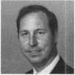

Patanya Johnson

is the Communications Coordinator  
(/Keynotes.



Tim McMullen

oversees legislative affairs for ALOA.  
He is a graduate of the District of  
Columbia School of Law and has  
an extensive background in  
legislative work.

Vicki Morgan is a freelance writer and public relations professional.

Evelyn Wersonick, CML, CPS served as ALOAs president from 1989-91 and has instructed classes for ALOA.

Embark on an Educational and Informative Journey . . .

24

October

Sunday,

1999

until

From

AM

800-282-2837 FAX: 800-447-2299

P.O. Box 1980; Pinellas Park, FL 33780-1980 e-mail: [sales@southemlock.com](mailto:sales@southemlock.com) [www.southemlock.com](http://www.southemlock.com)

Make plans now to attend the Southern Lock ATLANTA TRADE SHOW. Join us at the Holiday Inn Select in Norcross, Georgia on Sunday October 24,1999, and enjoy an oppor­tunity to chat with manufacturers’ reps, fellow locksmiths, and the Southern Lock crew. On Saturday, October 23rd, you can attend one or more of the classes and seminars. There's plenty to do nearby, so bring the family and turn your educational endeavor into a vacation!

The Southern Lock Trade Show, an annual Florida tradition, is coming to ATLANTA! Call Stephanie - toll free - at our main warehouse to register.

JOIN US FOR.:

* Show Specials! • Door prizes! • Plenty of food & drink!

• Product demonstrations! • Classes and Seminars!

* Manufacturers' reps available to answer your questions!

• The Latest in Electronic Access • All of this and its FREE!

Serving the Security Industry Since 1946.

Warehouses in Atlanta, Largo, FL, Oakland Park, FL & Charlotte, NC.

July/August 1999

Keynotes

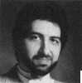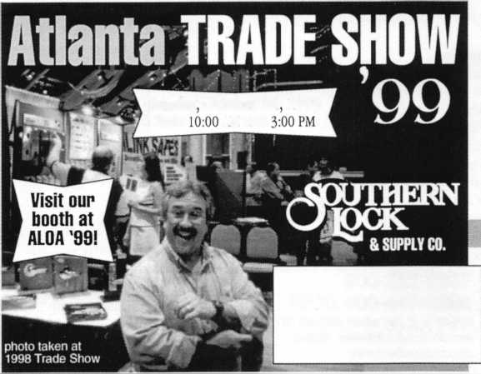

**Keynotes**

Classified



Dept

**j Classified Advertising Policy**

**Classified advertising space is provided free of charge to ALOA members, and for a fee of $.60 per word, $15 minimum for non-members. Classified ads may be used to advertise used merchandise and overstocked items for sale, “wanted to buy” items, business opportunities, employment opportunities/positions wanted and the like. Members or non-members wishing to advertise services or new merchandise for sale may purchase a “Commercial Classified Ad,” for a fee of $1.30 per word, with a minimum of $40. Each ad will run for two issues. For blind boxes there is a $5 charge to members and non-members. All ads must be submitted in writing to the ALOA office by the fifteenth of the month, two months prior to issue date. Send to Keynotes Classifieds, 3003 Live Oak St, Dallas TX 75204-6186. ALOA reserves the right to refuse any classified advertisement that it deems inappropriate according to the stated purpose of the classified advertising section.**

■ EMPLOYMENT Locksmith Wanted

7/F/3: Large Lock Shop in the Palm Springs area of California is looking for an experienced locksmith for field work. Must be proficient in master keying, safety deposit boxes and working knowledge of safes. Salary plus commission, health insurance benefits and a 401K plan.

Please fax resume to:

(760) 779-1811 or call (760) 346-5214.

Locksmiths Wanted

7/F/3: The Los Angeles Unified School District is looking for locksmiths. Industrial/institutional locksmithing skills are essential. The ability to design multi­level master key systems is a must. This is a full-time job with a beginning salary of $21.43 per hour. There are some “A” shift openings; but most of the openings are “B” shift positions with working hours from 2 p.m. to 10:30 p.m. In addition to the regular wages, “B” shift employees also earn a 5 1/2% differential. The District offers an excellent benefit program. It will pay the entire premium for you and your family for your choice of several medical and hospital plans, a dental care plan, a vision plan and a $20,000 life insurance policy. New employees earn two weeks of paid vacation each year, are granted an illness leave bank consisting of 13 days at full pay each year, 87 half days and receive full pay for 12 holidays. If you would like to be automatically sent an application when the filing period opens, please call:

Recruitment Office (213) 743-3551

Locksmith Needed

6/F/3: Immediate openings, Outside Technicians and Inside Technicians in Oxnard, Calif. Benefits plus salary, close to the beach, excellent weather. Fax resume to: Nasons’s Lock & Safe Inc.

(805) 487-8280fax

Salesperson Needed

6/F/3: Wholesale Distributor Seeking Inside Salesperson for its Dallas, Texas Distribution Center. Full Benefits including 401K Retirement Plan. Send resume to:

Accountants Office 6517 Hillcrest, Suite #308 Dallas, TX 75205

Lock & Safe Technicians Needed

5/F/3: King Safe & Lock in Houston is looking to hire experienced and trainee locksmiths. Positions available for dispatcher, inside/outside/sales technician. Established 25 year old company with heavy commercial customer base, servicing architectural door hardware, safes/vaults, master-keying and access control. We offer training to qualified applicants who wish to “earn while learning,” to be a professional locksmith. Experienced lock technicians are paid top wages with a benefit package. Medical/ Dental insurance, retirement plan, uniforms, commissions, trucks furnished and professional advanced training. All applicants handled in confidence, private appointments are available. Please send a resume with a recent photo to:

KSL Inc.

8429 Katy Freeway Houston, TX 77024 (800) K1NGL0K (713) 465-0824 Fax

kinglok@kinglok. com

Locksmith Wanted

5/F/3: California $30-60K plus benefits.

Two years experience minimum. Send or fax resume to:

Speedy Locksmiths Inc.

2517 N. Main Street Walnut Creek, CA 94596 (925) 933-9010 (925) 280-7274 fax

Lock/Safe Technician

6/F/3: Canada’s national safe and lock company requires a Service Technician. Located in Calgary, Alberta, Canada, you will provide service and maintenance to our clients’ physical security equipment. Experience with safes and/or locks is advantageous, but we are willing to invest in the training of a suitable candidate with mechanical ability and/ or aptitude. We offer a competitive salary and benefits package. Please mail or fax your resume to:

John Haining-Regional Manager Chubb Lock & Safe #8, 5708-1st Street SE Calgary, AB T2H 2W9 Canada (403) 255-2222 (403) 258-1702fax

Commercial Locksmith Wanted

5F/3: Located in the middle of God’s country, Charlotte, N.C. We’re a growing progressive, ethical, established and well financed 29 year old, second generation distributor of hollow metal, wood doors and finish hardware.

We’re seeking a Locksmith/Key Records Manager. Individual shall be professional, organized, familiar with different commercial lock manufacturers’ products and capable of generating Key Systems and Key Schedules according to industry standards. AHC or CML preferred but not required. Competitive salary with bonuses, medical insurance, 401K, profit sharing and relocation assistance. Send resume with requirements in confidence to:

Mark S. Burgess, AHC Burgess Sales & Supply, Inc.

2121 West Morehead Street Charlotte, NC 28208 (704) 333-8933 (704) 333-6521 fax

Experienced Technicians Wanted

6/F/3: Family owned business since 1911, serving Knoxville and surrounding areas in East Tennessee are in need of experienced commercial, industrial and residential technicians. Must supply background check, work and personal references. Must have a clean driving record, no felonies, able to be a team player, neat, honest and good communication skills. Monday through Friday 8 a.m. to 5 p.m. Guaranteed salaries with monthly and yearly bonuses. Insurance and prescription cards for employee and family, retirement after 90-day trial, paid vacation and sick pay after one year. Salary is negotiable. Send resume and cover letter to: William M. Peters Jr., CRL The F.M. George Safe & Lock Company Inc.

PO. Box 3398 Knoxville, TN 37927-3398

Experienced Locksmith Looking For Position

6/F/3: Downsizing is taking its toll. Locksmith with 20 years of experience is looking for a position in the Dallas/Ft.

Worth area. I am experienced in Commercial, Retail, Residential and Corporate locksmithing. I have certification in ASSA, VonDuprin Schlage and many other high security systems. Other

Keynotes

July/August 1999

experience includes Safe work, stand alone access control systems, masterkeying, lockshop management, purchasing and inventory. I have a lot to offer. Looking for a company I can retire with. I prefer to stay in the Dallas/Ft.Worth area, but relocation is negotiable. If interested, direct all inquiries to:

Keynotes Classifieds 3003 Live Oak Street Dallas, TX 73204 (214) 827-1701 (214) 827-1810fax

**M** BUSINESSES FOR SALE Business For Sale

7/F/3: Northern New Jersey locksmith business for sale. Concentration on Corporate and Commercial with less emphasis on retail. Three fully equipped mobile shops, inventory and equipment included in sale. Located in affluent residential town near heart of Corporate community.

Contact:

Michael Ryan (973) 399-9302

Business For Sale

5/F/3: Well established locksmith business, with many commercial and industrial accounts make this a very successful operation. Established in 1986, we have continued to grow reaching a $135K plus gross. Located in south-central North Carolina near good fishing, hunting and recreational areas. This community is growing, with a very strong base of banking, large office complexes, myriad of industrial sites and a state university. Our service area includes the surrounding counties. This is a great opportunity for the right “Go-Getter,” as instant growth is possible by adding residential and automotive service to our established commercial client base. Owner wants to retire but will stay on to smooth the transition. Price includes 1995 Dodge Maxivan-fully equipped and has 4K Onan genset and 1 IK BTU roof air, as well as all office equipment, including several computers. Asking $150K. Serious inquiry only-please. Contact:

RayP. Whitehead, CML American Safe & Lock 8301 Cedarbrook Drive Charlotte, NC 28213 (704) 363-9067 (704) 363-0134fax

Business For Sale

6/F/3: Well established business mostly commercial and government accounts, plus residential and automotive. Located in a growing community in northeast Dakota. Gross 118K, price includes inventory, tools computerized codes and MasterKey systems. 95 Ford Aerostar Van, fully equipped.

Owner planning to relocate. Call:

(701) 773-6993

Business For Sale

7/F/3: Complete Locksmith Business with a 1996 GMC Safari Van fully equipped. Located between Phoenix and Tucson in Casa Grande, Ariz. Shop is in the busy downtown area with lots of walk-in traffic plus over 200 established accounts-include commercial, industrial, retail, city, county, Indian reservations and residential. All phases of locksmithing including automotive and safe sales and service. Well established family business since 1969 with reputation of excellence in our community. Perfect family business for honest, dependable locksmiths. Last 5 years net over $200K. Owners moving, but will stay on for transition period. Asking $180K-terms negotiable. **Call:**

Carol Walker (888) 229-2464, or Milton and Florence Thompson (320) 836-7662

Business For Sale

5/F/3: Trenton-Princeton, NJ. Rt. 1 Corridor. Gross 175K, two person.

Locks, alarms, showroom, two vans with great potential. $185K with real estate, but will separate. Contact Jim Blake or fax your bid to:

Jim Blake

Blakes Locksmiths Security Inc.

1664 East State Street Trenton, NJ 08609 (800) 228-1268 (609) 386-2716fax

**M** WANTED TO BUY/SELL Used Safes for Sale

6/P/2: Used safes, all sizes: A-B-C, U.L.

Fire Rated, Iron Safes, Tellers, Lockers and Vault doors. Call:

Monroe

Empire Safe Company (800) 343-3412 (212) 684-3330fax

Misc. Items for Sale

6/F/3: 457 Magnum with magnets and case, various older safe locks, wheel packs nests, 3-wheel, 4-wheel, 5-wheel, OB2, Emperor, HHH, Debrid, etc. Old Safe Deposit Locks-3300, 3311, etc. 30 Lock nest with keys. Will trade all or part. Call for prices: **Dan Blackwood**

(208) 847-1999

HPC Code Punch Machine For Sale

6/F/3: HPC Code Punch Machine with Punches: PCH 1011, PCH 1014 and PCH 14. Accessories include: 79 code card/ 4 micro-meter cards, HPC Depth and Spacing book, Allen Wrench, Punch Die Wrench, Depth Adjustment Wrench, Manual and Carrying Case. $750 OBO. Serious Inquiries Only. Contact:

13610 Langtree Lane Woodhridge, **VA** 22193 (703) 897-0360

Web Site for Locksmiths and Safetechs

6/P/2: See the new web site <http://www.usalocksmith.com> For all Locksmiths and Safetechs. Password is “locksafe” lowercase. In the Locksmith forum post tips tricks, questions, seek, sell, etc. All for free. Other areas offer more exposure. You can advertise products, your business. Contact:

Larry Schamberger (303) 438-1096 webmaster@usalocksmith. com

Keys for Sale

5/F/3: 700 pair pre-cut Schlage original keys. Best offer.

Call: (213) 331-3286

Locksmith Tools and More For Sale

5/P/2: Locksmith tools, supplies, machines, two Curtis Automotive Code Cutters, Code books and safe tools. Depth key sets and over 5,000 automotive and domestic keys. $18,500 firm.

Contact:

John M. Merry P.O. Box 728 Dereby, NY 14047-0728 (716) 349-3439

Time Lock Specialist

5/P/2: Experienced Safe and Lock Technician servicing all makes and models of time locks since 1983. Go after that business you’ve had to shy away from. You pull and ship the clock, we repair/service it and ship it back for you to re-install.

Contact:

The Clockworks (362) 690-9967

Chicago Lock Wanted

5/F/3: Looking for Chicago Lock #4214A, double-prong Ace desk type lock, used on police call boxes. Requesting quantity and price.

Call:

E. Kostelaz (Gene)

(806) 332-2137

Reed Code Books Wanted

5/F/3: Locksmith looking for Reed code books. Have some volumes, but looking for others.

Contact:

August Gomes

Gus The Locksmith

P. 0. Box 1219

West Warwick, RI02893

(401)821-1834

[LOCK3MlTH@aol.com](mailto:LOCK3MlTH@aol.com)

**July**/August 1999

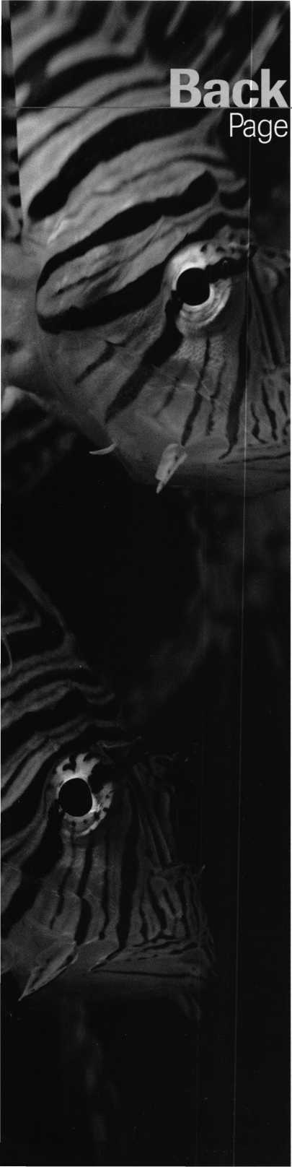

Another good reason to cool your heals in Cincinnati

As seen in this issue’s “Live and Learn” article, you don’t need a high-powered submarine to explore the ocean’s depths. Just take a short drive from downtown Cincinnati to One Aquarium Way, Newport, Kentucky to check out the Newport Aquarium. With 60 collections and 11,000 cool creatures to behold, the aquarium is one attraction any ALOA ’99 attendee won’t want to miss. Each section of the expansive aquarium is theme-oriented to give visitors the feeling that they’re actually in another world. Included are “Rivers of the World,” “The Shore Gallery,” and “The Dangerous and the Deadly” (which features an array of eels, piranha, stingray and alligator snapping turtles). Other exhibits include the “Jelly Fish Gallery,” “Gator Bayou” and the thrilling “Surrounded by Sharks.”

For more details on aquarium tickets and operating hours, call the Newport Aquarium at (606) 261-7444.

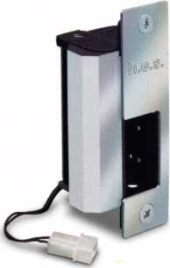

1976

The 1003 Series, the first  
electric strike able to  
accommodate a  
1" deadbolt.

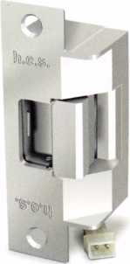

1996

The 7500 Series, the first  
electric strike able to release  
under a pre-load and U.L.  
listed as a Fire Door Acces-  
sory, Category 10b.

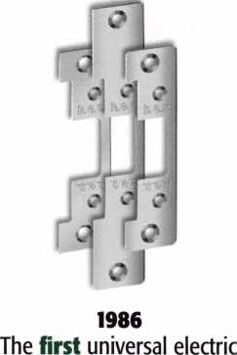

strike with power, operation  
and appearance options for  
a variety of applications.

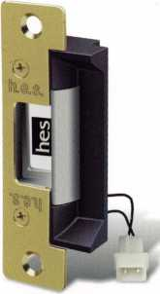

1997

The 5000 Series, the first "low-profile" electric strike with only a lV setback for ease of installation in limited space.

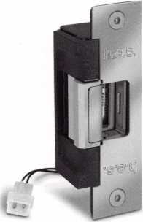

1989

The 7000 Series, the first easy-to-install electric strike capable of operating with up to 30 lbs. of door loading.

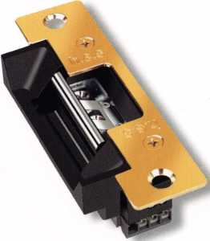

1999

Introducing our new 5700 Electric Strike with '/*" horizontally adjustable keeper.

Still the one after all these years.

Our new 5700 electric strike features an adjustable keeper that allows the installer to adjust the strike opening up to %" after installation. It also features latch bolt monitoring. The 5700's heavy-duty construction and compact design accommodates a TA" backset. 7 interchangeable face plates and 4 optional lip extensions make it very versatile. Contact HES, the recognized innovator in electric strikes, for more detailed information at (800) 626-7590.



Visit us at ALOA Booth #241

hes innovations

hes

HID CORPORATION

ISOProx® II

eProx™

Lock technology  
available from:

Alarm Lock

Introducing the ePROX™Lock Module f only from HID.

Now the security and

reliability of proximity access is available in standard electronic locks. It’s battery-powered for stand-alone applications, and, using the same HID card or keyfob, it can

I Cypress I Computer I Systems

I llco Unican

Locknetics

easily augment an

existing on-line access  
control system.With  
HID battery-powered

proximity, the one card  
solution becomes a simple and

V.

economical reality. The ePROX™ ' Lock Module from HID. Proximity access has finally arrived at your door.

[www.hidcorp.com](http://www.hidcorp.com)

Copyright 1999 HID Corporation

We identify with your business. #

(800) 237-PROX (7769) HID CORPORATION



rv\f\

